Table of Contents

1 Purpose 8

2 Overall 8

2.1 System Requirements 8

2.2 Next Steps 10

3 Body 10

3.1 Decision Matrix for New Features 11

3.2 Front Assembly 14

3.3 Back Assembly 14

3.4 Nerf gun dispenser 15

4 Head 17

4.1 Head Structure 17

4.2 Nodding Mechanism 18

4.3 Periscope 19

4.4 Iris Aperture 20

5 Nerf Blaster 21

5.1 Purpose 21

5.2 Design 21

5.2.1 Initial Design 21

5.2.2 Final Design 22

5.2.3 Torque Calculation 23

5.3 Nerf Blaster Selection/Modification 23

5.3.1 Selection 23

5.3.2 Modification 24

5.3.3 First Iteration of Modified Nerf Blaster 24

5.4 Arduino Implementation 26

5.5 Second Iteration of Modified Nerf Blaster (Spring 2019) 27

5.5.1 Electrical 27

5.5.2 Mechanical 29

5.6 Future Steps 30

6 Precise Arm 30

6.1 Arm Design 30

6.1.1 Decision Matrix 31

6.1.2 First Design 34

6.1.3 Geared Motor Selection 34

6.1.4 Final Arm Design 35

6.1.5 Generative Design 36

6.1.6 Future Steps 39

6.2 End Effector 39

6.2.1 Interface Plate 39

6.2.2 Two-Finger End Effector 40

6.2.3 Motor Selection 40

7 Strong Arm 44

7.1 Purpose 45

7.1.1 Decision Matrix 45

7.2 Design 48

7.2.1 First Iteration 49

7.2.2 Second Iteration 50

7.2.3 Assembly 51

7.2.4 Mounting Plate 52

7.3 Motor Selection 54

7.3.1 Calculations 55

7.4 Electronics 55

7.5 Integration with R2 58

7.6 Next Steps 62

7.7 Appendix 63

7.7.1 Calculations 63

7.7.2 Motor Specs 65

8 Arm Control 67

8.1 Task Definition 67

8.2 Concepting Controller Flow 70

8.3 Implementation in MATLAB and Python 73

8.4 3rd Axis Programming 75

8.5 Strong Arm and Simulink-based Controller Development 79

8.6 Strong Arm Arduino-Based Control 80

8.7 AprilTag Localization 80

8.8 Integration 83

8.8.1 Servos and Potentiometers 83

8.8.2 Structure and Interference 83

8.8.3 Communication Protocol 83

8.8.4 Debugging Controls on Precise Arm and Algorithm Breakdown 84

8.8.5 Integration & Testing Before NASA Presentation 84

8.8.6 Next Steps 84

8.8.7 Interfaces and Component Data Tracking 84

9 Facial Recognition 87

9.1 Goals and Objective 87

9.2 Design 87

9.3 Run Instructions 88

9.3.1 Client 88

9.3.2 Server 89

9.4 Timeline 89

9.5 Implementation Details 90

9.5.1 Client 90

9.5.2 Server 91

9.5.3 GUI 95

9.6 Issues 98

9.7 Next Steps 98

9.8 Code Appendix 98

9.8.1 Google Sheets Authentication Guides 99

10 Speech and Sentiment Analysis 99

10.1 Goals and Objectives 99

10.2 Microphone Improvement 100

10.2.1 Timeline 100

10.2.2 Implementation 100

10.2.3 Testing 101

10.3 Sentiment Analysis Algorithm Improvement 101

10.3.1 Timeline 101

10.3.2 Implementation 102

10.3.3 Testing 103

10.4 Main Program/User Interface Changes 103

10.4.1 Timeline 103

10.4.2 Implementation 104

10.4.3 Testing 105

10.5 Next Steps 106

10.6 Code Appendix 106

11 Object Detection 106

11.1 Goals and Objective 106

11.2 Design 106

11.3 Timeline 107

11.4 Implementation Details 107

11.5 Issues 109

10.6 Next Steps 109

10.7 Code Appendix 110

11 Low Battery Detection and Wireless Charging 110

11.1 Objective 110

11.2 Background 110

11.2.1 Low Battery Detection 110

11.2.2 Wireless Charging 110

11.3 High level design 110

11.4 Initial Research 111

11.4.1 Battery Voltage Detection 111

11.4.2 Wireless Charging Module 112

11.5 Final Design and Implementation 113

12 R2C Protocol 114

12.1 Protocol data packet schema 114

12.2 Example 115

12.3 Future Perspective 117

13 RPLidar and proximity sensors 117

13.1 RPLidar 117

13.2 Other Proximity Sensors 118

14 Communication and Integration 119

14.1 Overall process 119

14.2 Xbox Controller setup 119

14.2.1 Establishment of Xbox Controller Connection with Pi 119

14.2.2 Xbox control vs. keyboard control 120

14.3 Arduino and Motor Encoder 120

14.4 Lidar sensor 122

14.5 Main Program 123

14.6 Software User Guide 123

15 Power 124

15.1 Charging Procedure 124

15.2 Battery and Power Specifications 125

16 Path Planning 126

16.1 Goals and Objectives 126

16.2 Design 127

16.2.1 Localization 127

16.2.2 Search Algorithm 127

16.2.3 How To Use 129

17 References: 129

Table of Figures

Figure 3.1 - R2 Full Body CAD 9

Figure 4.1 - Icosahedron Head CAD 16

Figure 4.2 - Head Jig Design 16

Figure 4.3 - Head Structure CAD 17

Figure 4.4 - Head Nodding Frame 18

Figure 4.5:Iris Lense Schematic 19

Figure 4.6: Iris Aperture 20

Figure 5.1 - CAD rendering of the initial design 21

Figure 5.2 - Metal plate from ServoCity 21

Figure 5.3 - CAD Rendering of the Final Design 22

Figure 5.4 - Final Design – Front view 22

Figure 5.5 - Shortened blaster 23

Figure 5.6 - Anatomy of a Nerf Blaster 24

Figure 5.7 - Arduino Circuit of the aiming system 26

Figure 6.1 - CAD Renderings of original arm design (extended and retracted views) 33

Figure 6.2 - TM-805MG Servo with attached 5:1 gearbox 34

Figure 6.3 - Final CAD renderings of arm with motors and gearboxes 34

Figure 6.4 - 3D printed precision arm prototype 35

Figure 6.5: Final generative design assembly of upper and lower arm sections. 37

Figure 6.6: CAD renderings of the interface plate 3D printed piece (left), and final assembled interface plate (right). 40

Figure 6.7: The final printed interface plate assembly. 42

Figure 6.8: End Effector wrist base. 44

Figure 6.9: Left gripper (left) and right gripper (right) featuring meshed gear interface and textured grip faces. 45

Figure 6.10: Closed and open renders of the 2 finger end effector assembly. 47

Figure 6.11: Render of end effector and interface plate mounted on precision arm. 48

Figure 6.12: Final assembled end effector mounted on precision arm. 50

Figure 7.1 - Completed Strong Arm at NASA Kennedy Space Center 51

Figure 7.2 - Arm Design (Isometric View) 56

Figure 7.3 - Ratchet and Pawl Passive Locking Mechanism 56

Figure 7.4- End Effector (Side View) 57

Figure 7.5- End Effector (Top View) 57

Figure 7.6 - End Effector (Isometric View) 57

Figure 7.7 - CAD Render of Second Iteration of Strong Arm (Isometric View) 58

Figure 7.8 - R2 Base Mounting Plate 59

Figure 7.9 - Labeled Top View of Attachment Locations 60

Figure 7.10 - Mounting Plate on R2 Before Components were Attached 61

Figure 7.11 - Encoder + Motor Wiring Diagrams 63

Figure 7.12 - CLT86 Driver Used for Stepper Motors 63

Figure 7.13 - Serial Control Code 64

Figure 7.14 - Motor Control Code 65

Figure 7.15 - Strong Arm Integrated with R2 66

Figure 7.16 - Strong Arm on R2 Preparing to Lift Basket Weighing 10 lbs. 67

Figure 7.17 - Strong Arm on R2 Lifting a Basket Weighing 10 lbs. 68

Figure 7.18 - MATLAB Code for Calculating Required Moments for the First Two Joints 70

Figure 7.19 - Calculations for Output Speed 70

Figure 7.20 - Calculations for Power Requirements 71

Figure 7.21 - Calculations for Ratio of Spools 71

Figure 7.22 - NEMA 34 Hybrid Stepper Motor Specs (Part 1) 72

Figure 7.23 - NEMA 34 Hybrid Stepper Motor Specs (Part 2) 72

Figure 7.24 - NEMA 34 Hybrid Stepper Motor Specs (Part 3) 73

Figure 7.25 - NEMA 34 Hybrid Stepper Motor Specs (Part 4) 73

Figure 7.26 - NEMA 34 Hybrid Stepper Motor Specs (Part 5) 74

Figure 8.1 - FFBD for R2 Movement Through Door 76

Figure 8.2 - Multi-State R2 Control Thought Exercise 78

Figure 8.3 - Control Flow for Arm Grabbing Object 79

Figure 8.4 - MATLAB Implementation of Inverse-Jacobian Based Control 81

Figure 8.5 - Python Implementation of Two Motor Control 82

Figure 9.1 - Facial Recognition Code Structure 87

Figure 9.2 - A New Attendance Spreadsheet 92

Figure 9.3 - Attendance Spreadsheet with Sample Data 92

Figure 9.4 Spreadsheet with Varied Data Entries 93

Figure 9.5 A Sample Pivot Table 94

Figure 9.6 R2 Tablet GUI General Info Tab 96

Figure 9.7 R2 Tablet GUI Data Streaming Tab 97

Figure 9.8 R2 Tablet GUI Sign Up Tab 98

Figure 9.9 R2 Tablet GUI Quit Tab 98

Table of Tables

Table ‎1.1 - Scenarios for R2 to complete 7

Table ‎2.1 - High level Tasks for R2 8

Table ‎2.2 - High Level Requirements 8

Table ‎3.1 - Head and Features Decision Matrix Category Scale 11

Table ‎3.2 - Head and Features Decision Matrix Sub-Category Scale 11

Table ‎3.3 - Features Decision Matrix, Part 1 12

Table ‎3.4 - Features Decision Matrix Part 2 12

Table ‎5.1 - Nerf Blaster Anatomy Labels 20

Table ‎5.2 - Circuit Diagram Labels 22

Table ‎6.1 - Precise Arm Decision Matrix Category Scale 24

Table ‎6.2 - Precise Arm Decision Matrix Sub-Category Scale 24

Table ‎6.3 - Precision Arm Decision Matrix Part 1 25

Table ‎6.4 - Precision Arm Decision Matrix Part 2 25

Table ‎7.1 - Strong Arm Decision Matrix Category Scale 36

Table ‎7.2 - Strong Arm Decision Matrix Sub-Category Scale 37

Table ‎7.3 - Strong Arm Decision Matrix (Part 1) 38

Table ‎7.4 - Strong Arm Decision Matrix (Part 2) 39

Table ‎8.1 - R2 Task List 58

Table ‎8.2 - Arm Control Raspberry Pi Software Interfaces 69

Table ‎8.3 - Sensor Information 69

# Purpose

The R2 project objective is to expand upon and refine the R2D2 Project of past years. The original R2D2 Project focused upon creating a semi-autonomous lab assistant that would primarily move around and map out the surrounding environment. This old model also focused on recreating the visual appearance of the character R2D2 from the Star Wars franchise. The objective for this semester was to expand upon R2’s ability to interact with the environment around the robot while straying away from the original project inspiration of R2D2. Similarly, the design objectives for the R2 project were slightly altered to focus more on completing individual scenarios that could then be demonstrated for a larger audience. One of the main goals for the R2 project this year was to change the focus towards inspiring excitement and interest in robotics and engineering in general. One of the main ways we are going to be meeting this goal is to create an update a Kickstarter campaign with the progress of the R2 robot. We hope that this will help advertise the R2 project and generate interest in the design process. This hopefully will work towards the long-term goal of having the R2 robot appear in a Star Wars movie. For that aim the project team for R2 this semester devised six general scenarios that the R2 project would be designed towards completing. The parameters that helped us decide upon these scenarios were how interesting or exciting they could be, the educational value of the scenario and the feasibility of the scenario to complete by the end of the ear. Additionally, certain scenarios such a “high five” and picking out a specific object were chosen to act as initial scenarios that would then be built upon to complete the more complicated scenarios. This is so that we would have presentable progress for the Kickstarter throughout the design process. The scenarios for the R2 project are shown below:

Table . - Scenarios for R2 to complete

|  |
| --- |
| UIT Scenarios |
| Get a soda / snack from a fridge and hand to user |
| Open and move through a door |
| Recognize and greet individual people |
| Fire a nerf dart at a specific target |
| Pick out a specific object from a mess |
| “High Five” |
| Visually represent object detection, speech analysis and facial recognition via tablet |

This Document contains the changes and additions to the R2 system in the Fall 2018 Semester with the intent to allow R2 to complete the tasks listed above. The eventual goal for the R2 system is for it to appear in the next move in the Star Wars franchise.

# Overall

## System Requirements

The six scenarios shown in Table ‎1.1 were then broken down into several tasks required to complete each of the outlined scenarios. These tasks were not yet broken down into the requirements for the R2 system in order to complete the desired scenarios. These tasks are merely what individual actions the R2 unit would have to complete in order to complete the desired scenarios. The R2 project team also identified the estimated technical difficulty, level of autonomy and minimal time allowable to complete each goal required for each task.

Table . - High level Tasks for R2

|  |  |  |  |
| --- | --- | --- | --- |
| Task | Technical Difficulty | Level of Autonomy | Time Goal (minutes) |
| Open Door | Medium | 2 | 15 |
| Open Door and Enter | Hard | 3 | 60 |
| Open Door and Hold Open | Hard | 3 | 30 |
| Pick Up Light Object | Medium | 2 | 30 |
| Pick Up Heavy Object | Medium | 2 | 30 |
| Pick Up and Deliver Light | Hard | 3 | 60 |
| Pick Up and Deliver Heavy | Hard | 3 | 60 |
| Identify and Wave | Medium | 4 | 10 |
| Identify and Record Attendance | Easy | 4 | 5 |
| Identify Fridge Handle | Easy | 4 | 10 |
| Identify Door Handle | Easy | 4 | 10 |
| Identify Unique Object | Easy | 4 | 10 |
| Identify Soda Can | Easy | 4 | 10 |
| Identify Nerf Target | Easy | 3 | 10 |
| Open Fridge | Medium | 2 | 30 |
| Open Fridge Grab Soda Hand to User | Hard | 4 | 60 |
| Open Drawer | Medium | 2 | 20 |
| Open Drawer Remove Specific Object | Hard | 3 | 45 |
| Fire Nerf Dart at Desired Target | Easy | 3 | 5 |

The high-level requirements for the R2 system were derived from the tasks shown in Table ‎2.1 and are shown below in Table ‎2.2:

Table . - High Level Requirements

|  |  |
| --- | --- |
| Requirement Number | Requirement: The System Shall: |
| T1_1 | Be able to pick up an object under 1.5lbs and deliver it to a user |
| T1_2 | Be able to pick up an object of up to 15 lbs and place it elsewhere |
| T1_3 | Have a range of motion of a hemisphere for light objects, as defined in T1_1 |
| T1_4 | Have a range of motion of a plane for heavy objects as defined in T1_2 |
| T1_5 | Support Loads as defined in T1_1 and T1_2 throughout range of motion |
| T1_6 | Be able to detect if an object is in the way of performing an action and alert nearby people |
| T1_7 | Be able to grab a light object, as defined in T1_1, of up to 3x3 in in cross sectional area |
| T1_8 | Be able to grab a heavy object, as defined in T1_1, of up to 3x3 in in cross sectional area |
| T1_9 | Be able to rotate a door handle with up to 3lbs of force |
| T1_10 | Weigh Less than 200 lbs |
| T1_11 | Be able to be commanded through a remote control |
| T1_12 | Be able to shift to autonomous mode to perform tasks |
| T1_13 | Not cause any bodily harm to users |

## Next Steps

At the end of the spring semester we were able to physically integrate the different systems together into one robot. However, due to time constraints and difficulties when transporting the robot to and from the Cornell Cup competition, the robot was only able to complete the barest of commands such as basic locomotion. The next goals for the R2 project is to finish integrating the different subsystems, complete minor lower priority tasks such as fine tuning the nerf blaster and assembling the end effector for the strong arm and testing and expanding the use cases for the robot. The main problem to overcome in future work for the R2 project would revolve around properly integrating the computer science projects, such as object detection and voice recognition, with the physical capabilities of the robot to properly and autonomously complete the outlined scenarios. After the R2 system can complete the six desired scenarios then future work on the R2 system would entail working on more complicated scenarios for the R2 robot to complete. There were multiple scenarios that were discussed by the R2 team as interesting, however were eventually scrapped due to the complexity of the scenario, these scenarios were: Identifying someone wearing a storm trooper mask and firing the nerf blaster at said person, picking up a pen and signing a signature, playing rock, paper, scissors with the user, bringing coffee to the user and hitting a hockey puck with a hockey stick.

**Error! Reference source not found.**Table ‎2.1

# Body

The overall body structure of R2 has increased in size from the frame of the previous semesters, while the size of the head and lower footprint has remained the same. R2’s height was increased by 6 in to better enable the precision arm to reach objects at table height and the width and length of the body channels were increased by 2 in to make more room for internal storage of the nerf blaster and battery.

‎4

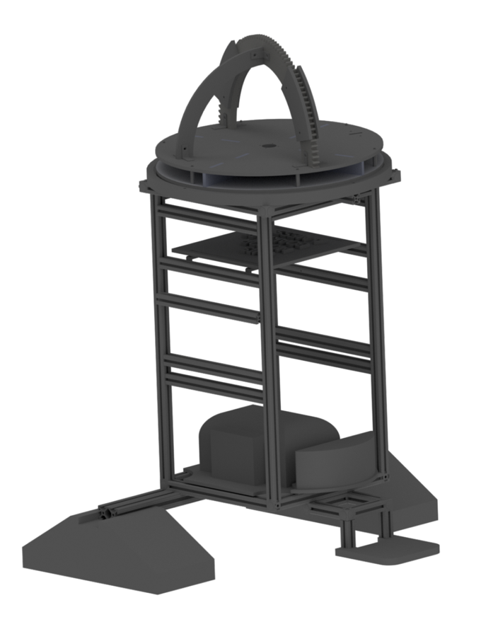

Figure . - R2 Full Body CAD

The outer shell of R2 was designed with angular, long pieces of acrylic to match the polygonal aesthetic of the head. As shown below, it features opening doors in the front for the nerf blaster for it to come out through, which have been attached but not yet actuated. The shell was constructed using machined pieces of thin aluminum connected with 3D printed jigs and covered using acrylic with dual-lock Velcro connections. This was done so that sensors screwed into the metal plates could be accessed through easy removal of the acrylic.

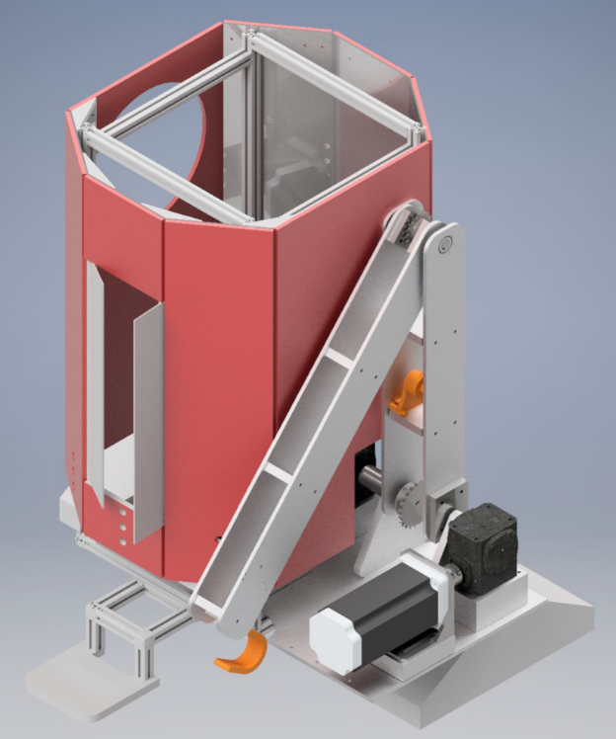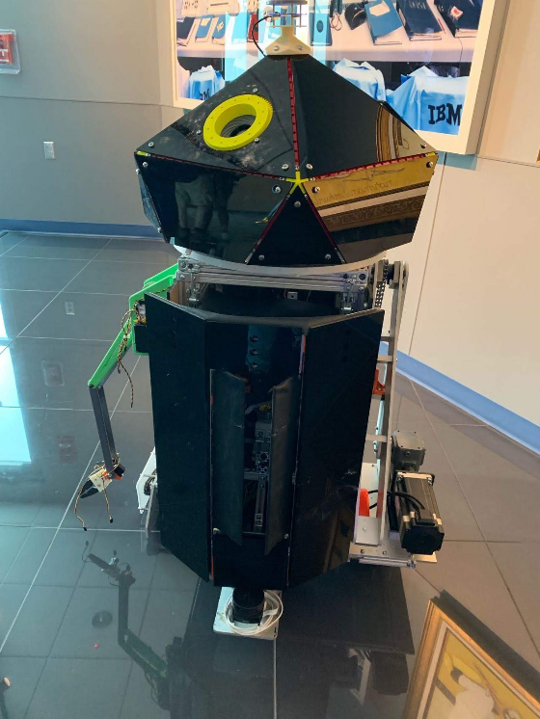

Figure 3.2: R2 Outer Shell: (left) CAD rendering; (right) Physical body

## Decision Matrix for New Features

In order to determine general design choices for R2 and the tasks that it would be designed to accomplish, it was important to initially create a decision matrix for these components. A decision matrix provides a method of comparing different proposed design choices by assigning each design a score in various categories. The scores are then weighted to provide a final score (out of 5), and the features with the highest scores will be implemented in our final design.

The categories that were used to determine the collective value of each feature were educational value, feasibility, meeting project objectives and visibility along the way. Educational value was given a 2. This category determined how important the feature was to help the team develop new skills. Feasibility was weighted with a 3 and entailed how realistic it was that the team would be able to take on each feature. Meeting project objectives was weighted with a 5 and entailed how well the feature added to the overall goal of R2. Finally, visibility along the way was weighted with a 1 and entailed how easy it was to see milestones as we progressed with the project. The scale can be seen in

Table ‎3.1 below:

Table . - Head and Features Decision Matrix Category Scale

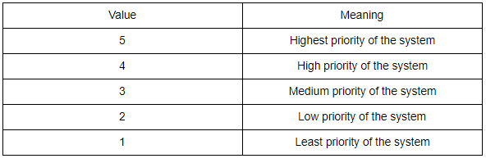

Within these main categories, we created sub-categories. For Education, only educational value was a sub-category. Within feasibility, team skills, cost, time required, resources available and risks are all assessed. Under the Meeting Project Objectives category, interactivity, autonomy, and excitement to audience were all considered. Lastly, for Visibility Along the Way, milestones were assessed in the sub-category. The sub-category scale can be seen in Table ‎3.2 below:

Table . - Head and Features Decision Matrix Sub-Category Scale

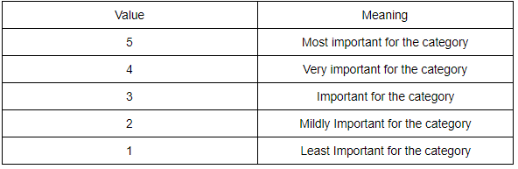

After all categories were considered, it was decided that the head would include the nodding feature while keeping the heads ability to fully rotate. The ability for extra features to be attached or extend out of the head was also highly considered for the head design of R2. While there are no set extensions or features that are currently part of the design of the head, multiple ideas have been thrown around and the head was specifically designed with adding future features in mind. Additionally, the idea of adding a Nerf Blaster to R2 was further analyzed and eventually decided that the nerf blaster functionality would be a good addition to the scope of the project. This was due to the large excitement value of such a project as well as the Nerf Blaster would have a high educational value.

Table . - Features Decision Matrix, Part 1

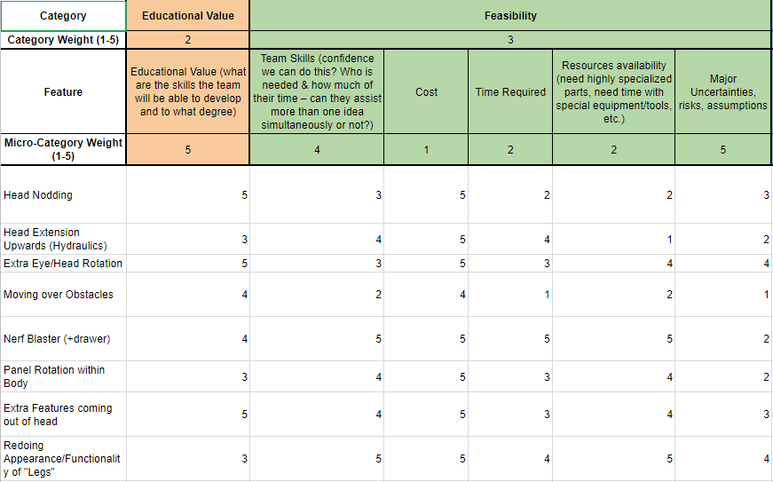

Table . - Features Decision Matrix Part 2

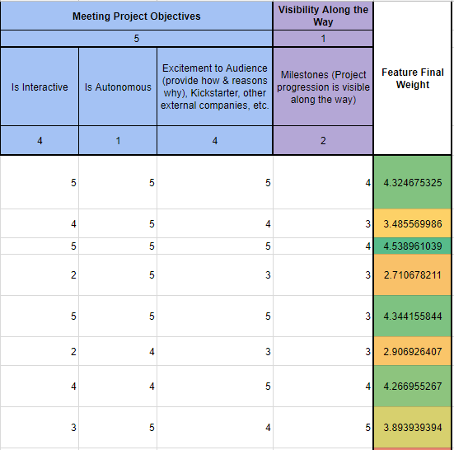

## Front Assembly

The acrylic plates were used to match the aesthetics of the head; however, the shape of the head could only be constructed with custom made angle brackets. Since the head is a decagon (10 sides), the body was designed to have the same shape, however the sides were flat to account for the movement of the precision arm and strong arm. The custom-made angle brackets (shown in Figure 3.3 were designed to hold the acrylic and aluminum plates together which would bear a load on these parts. Due to this reason, the angle brackets were designed to be relatively larger and to be able to withstand any bending stress. The parts were manufactured using the 3D printers in the Rapid Prototyping Lab. The assembly of the front shell is shown in Figure 3.4, where the corner brackets are visible in the back view. corner brackets are visible in the back view.

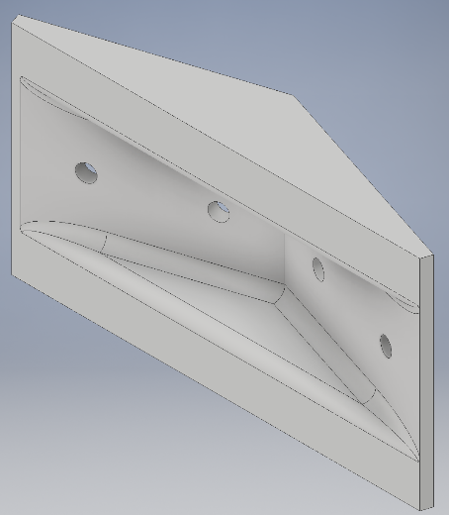

Figure .3 – Old Drawer Mechanism

## Back Assembly

The back cover of the shell could not be rigidly connected to the frame of the body because the electrical components had to be accessed easily, which would be easier to implement on the back side. The concept of the design was to simply connect the back shell to the frame with hinges, to allow for the shell to open therefore allowing ease of access to the inside of R2. Another functionality of the shell was to hold the appliances, while in a vertical position, which was achieved by adhering the appliances to the board using ‘dual lock’ (Figure 3.4).

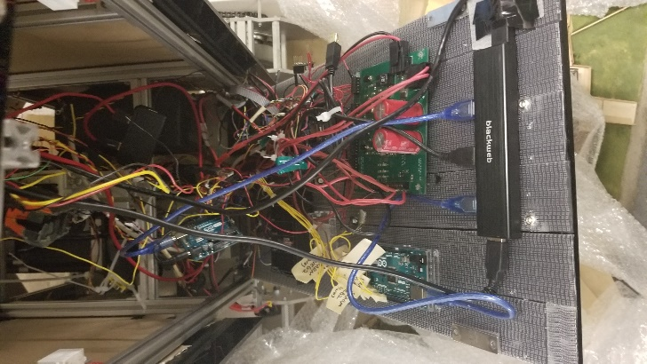 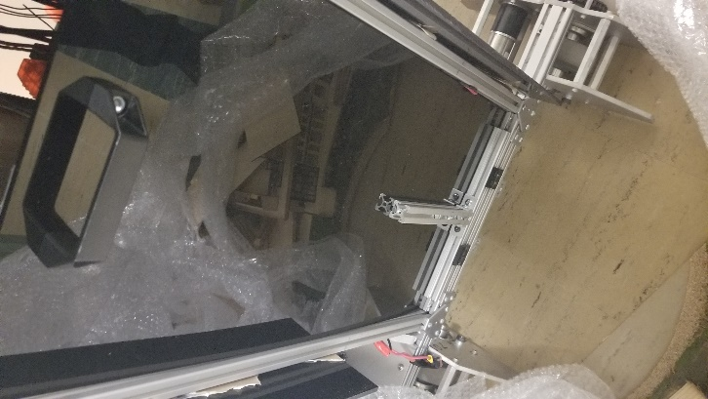

Figure .4 – Back Shell/ drop-down ECE Board: Inside view (left), outside view (right)

## Nerf gun dispenser

The old design of the drawer mechanism (shown in Figure 3.5was replaced because the purpose of the drawer did not overlap with the requirements of the nerf gun dispenser. The old design was unnecessarily heavy and could not accommodate for the vertical size of the nerf gun. The nerf gun dispenser needed to be consistent with the functionalities as the old design in terms of dispensing the nerf gun by translating outside the frame of R2. The nerf gun dispenser needed to be consistent with the functionalities as the old design in terms of dispensing the nerf gun by translating outside the frame of R2.

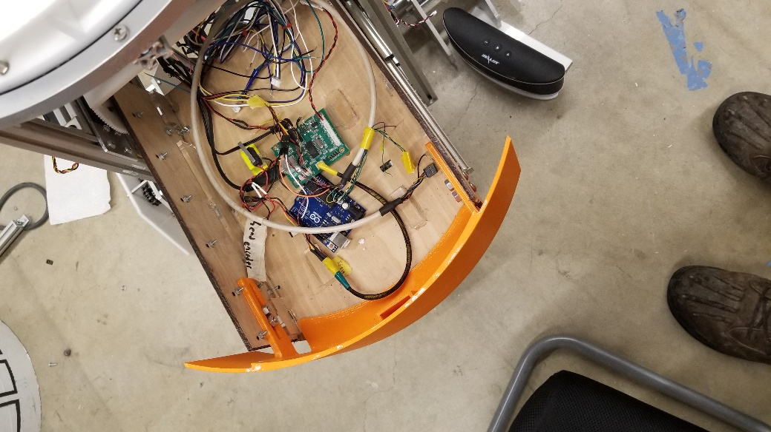

Figure .5 – Old Drawer Mechanism

This translational movement outside the frame of the robot would have to be accounted into the construction of the outer shell. To implement this, two opening doors were added in the front of the outer shell as shown in Figure 3.6.

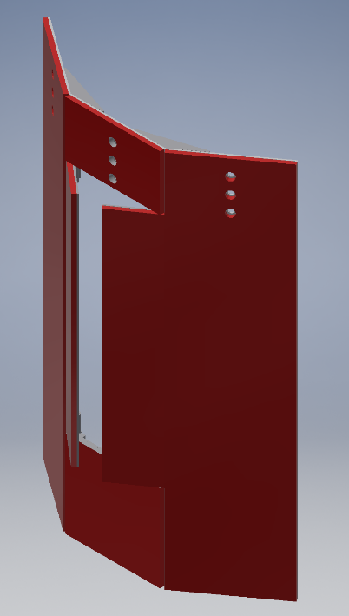 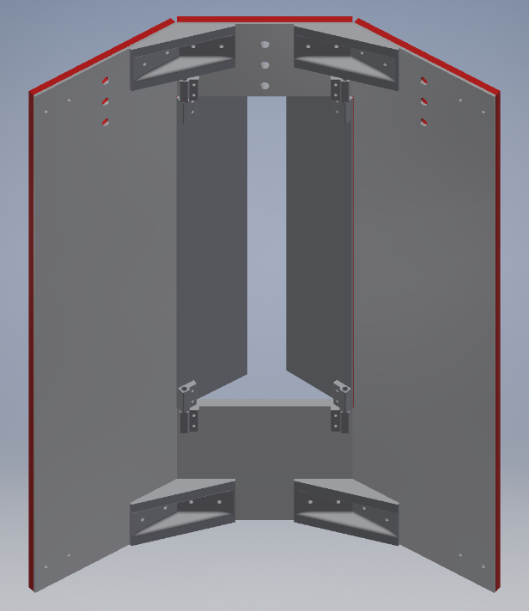

Figure .6 – Front Side: Front view (Left), Back view (Right)

The opening door mechanism resembled the mechanism used in ‘cuckoo’ clocks for moving the bird out of the bird house. In this case, 3d printed parts (Figure 3.7) were designed to allow the doors to open while being mounted onto the rest of the shell. The implementation of the design includes two of these parts, a long screw, washer and a lock nut, and the concept is for one of the parts to be installed on the door while the other is installed on the rigid shell. This provides the door with a pivot point.

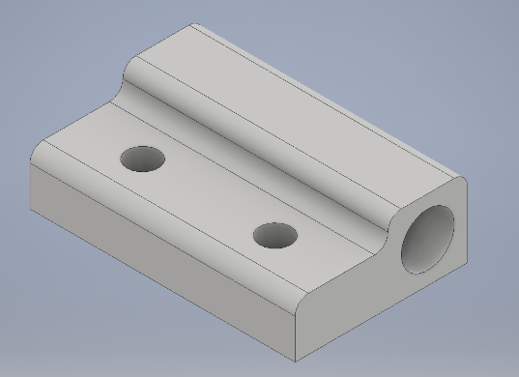

Figure .7 – 3d printed hinges for the nerf gun doors.

# Head

For the redesign of the R2 head, functionally, the new design must integrate with the current rotational platform and the body, have space inside for electronics and additional features, and easily be able to have features mounted to it. To generate interest for the kick starter campaign and at maker fairs, the new head must also have an interesting shape enough to be visually exciting to an audience and the new features should simulate a personality for the new R2.

## Head Structure

The final head structure is half of a regular convex icosahedron, a 20-sided figure with triangular sections, shown below. The design was chosen partially due to its many flat faces, which are highly compatible with adding and mounting features to them as well as ease in customizing individual faces for these features. The shape itself is also more visually interesting while still having a similar overall shape to the previous R2 hemispherical head design with the same internal radius.

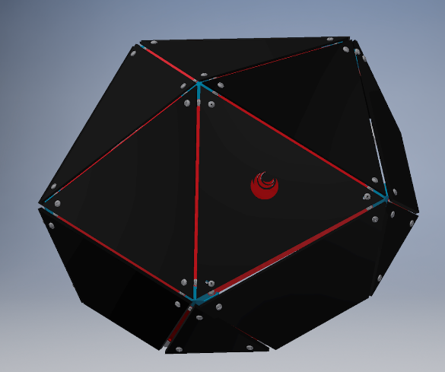

Figure . - Icosahedron Head CAD

The head itself is entirely laser cut and 3D printed so the whole structure can be made in-house, a large advantage over other head designs considered, especially considering certain sections will need to be altered for features to be integrated. This head structure is accomplished using 3D printed corner jigs and laser cut struts and triangular panels.

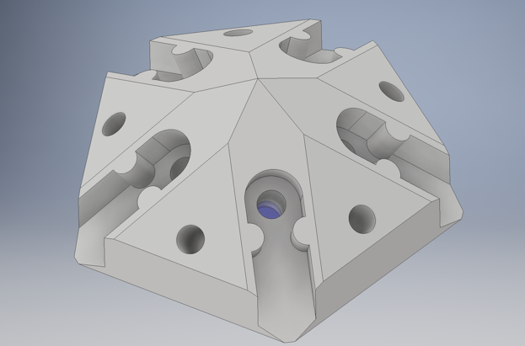

Figure . - Head Jig Design

The head corner jigs, shown above, have five slotted interfaces which the struts slide into and can be screwed in to the captive nuts on the other side. The strut was designed for a convex icosahedron with a dihedral angle, the angle between each triangular face, of 138.19 degrees and internal tangent sphere radius of 9.75 in, although the design was parametrized to be able to be altered for a different internal tangent sphere size if R2’s head size is increased.

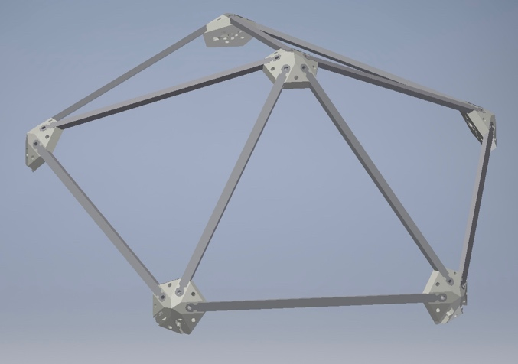

Figure . - Head Structure CAD

On top of each of the struts will sit the laser cut triangular faces, which are coplanar with the top faces of the jig and screw into the holes on three jigs to secure them. These faces will be red and black and are customized to certain features. This includes replacing one with a mesh triangle near the speaker for clarity of sound, having an inset Cornell Cup logo in red acrylic, housing a tablet, and mounting the lens aperture. A small 3D printed piece for the microphone for voice recognition sits on top of the peak of the head. The final head is shown in the figure below and while the rest of the head features were successfully implemented with the panels and head structure, the mechanism to move a panel down for the periscope to come out was not finished so the panel was removed to demo the periscope.

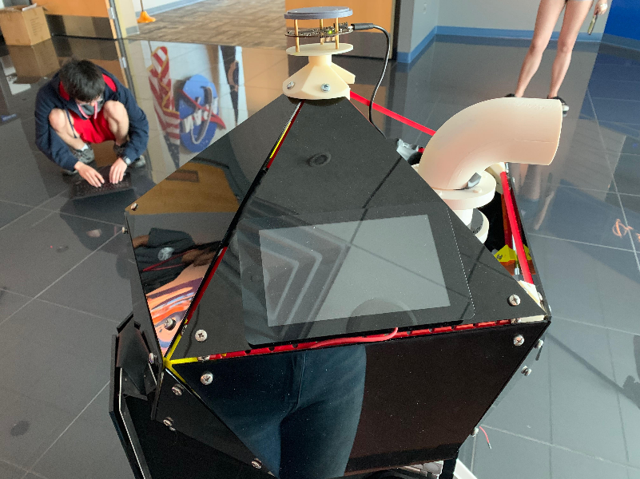

## Nodding Mechanism

To allow the head to nod in both directions, there must be some clearance between the body and the bottom of the head structure as well as a supportive frame structure on which the head rotates and leans on. To accomplish this, a frame is implemented underneath the head structure, which is similar to a rack and pinion, yet the rack itself resembles a gear with its circular, albeit stationary, design. Two smaller gears will be attached to the outer head structure and continuous rotation servos so as they simultaneously rotate, the two points will move along the pinion frame structure and tip the head forward and backwards.

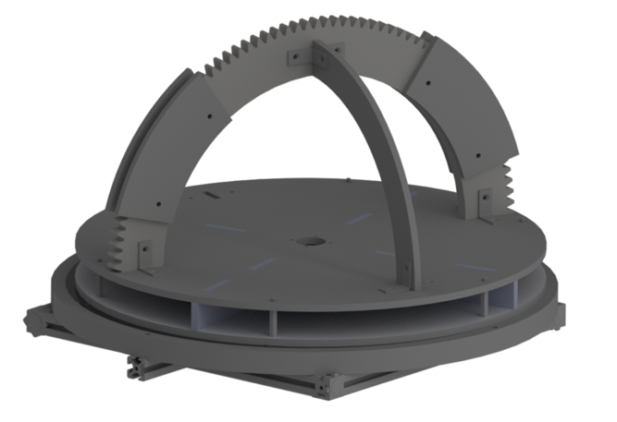

Figure . - Head Nodding Frame

As can be seen in the figure, this design is fully integrated with the previous head rotation platform and can be directly attached to it. Like the head rotation platform, the entire design is laser cut and easy to manufacture, the pieces connected both with slotting tabs and L-brackets. The perpendicular piece to the pinion frame supports the structure from a net moment to either side due to uneven weight distribution in the head structure.

To prevent the servo gear from becoming misaligned or falling off of the track, the pinion frame is doubled with an extra sheet of acrylic and has two “rails” to prevent the gear falling off entirely and the head structure possibly damaging the frame or head components.

## Periscope

Inside the head is a periscope which uses a small camera to output a feed to the tablet so users can control the periscope and “see through R2’s eyes.” This was designed to increase user interest and add a more interactive element to R2 that users can directly experience and control. The periscope was 3D printed in 6 pieces due to its irregular shape: two top and bottom rounded edges and a middle cylindrical piece. The top and bottom sections press fit into inset edges of the middle section so the entire assembly can easily be assembled and disassembled. A 3D printed mount connects the middle section to the linear actuator for vertically moving the periscope and houses a servo which meshes with a laser cut gear on the bottom ring of the periscope to rotate the periscope. To create the periscope effect, two acrylic laser cut mirrors and placed in inset sections of the top and bottom pieces. For future semesters, a new camera mounting must be created or the camera must be replaced because while the camera fits into the laser cut mounting that can be inset into the bottom of the periscope, the camera’s lack of zoom capabilities make the image too small.

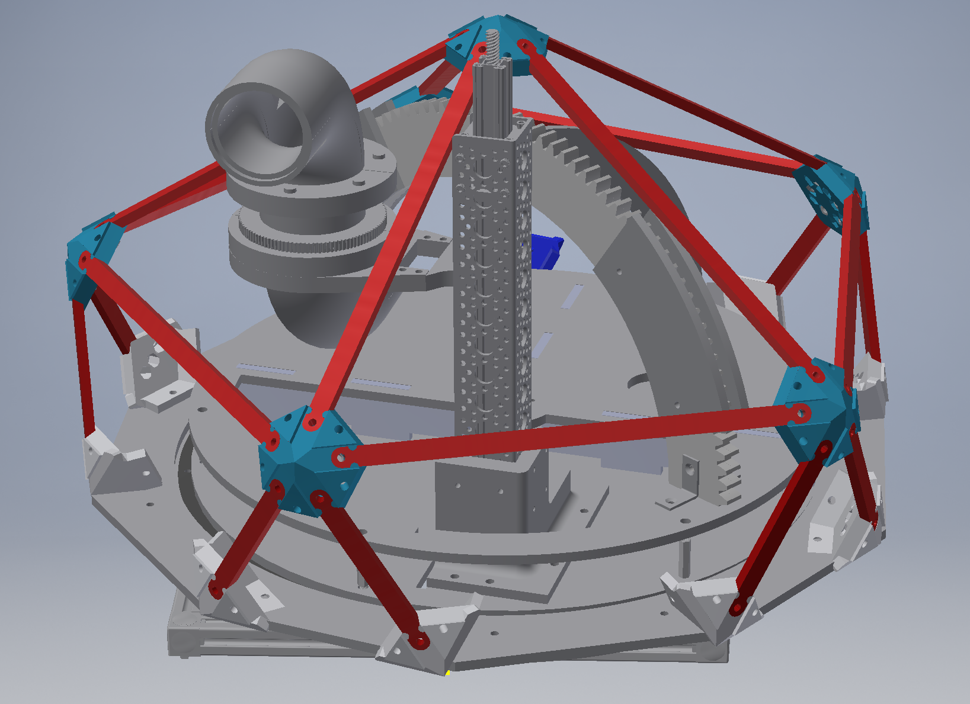 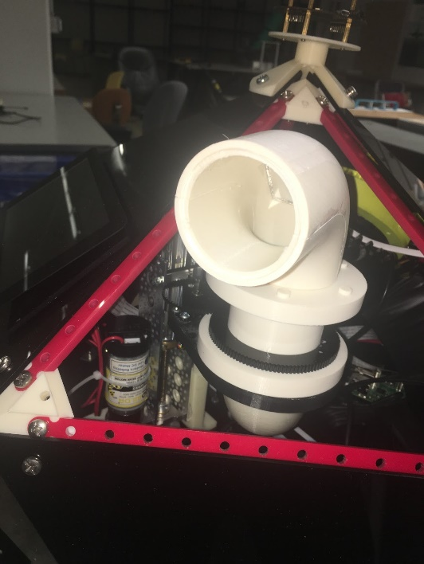

## Iris Aperture

Another feature in the head is the Iris Aperture, which mimics camera lens’ opening and closing motion. This was designed to increase user interest and add a more interactive element to R2 that users can directly experience and control. With requirements for precise dimensions in several components, the initial dimensions were calculator using iris-calculator.com. Before fabricating, research was done on the mechanism behind the iris aperture. The opening/closing of aperture is done by the movement of the 12 leaves that each has 2 pins on opposite sides and ends of the leaf. Iris aperture consists of the leaves that open and close the iris lens, the body casing, the slot casing that allow the leaves to move linearly towards the center of the body, and the actuator ring that spins around the body. As this ring that is connected to one end of the 12 leaves spins, all leaves start moving linearly on the other end. This movement helps moving each leaf closing to the center of the casing. The aperture was then 3d-printed: leaves were very difficult to print (due to design because of the support material that is needed), but works best rather than laser cutting acrylic because of its soft and flexible nature, thickness required was the leaf is 1mm, the thinner the leaf is, the closer to the center the closing movement can get.

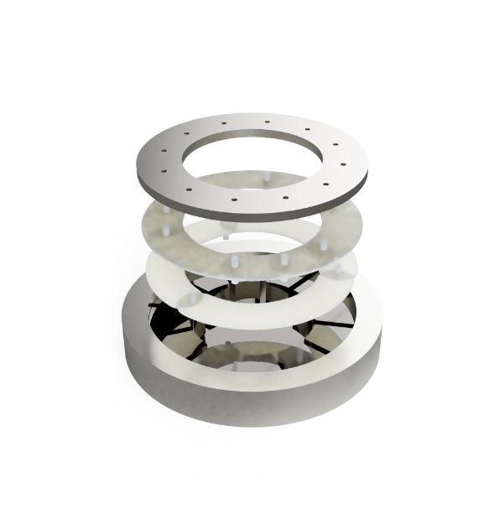

Actuator Ring

12-leaf setup

3-leaf setup

Slot+Body casing

Figure .:Iris Lense Schematic

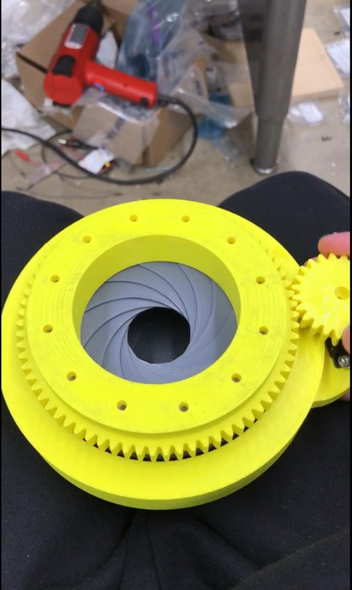

Figure .: Iris Aperture

# Nerf Blaster

## Purpose

The original concept for the Nerf Blaster implementation was to improve R2 interaction with the audience and on the demonstration performance of R2. The nerf blaster project was selected due to its high ranking in the decision matrix created by the locomotion sub-team, shown in section 3. The main criteria include different weights to rank which is most important to the team: Educational Value, Team Objective, Feasibility, and Visibility. Within these main categories, we created sub-categories. For Education, only educational value was a sub-category while within feasibility, team skills, cost, time required, resources available and risks are all assessed. Under the Meeting Project Objectives category, interactivity, autonomy, and excitement to audience were all considered. The Nerf Blaster was the third highest ranking option, scoring consistently high in most of the sub-categories, and the highest ranked feature unrelated to the head and thus it was chosen as a feature for this semester. Use cases include playing Nerf battles with users, using object detection to aim and fire at specified targets, activating buttons to send an object in projectile motion, and communicating with other systems via directed sonar/infrared signals.

## Design

### Initial Design

For the nerf blaster, two degrees of freedom in the aiming system were found to be sufficient for the use cases. One would be for the horizontal pan and the other for the vertical tilt, each controlled by separate servos. The projectile motion of nerf darts, which is controlled by these motions, and the strength with which it is shot, acts the third degree of freedom. These three degrees of freedom allowed for mapping out the plane with x and y coordinates and aiming the blaster within these coordinates for better precision. For the initial servo selection, the micro servos modeled HS5087MH found in lab was used because of the compact size and low weight. Servo selection was based on torque calculation, provided in ‎5.2.3 below.

The initial CAD was done with the intent to rapidly prototype the design using laser-cutting, as many parts were designed to be made from acrylic plates that can be easily purchased and laser cut. In the first design, it includes laser-cut acrylic components attached by zinc-plated steel brackets to strengthen the acrylic side supports. The bottom servo was connected to the bottom plate through press-fitting with an aluminum tube. However, upon further testing, these acrylic plates had various problems with store-bought steel brackets: the dimensions of the brackets and the aluminum were slightly bigger than the dimensions provided on McMaster, so press-fitting was impossible. Additionally, in order to get the desired thickness, acrylic plates were stacked and adhered together instead of using nuts and bolts. By doings so, the side supports, and the base could not be taken apart for any other modification, such as fitting in a tube of a different diameter (for tilting).



Figure . - CAD rendering of the initial design

### Final Design

To avoid the issue with inaccurate dimensions when mounting laser-cut components with McMaster-bought ones, metal plates, brackets and aluminum tubes from ServoCity were used instead. The pattern plates have precut holes for half-inch diameter tubes and 1/8’’ nuts, allowing for easy assembly and modification.

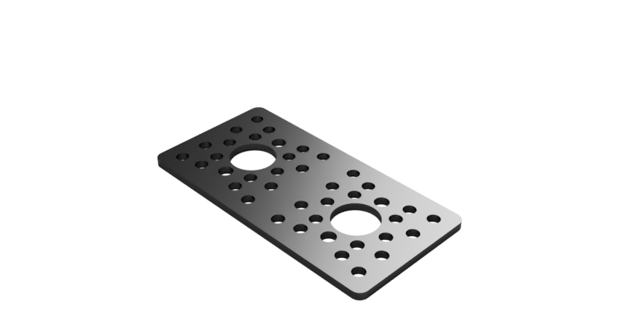

Figure . - Metal plate from ServoCity

For servo selection, in order to allow for fluid and continuous movement, HSR-2645CRH high torque servo was selected after testing out different servos already available in lab. This servo came with a gearbox of ratio 5:1, which allows for more fluid motion as the rate of tilt of the blaster is only 1/5 the rate of rotation of the servo. Since there was no need for fast tracking movements, using gear ratios allow for slower, but also significantly more precise movement of the blaster.

The pattern plates were true-to-size, which made press fitting them onto 3D-printed components easy. With increased thickness, 3D-printed components were reliable enough to withstand the load of 3D-printed components allow for less time and more ease for testing designs with different thickness and shape, which are important to meet both the limited space requirement of R2, and the strength required to support the blaster. It is also a precursor to next semester’s goal, which is to design 3D-printed components as connections between the drawer and the aiming system.

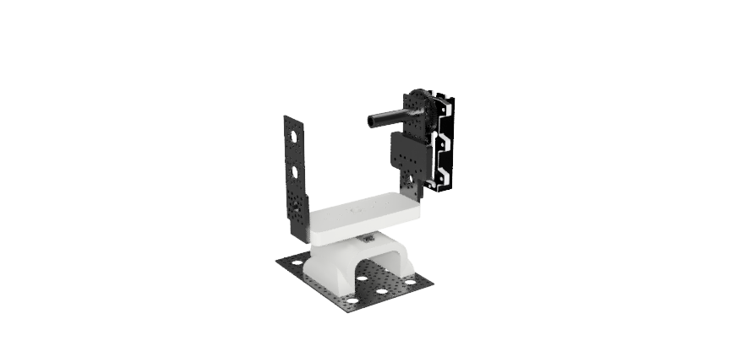

Figure . - CAD Rendering of the Final Design

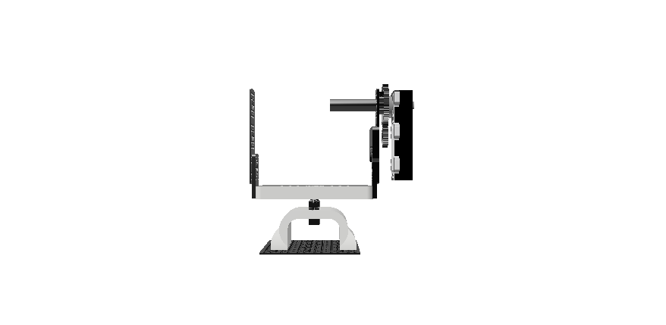

Figure . - Final Design – Front view

### Torque Calculation

In order to select the right servo, the torque necessary to tilt the Nerf Blaster needed to be calculated. With the modified Nerf Blaster that was reduced to half its length, it has a moment arm of length ~15cm. The assumed weight of added circuitry and Arduino was estimated to be at maximum 1kg. The blaster and the dart drum weighed 1kg. Assuming all weights were place at the end of the arm length, the torque needed to support tilting the blaster is:

*Tmax = Fd = (0.5kg+1kg)*(9.8m/s2)*(0.15m) = 2.2 Nm*

For the continuous HSR-2645CRH Servo, it provided 0.8 Nm, with a gearbox of ratio 5:1, the torque would be 4 Nm. This means the factor of safety is 1.8 for the highest torque of our application.

## Nerf Blaster Selection/Modification

### Selection

The Nerf N-Strike Elite Hyperfire blaster was chosen due to its automatic, motorized firing mechanism. This meant that the trigger mechanism could be replaced with an electronic signal to fire the blaster autonomously.

### Modification

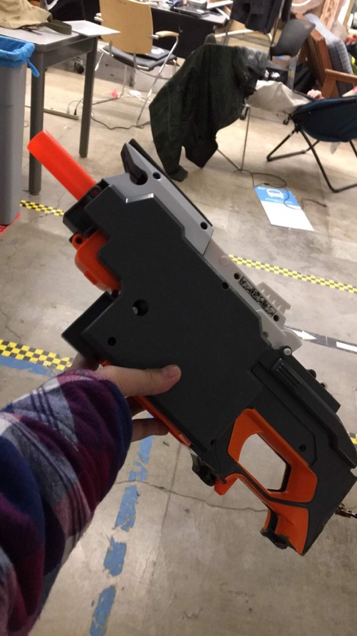

Figure . - Shortened blaster

#### Mechanical

In order to fit inside R2, the 2x1ft blaster was cut in half, only keeping the parts of the blaster that contributed to the firing mechanism. The blaster’s battery pack and hand holds were sawed off. Additionally, we decided to strip the blaster of its aesthetic outer covering to make the blaster more compact.

#### Electrical

The two main electrical components of the Nerf Blaster were the wiring within the hacked Nerf Blaster and the two degree of freedom arm.

### First Iteration of Modified Nerf Blaster

Before going into how the Nerf Blaster is hacked, it would be beneficial for an overview of the Nerf Blaster circuitry.

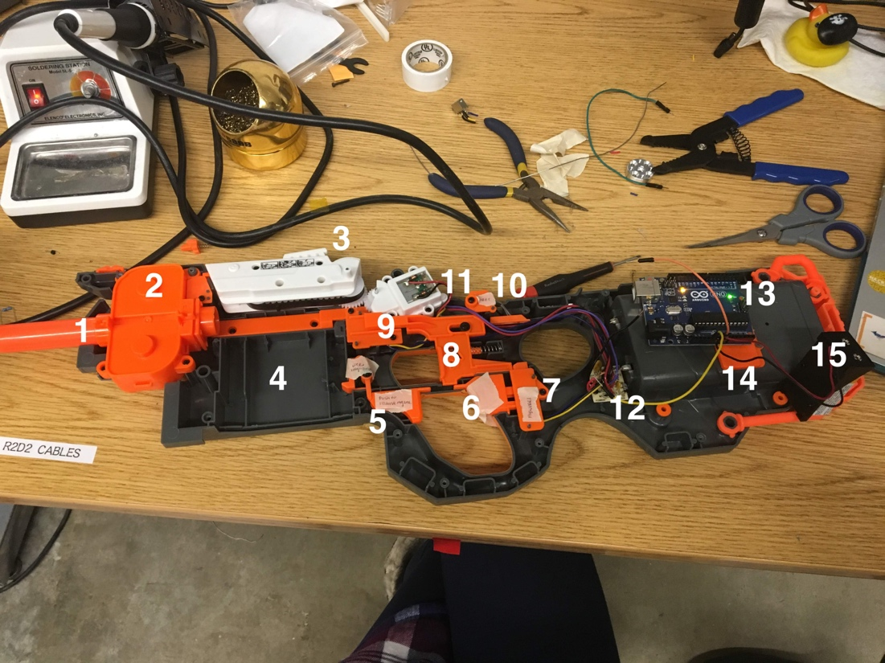

Figure . - Anatomy of a Nerf Blaster

Table . - Nerf Blaster Anatomy Labels

|  |  |  |
| --- | --- | --- |
| Part Number | Part Name | Use |
| 1 | Barrel | Where the bullet comes out of. It has treads along the inner wall pointing in the direction of the bullet in order to prevent the bullet from spinning inside the barrel as it is launched. |
| 2 | Firing Motors | The two squarish boxes each hold a motor. Together, the motors launch a Nerf dart through the barrel. |
| 3 | Conveyor Belt | A single Nerf dart is fed into the conveyor belt where the flat orange piece of plastic with two black screws are below it. The conveyor belt has a bump that pushes the dart to where the firing motors are when it is turned. |
| 4 | Magazine | Although not shown, this is where the magazine would go. |
| 5 | Physical Magazine lock | Physical trigger that locked the magazine into the blaster. |
| 6 | Physical firing trigger | When pressed, this trigger presses the electrical firing trigger button. |
| 7 | Electrical firing trigger button | When this button is pressed, it allows the nerf gun to fire by sending power to the conveyor belt motor and firing motors. |
| 8 | Mechanical Lock Trigger | Mechanical lock that must be pressed in order for the gun to fire. This lock, when triggered, presses on the electrical conveyor belt motor lock. |
| 9 | Electrical Magazine Lock | Makes sure the magazine is loaded into the gun. Gun does not fire if this button is not pressed. |
| 10 | Electrical Conveyor Belt Motor Lock | Must be pressed in order to allow power to go to the conveyor belt motor. |
| 11 | Conveyor Belt Motor | Turns a gear that turns the conveyor belt. |
| 12 | Black Box Control Hub | Electrical control hub already in the Nerf Blaster. |
| 13 | Arduino | At the time this image was taken, the Arduino was giving 5V power to the Nerf Blaster since the 9V battery made the Nerf firing very aggressive. |
| 14 | Nerf Battery Pack | Houses batteries to power Nerf Blaster. |
| 15 | 9V Battery | Powered the Nerf Blaster |

Within the Nerf Blaster, we altered the electrical magazine lock and electrical conveyor belt motor lock in order to make testing and firing easier. Each lock consisted of a button with three wires- power, ground, control- connected to it. Each lock could be bypassed by holding down the button using tape or by cutting off the button and soldering the power and ground wires together, effectively bypassing the control wire that was given current via the press of the button. The first technique was used to bypass the magazine lock while the second was used to bypass the conveyor belt motor lock.

With these locks removed, we were able to test if the blaster was running by pressing the electrical firing trigger button. By pressing this single button, both the conveyor belt motor and firing motors would turn on. Having to only press one button to control firing made controlling the blaster via an Arduino much easier.

A side effect of removing the locks was that the gun was able to shoot darts faster.

## Arduino Implementation

The second major electrical component was integrating the firing of the blaster and controlling the pan and tilt system with an Arduino.

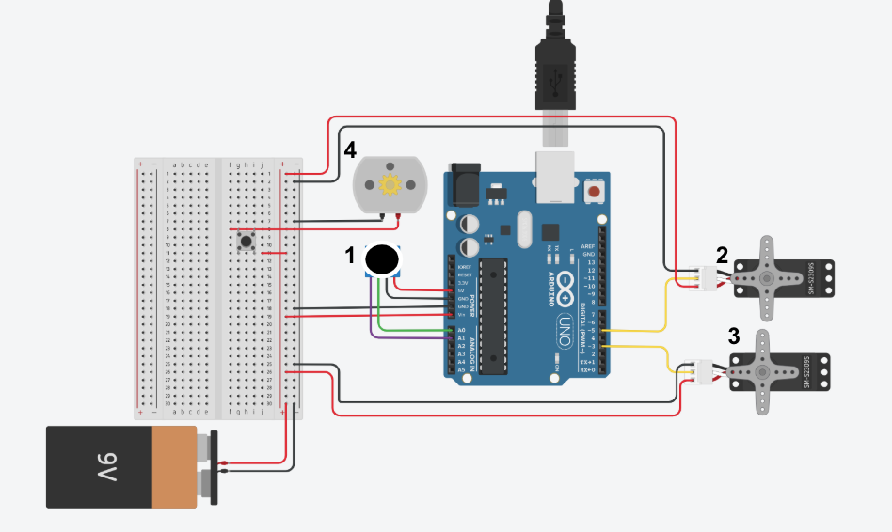

Figure . - Arduino Circuit of the aiming system

Circuit Diagram of the integrated Nerf Blaster and pan and tilt system with an Arduino.

Table . - Circuit Diagram Labels

|  |  |  |
| --- | --- | --- |
| Part Number | Name | Use |
| 1 | Arduino Joystick | Controlled the pan and tilt system |
| 2 | Continuous Servo | Horizontally panned the Nerf Blaster |
| 3 | Continuous Servo | Vertically tilted the Nerf Blaster |
| 4 | Representation of the Nerf firing system | Controlled by pressing the button the firing system is connected to |

One of the issues we ran into was that the Arduino pins were not outputting enough current to the Nerf firing system, so we had to resort to controlling the firing system manually with a button. In the future, this will be replaced by a relay that will be controlled by the Arduino.

## Second Iteration of Modified Nerf Blaster (Spring 2019)

### Electrical

The second iteration of the Nerf Blaster included mounting it onto R2 and increasing its autonomy by having the Arduino fully command the position the Nerf Blaster should be in.

We used continuous servos to control both the pan and tilt of the Nerf Blaster. Unlike encoded servos, these continuous servos needed to be controlled using a “degree” and a delay. The “degree” variable actually controlled the speed of the motor. 90 “degrees” kept the motor at that same position while “degree” angles less than 90 moved the motor clockwise and those greater than 90 moved the motor counterclockwise. The greater the “degree” angle was from 90, the faster the motor would spin in the clockwise or counter clockwise direction. Sometimes the motor drifted while staying still when set to 90 “degrees”, so the “degree” angle was adjusted to 93, which kept the motor at its desired position. The delay variable told the motor how long to move for. Through testing, we were able to find a relationship between the delay sent to the motor and the degree that the motor turned.

Below are graphs that map the relationship between the angle and the delay in microseconds when the “degree” angle is set to 40 in the counterclockwise direction and 130 in the clockwise direction.

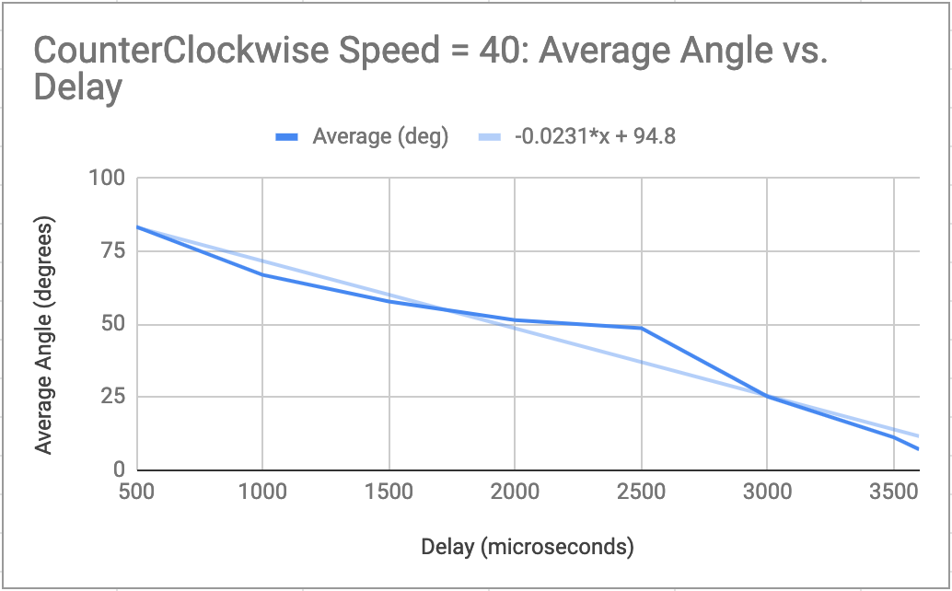

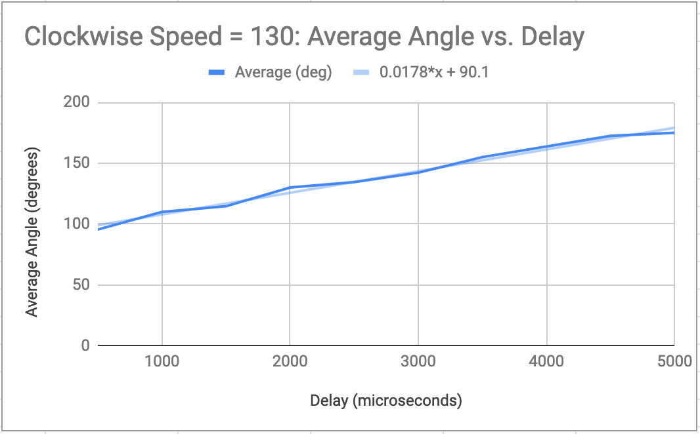

This relationship was found to use as a fallback in case the motor encoders we purchased could not be used for any reason.

For the motor encoders, we used the AMT203-V absolute position rotary encoders. In order to read data from the rotary encoders, we used AMT cable. There was a small extrusion on black plastic end piece of the cable that prevented us from inserting the cable into the rotary encoder, so we shaved it off. Due to limited spacing, we were only able to add one motor encoder (for the tilt motor) to the Nerf Blaster.

### Mechanical

The second iteration of the Nerf Blaster involved further reduction in mounting components, due to the limited space inside R2 body. With the initial dimensions of 5”x17”x16” (width-length-height), placement in R2 would require the maximum space of 4”x14”x12”, which means a significant decrease in the original height.

#### Size reduction method

For the width, the rotation shaft length, which was originally 2 inches long was reduced to 0.25 inch. This helps with reducing the torque on the servo shaft as well. The mounting plate to attach the rotation shaft to the blaster was removed for a more robust integration: blaster’s left plastic covered was opened to have 4 holes drilled inside so that it the cover can be connected to the shaft clamping mount. As a result, the width was reduced by 2 inches.

For the height, unnecessary space between the lowest part of blaster and the bottom servo was removed. This eliminated 2 inches of extra gap. Another large contributor to R2 height is the dart cartridge. The original 30-dart cartridge was 4.5 inches above the blaster and was replaced with a smaller 2.5-inch tall 8-dart cartridge. In total, blaster height was reduced by 4 inches.

blaster’s length was shortened with the removal of the nozzle and further cut into the plastic back of the blaster. Nozzle’s length was 2 inches long.

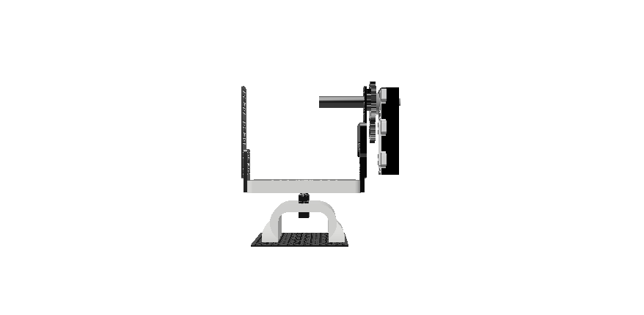vs 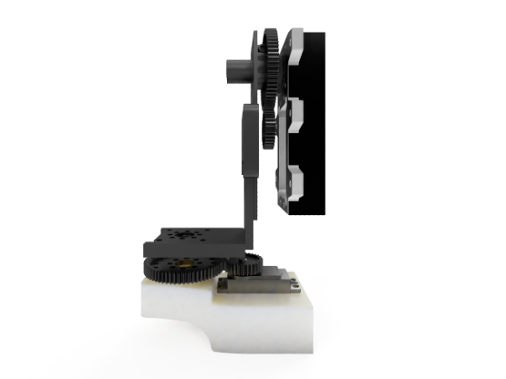

#### Custom Gearbox

After Fall 2018 demo day, an important aspect that the mount was lacking was the precise and consistent horizontal panning. With the addition of the custom-made bottom 2:1 gearbox, panning movement was twice as precise as before.

#### Sliding Servo

In order for the blaster to move in and out of R2, the addition of another servo to enable this linear actuation was introduced. Rack-and-pinion acrylic mesh was used.

## Future Steps

Due to time constraints, computer vision was not implemented yet this semester. More robust control can be done with the addition of a servo encoder for the bottom servo. Dart trajectory can be improved with a customized nozzle and dart shoot rate can be optimized for consistent firing.

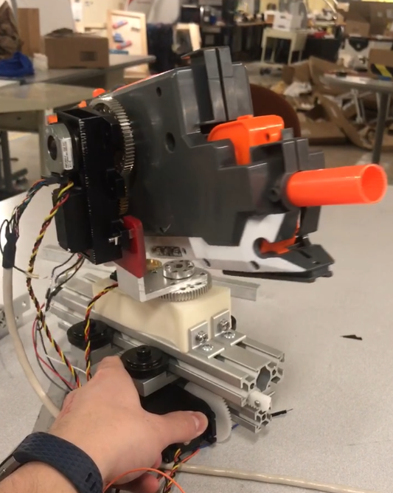

Figure 5.8: Nerf Blaster New Mount

# Precise Arm

## Arm Design

The original concept for the R2 precision arm was to give R2 the functionality of having a precision instrument for interaction. Some of the possible use cases could be waving hello to the user, assisting strong arm with a task, or picking up a small object, like a pen, and performing a precision task with it, like signing a signature. To further add to the user experience, and to differentiate precise arm from strong arm, precision arm is intended to have more organic, fluid motion. This will add to the life-like characteristics of R2.

The arm design process began with defining which degrees of freedom were necessary. In order to maximize functionality and arm range, as well as fulfill more use cases, we decided on five degrees of freedom: shoulder rotation, shoulder actuation, elbow actuation, wrist rotation, and wrist actuation. With these five DOF in mind, extensive research was done into robotic arm actuation mechanisms, with an emphasis on precise control and fluid motion.

Servo motors were found to be most desirable for this application because of their low rotation rate, exact positioning, and closed loop feedback. This would allow the arm to move and receive constant feedback on the position of the joint, allowing easy position correction and precision positioning. Other motors like DC motors, stepper motors, etc. didn’t have this same feedback system.

The other limiting constraint on the arm was its lifting capability. With the use cases defined, it was not necessary to make precision arm have the same lifting capacity as strong arm, but it still needed to be able to lift a soda can or water bottle, based on our listed possible functionality. This posed an issue for the length of the arm, because the moment (*M*) on the motors increases as the length (*r*) increases: $M= \tilde{F} ⋅ \tilde{r}$. The desired length for the arm, defined by constraints in the use cases, was 60cm (1.9685ft) from shoulder joint to wrist joint. This meant that under maximum moment conditions, with the arm fully extended horizontally holding a soda can (390g = 0.859803lbs), we would need a holding torque of:

$$T_{max}=\left(0.859803lbs\right)\left(1.9685ft\right)=1.6925lbs⋅ft$$

This *T­max* value would be the holding torque of the motor to keep the soda can in place and does not include the weight of the arm itself, which is also held by the motor.

### Decision Matrix

In order to determine general design choices for R2, the tasks that it would be designed to accomplish, it was important to initially create a decision matrix for each component including the Precise Arm. Our Systems Engineers created a decision matrix for the Precise Arm. A decision matrix provides a method of comparing different proposed design choices by assigning each design a score in various categories. The scores are then weighted to provide a final score (out of 5), and the features with the highest scores will be implemented in our final design.

The categories that were used to determine the collective value of each feature were educational value, feasibility, meeting project objectives and visibility along the way. Educational value was given a 2. This category determined how important the feature was to help the team develop new skills. Feasibility was weighted with a 3 and entailed how realistic it was that the team would be able to take on each feature. Meeting project objectives was weighted with a 5 and entailed how well the feature added to the overall goal of R2. Finally, visibility along the way was weighted with a 1 and entailed how easy it was to see milestones as we progressed with the project. The scale can be seen in Table ‎6.1 below:

Table . - Precise Arm Decision Matrix Category Scale



Within these main categories, we created sub-categories. For Education, only educational value was a sub-category. Within feasibility, team skills, cost, time required, resources available and risks are all assessed. Under the Meeting Project Objectives category, interactivity, autonomy, and excitement to audience were all considered. Lastly, for Visibility Along the Way, milestones were assessed in the sub-category. The sub-category scale can be seen in Table ‎6.2 below:

Table . - Precise Arm Decision Matrix Sub-Category Scale



After all categories were considered, it was decided that the precision arm would be retractable into the body, transmission-based motors would be used, the arm would have a rotating and panning wrist and the arm would be hanging. However, the final arm design is radically different from what the decision matrix predicted because two categories were not considered when determining the total value of each feature: weight and space. The weight of the motors is too much for the large joint motors to be attached directly to the joints and therefore rotation about the elbow was cut from the overall design Additionally, there is not enough space inside R2 to make the precision arm retractable into R2’s body so as a result, it must be mounted on the side of the body.

Table . - Precision Arm Decision Matrix Part 1

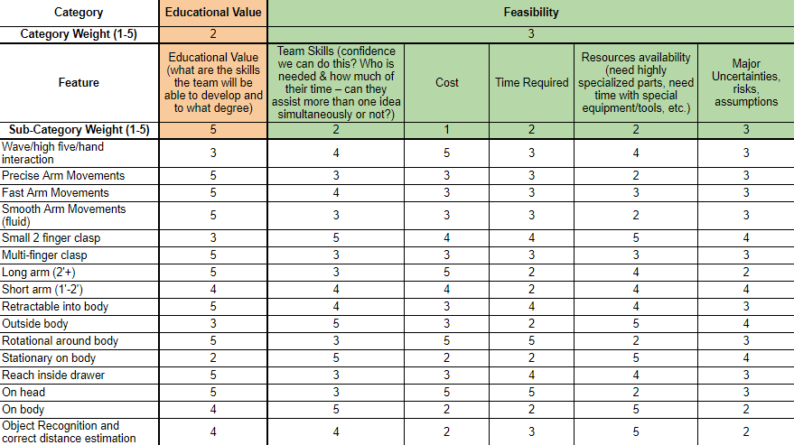

Table . - Precision Arm Decision Matrix Part 2

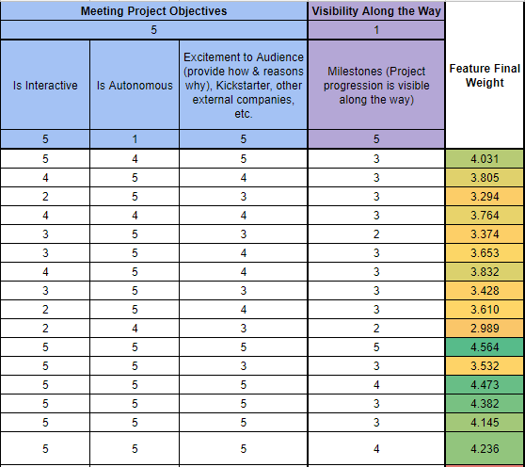

### First Design

We developed an original CAD design for the arm, involving five 3D printed components. 3D printing was chosen because it allowed us to create prototypes rapidly, it was lightweight, and because the plastic was sturdy enough to hold the smaller weight requirement of the arm. We originally chose to use the HiTec 785-HB servo motors for the shoulder and elbow motions because they were high torque and were readily available in the lab to use. These servos are very large and heavy, however, so instead of placing a servo at the end of the upper arm section for the elbow, which would have increased torque on the arm and lowered our lifting capacity, the servo was placed at the base of the arm and uses a linkage to articulate the elbow joint.

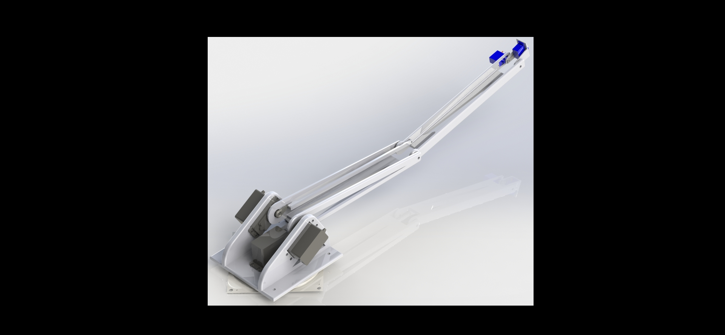 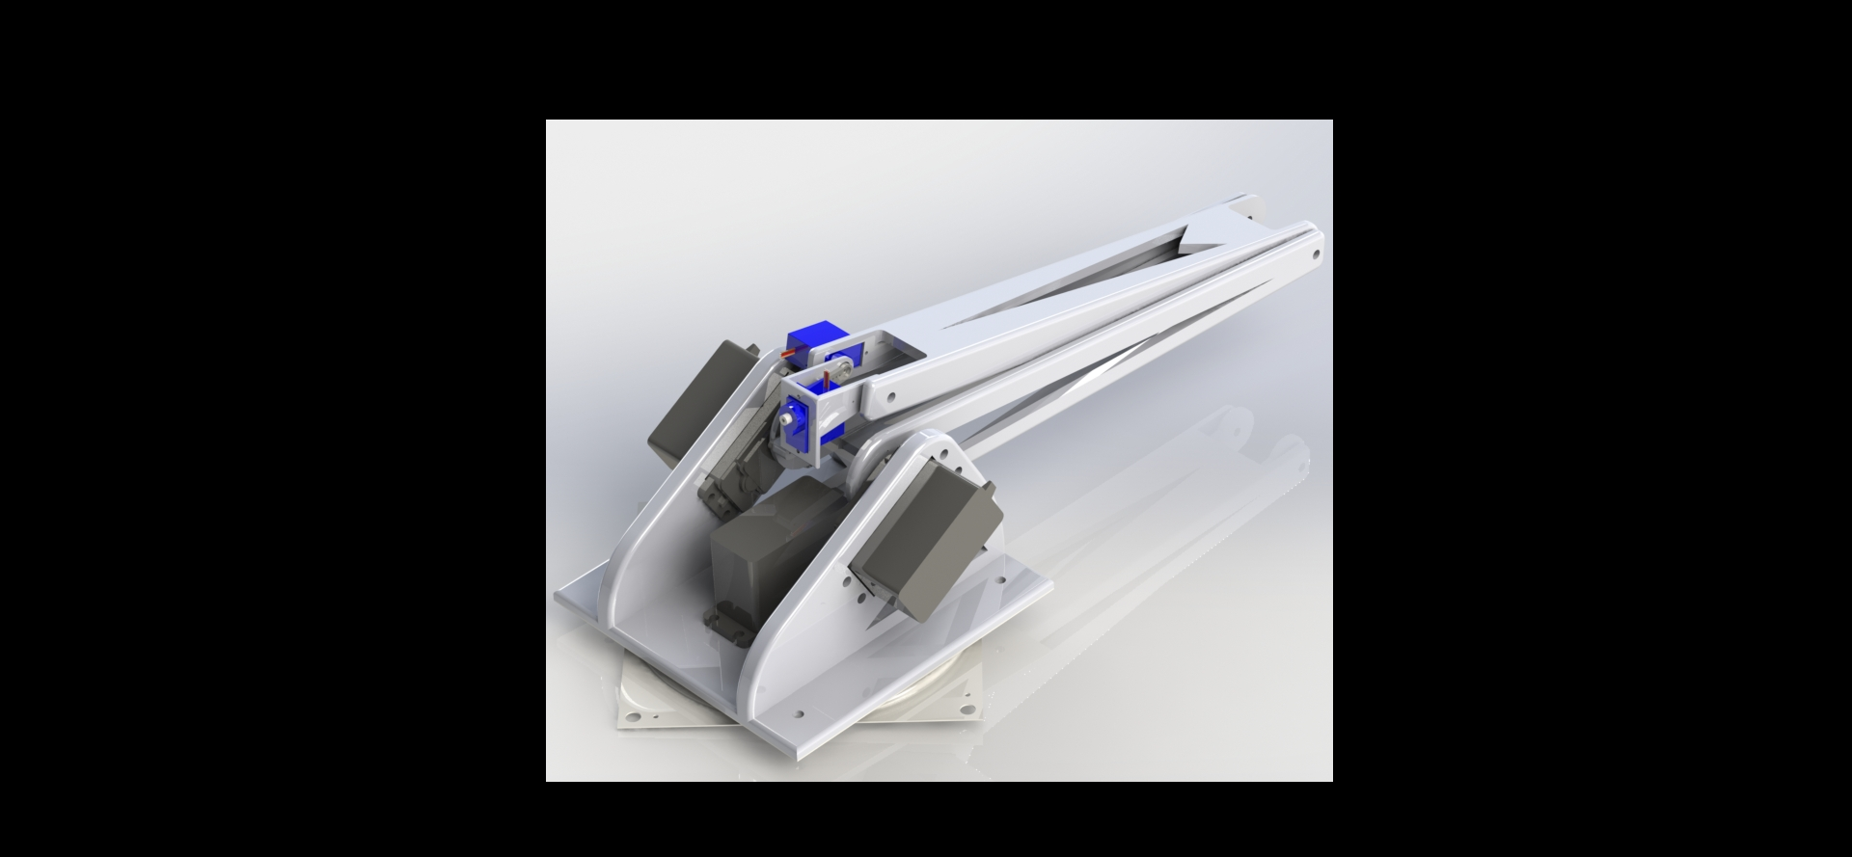

Figure . - CAD Renderings of original arm design (extended and retracted views)

After doing further calculations with this design, however, it was found that the HiTec servos would not provide enough torque to hold the can with the arm fully extended and horizontal.

### Geared Motor Selection

Because the servos provided the required precision, but not the required torque, we decided to find similar motors, but use a gearbox to translate the motion. Gearing up the motor rotation will increase the torque output of the shaft and will allow for more precise position control because every rotation of the servo shaft will translate to only a fraction of a rotation of the output shaft. After researching, we chose the HiTec HS805-MG servos to use because they are very high torque servos and because they are sold with an included 5:1 gearbox and external potentiometer.

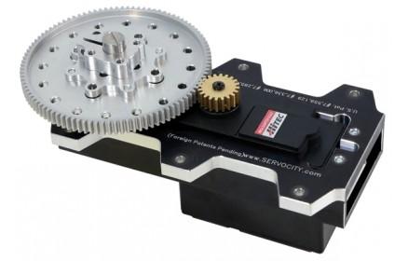

Figure . - TM-805MG Servo with attached 5:1 gearbox

The external potentiometer will allow the arm to get exact feedback on the position of the output shaft instead of the servo shaft. These motors are rated for max torque (6V) of 8.933lbsft. This will allow the arm to lift (including the weight of the arm itself):

$$F_{max}= \frac{8.933 lbs⋅ft}{1.9685ft}=4.538 lbs$$

### Final Arm Design

The arm was redesigned to accommodate the new motors and gearboxes. The final design consists of three 3D printed parts: the arm base with motor mounts, upper arm length, lower arm length. This semester, the elbow lever was redesigned to be made of metal instead of 3D printed plastic. This strengthened the linkage and minimized inaccuracies in the elbow rotation.

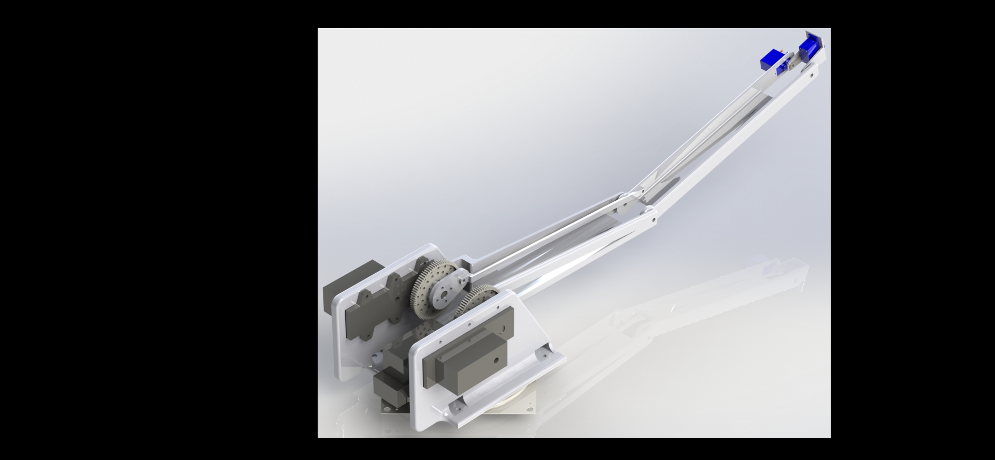 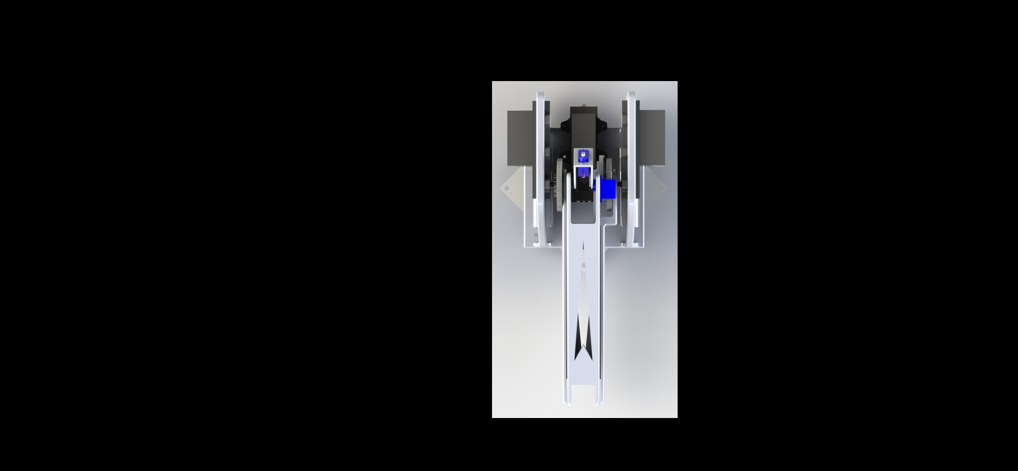

Figure . - Final CAD renderings of arm with motors and gearboxes

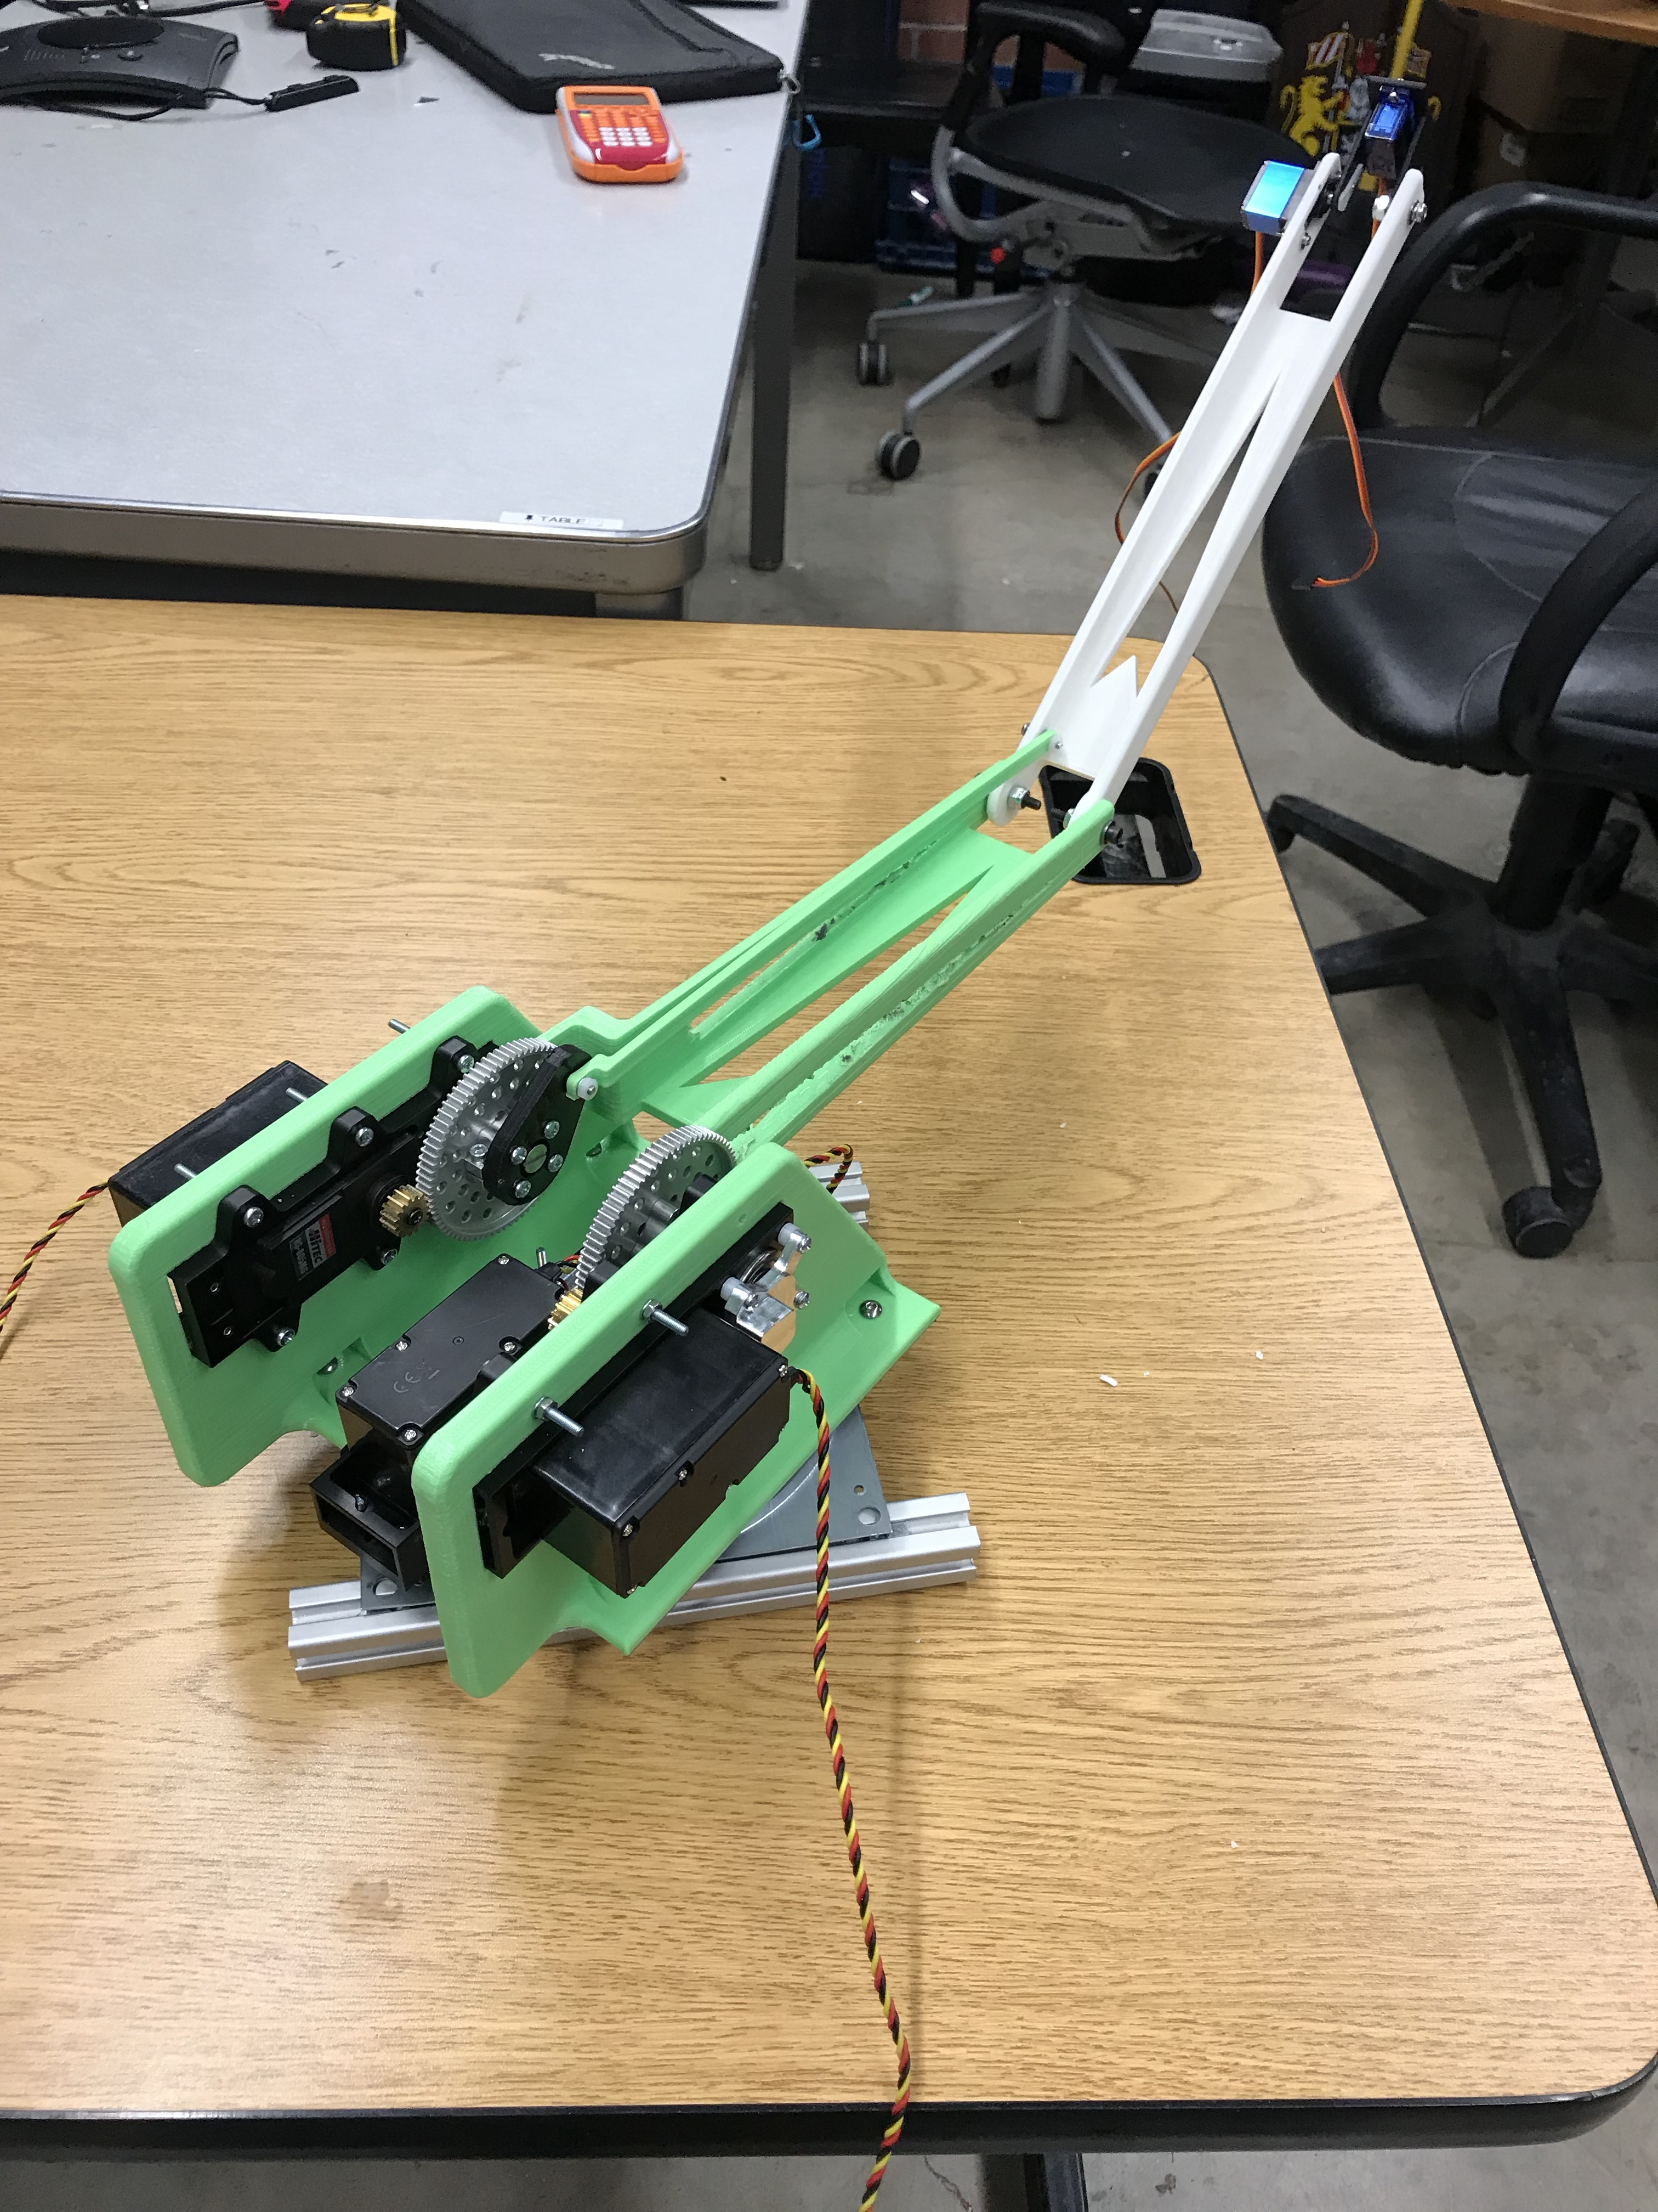 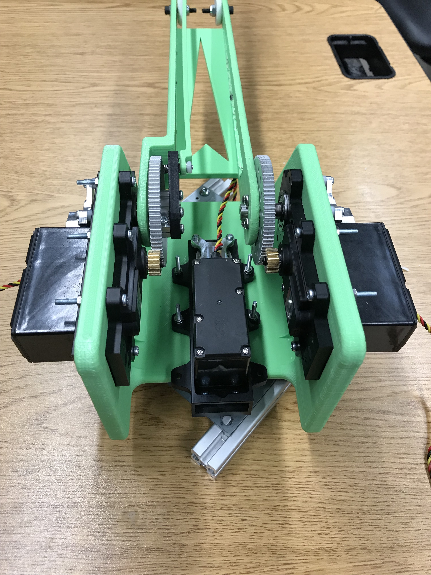

Figure . - 3D printed precision arm prototype

### Generative Design

This semester we were introduced to the generative design tools in AutoDesk Fusion 360. Using this technology, the idea was presented to redesign the upper and lower sections of the precision arm to minimize weight and to enhance the aesthetics. Less massive arm sections would result in an increased lifting capacity for the arm.

Over the course of the beginning of the semester, we worked to create generative designs of the upper and lower sections of the arm given the load cases necessary in the worst case lifting scenario (lifting a 1lbs soda can on the end with 4x factor of safety). The materials selected to test were aluminum and ABS plastic, for their ease in manufacturing, and the possible manufacturing methods were additive manufacturing (3D printing), 3-axis and 5-axis CNC, and just unrestricted. Over the course of many iterations, we finally settled on a rough version of the final generative arm design.

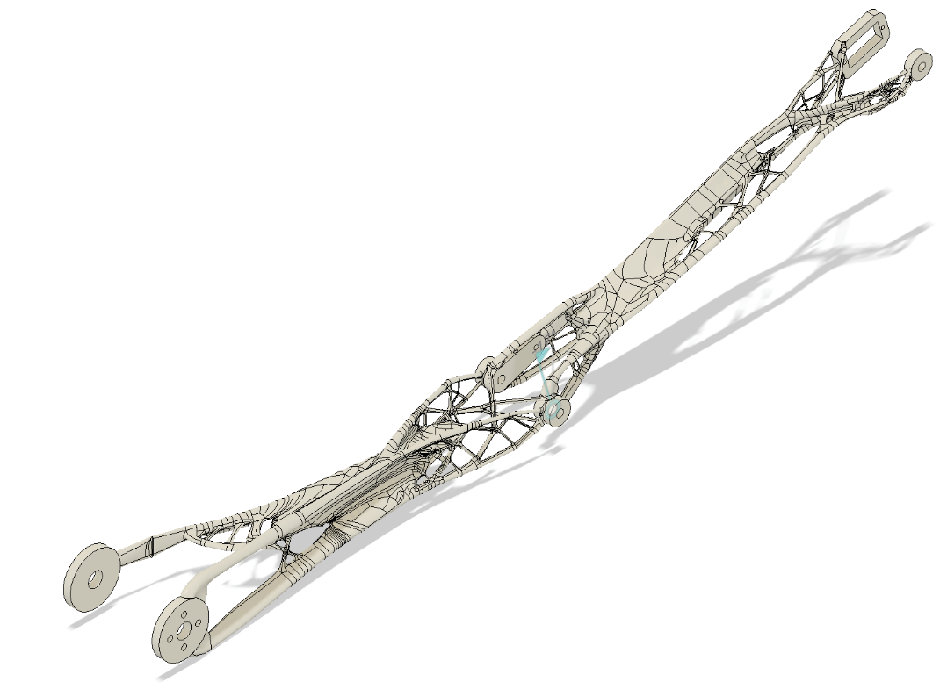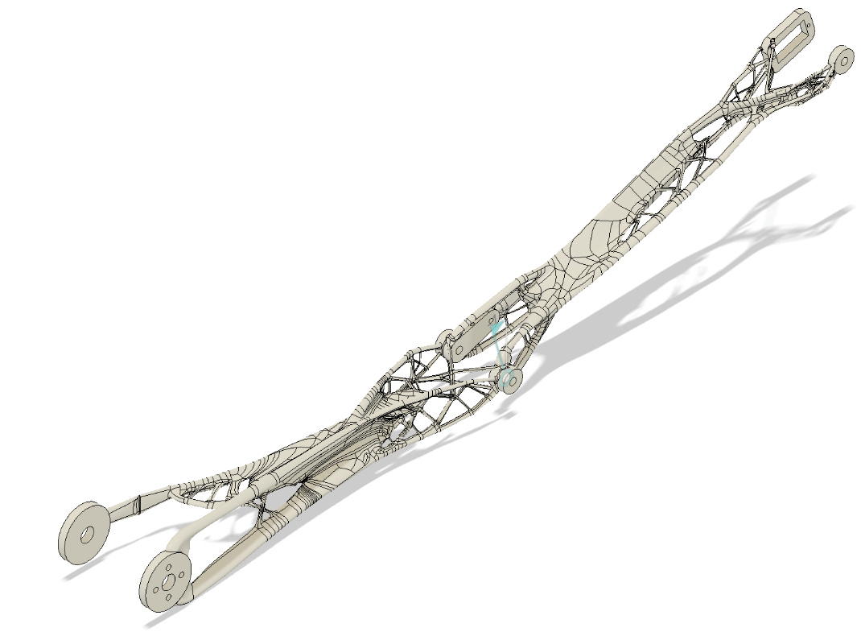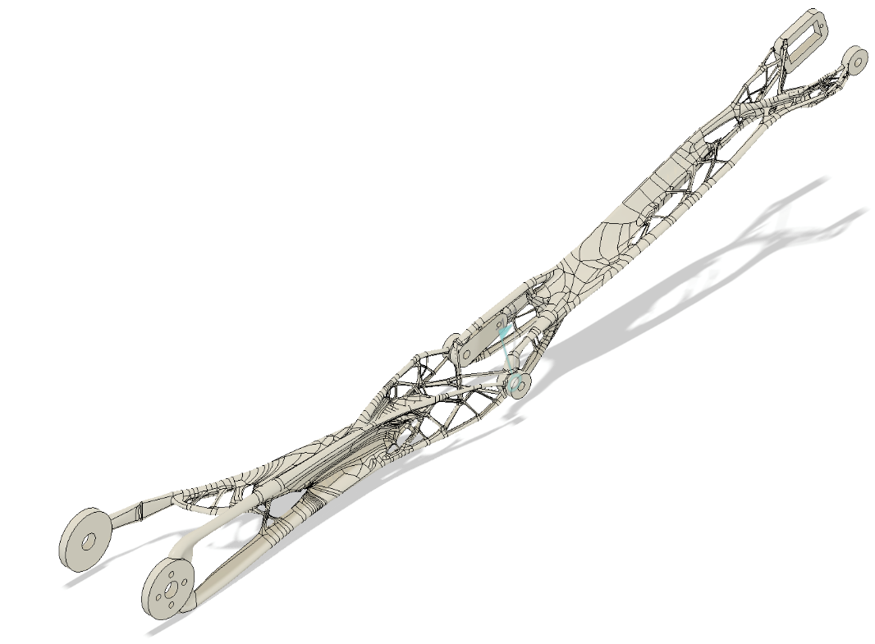

Figure .: Final generative design assembly of upper and lower arm sections.

The final selected generative designs were made of ABS plastic, as it was lighter mass and had a better, more alien-like appearance with its spider-webbing supports. An issue with this design is that it was developed with unrestricted manufacturing selected. This means it is not feasible to manufacture with Cornell’s current rapid prototype methods, so it was not manufactured this semester. However, next semester, it should be manufactured by an outside rapid prototyping company, like Shapeways. This would allow more precise manufacturing, and would allow more generative designs to be created with more diverse materials.

### Future Steps

Next semester, the elbow lever should be fixed again to minimize flex and increase our precision and reliability. The generative design option should also be looked into more thoroughly, with additional designs created for a more diverse range of materials made possible by using Shapeways for manufacturing. A generative design prototype should then be created by Shapeways and tested for our application, as the weight savings and improved appearance would be advantageous for the user experience and functionality of the arm as a whole.

## End Effector

This semester, the precision arm end effector was completely redesigned, as the old design was too heavy and too mechanically complex to be reliable. As a result, we went through the process of miniaturizing our design to save on mass, but potentially limiting our use cases. We also began looking into specialized end effectors to increase the functionality of the arm.

### Interface Plate

In order to maximize the functionality of the arm, specialized end effectors are necessary, but it must be easy to swap between two end effectors. Because of this, we were tasked with creating an interface plate for any end effector to attach to and easily be connected and disconnected. This interface plate would connect to the arm at the end of the lower arm section at the wrist vertical motion servo. It would also have to house the motor necessary for wrist rotation.

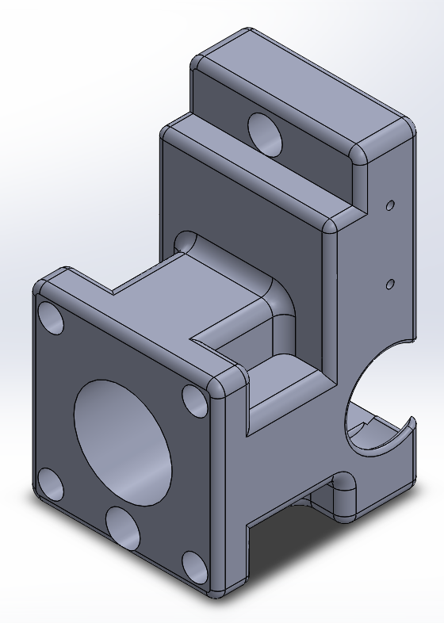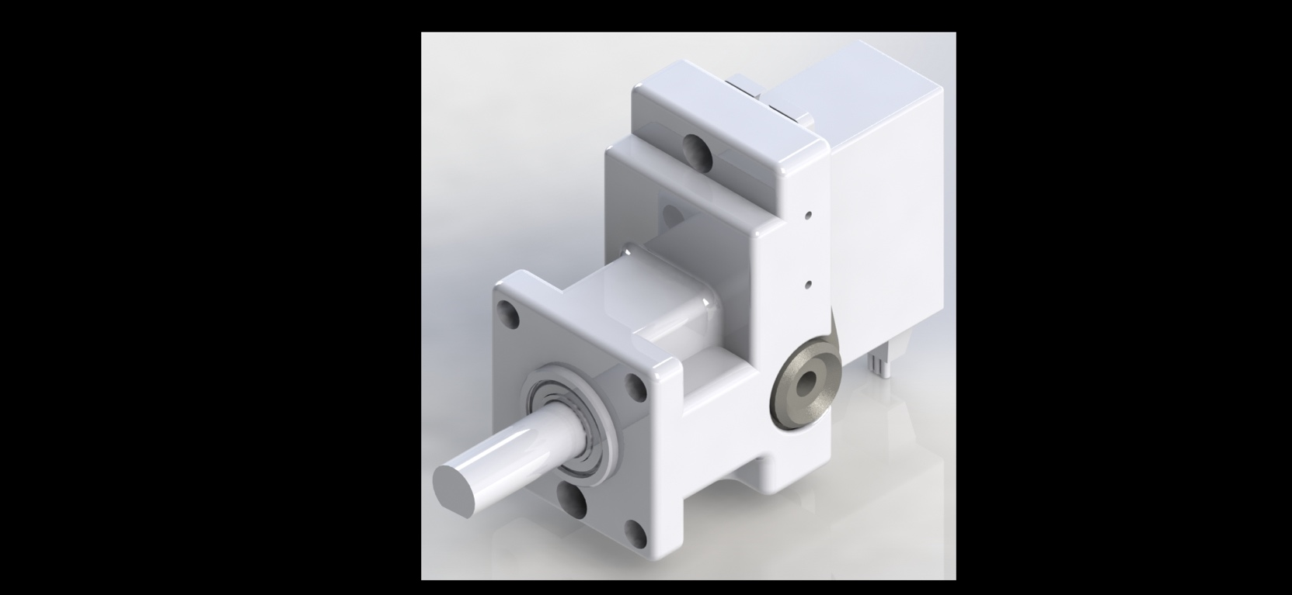

Figure .: CAD renderings of the interface plate 3D printed piece (left), and final assembled interface plate (right).

The final interface plate design consists of a 3D printed piece, with a mounted servo, bearing and shaft mount, and servo horn for attachment to the wrist vertical motion servo. This design allows end effectors to be mounted to the four mounting holes on the front of the plate, for end effectors that do not require the wrist rotation degree of freedom. For end effectors that do require this degree of freedom, a ¼” D-Shaft is extended from the rotation servo and through a supporting bearing. The end effector can be easily attached and detached from this shaft using a simple set screw. This design is minimal in size, lightweight, and mounts the wrist rotation degree of freedom directly perpendicular to the wrist vertical degree of freedom. The interface plate was 3D printed and assembled onto the precision arm.

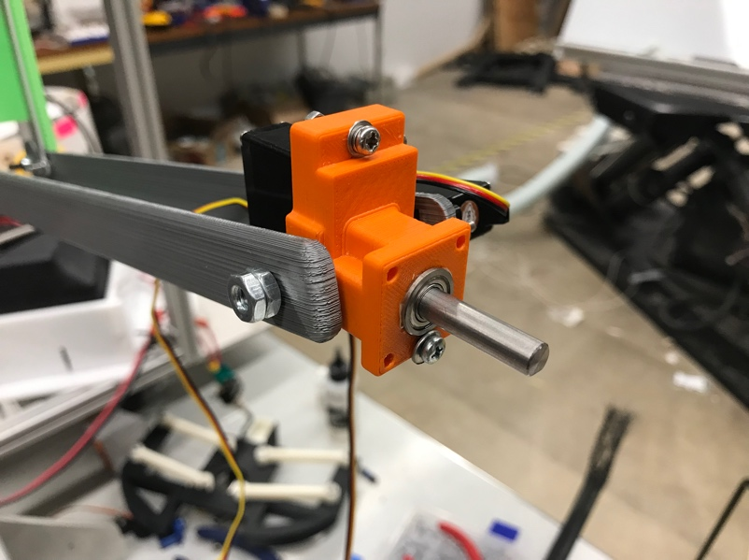

Figure .: The final printed interface plate assembly.

### Two-Finger End Effector

The end effector we decided to create for this semester, was just the basic 2 finger gripper. This end effector would allow the precision arm to pick up basic items, like a pen or flyer. It also needed to be lightweight, as its weight would act against the holding torque of the wrist vertical motion servo.

The two-fingered end effector was designed in 3 separate pieces: the wrist base, and the two fingers. The wrist base was designed to attach to the D-shaft of the interface plate, hold the servo to open and close the two fingers, and house the rotational base of the two fingers.

### Motor Selection

For the wrist vertical, and rotation degrees of freedom, as well as the opening and closing of the two fingered end effector, we decided to use the HiTec HS-5087MH Micro Servo. This servo motor is optimal for its small form factor, light weight, and relatively high torque, as is required to hold the torque created by the end effector and the payload it is carrying.

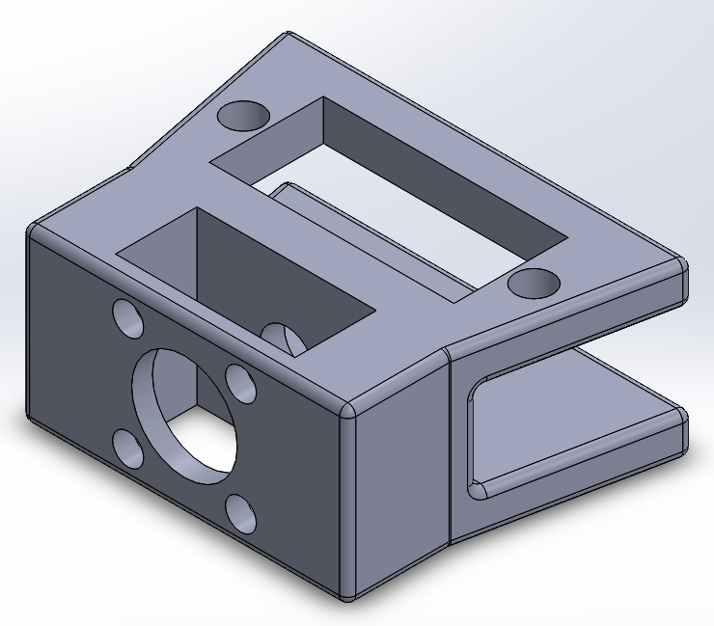

Figure .: End Effector wrist base.

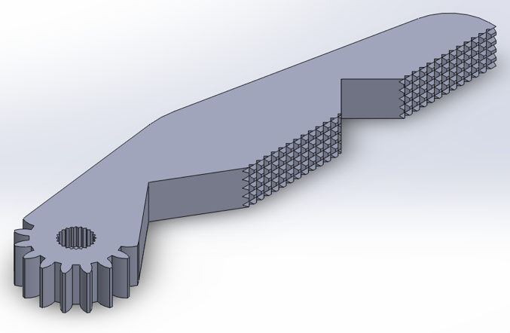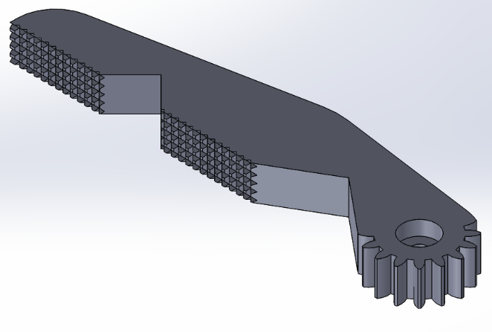

Figure .: Left gripper (left) and right gripper (right) featuring meshed gear interface and textured grip faces.

The left and right grippers were designed with meshing gears of the same radius (to ensure 1-1 rotation of each gripper). The left gripper is directly mounted to the servo, and rotates the right gripper through the gear interface. Each gripper extends out and has two lengths of textured grip surface, to enhance friction between the fingers and the object they are gripping. The grips are not parallel when closed, because when gripping an object, they will have better gripping pressure if parallel with the object between. Each gripper has a triangular cutout, which when closed, acts as a hole to hold and direct a pen, giving the arm the ability to sign a signature.

The servo is mounted on top of the wrist base. The left gripper is directly mounted to the servo horn. The right gripper is mounted to the bottom lip of the wrist base, but directly meshed with the left gripper.

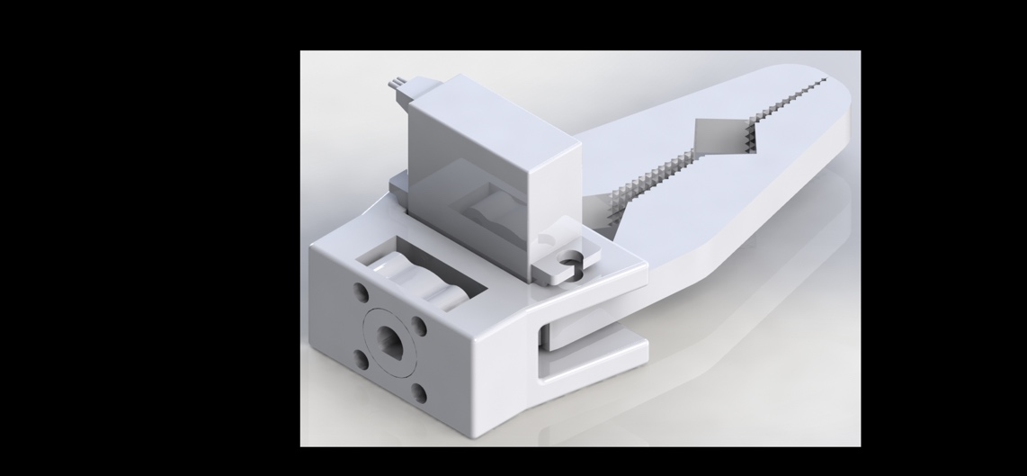 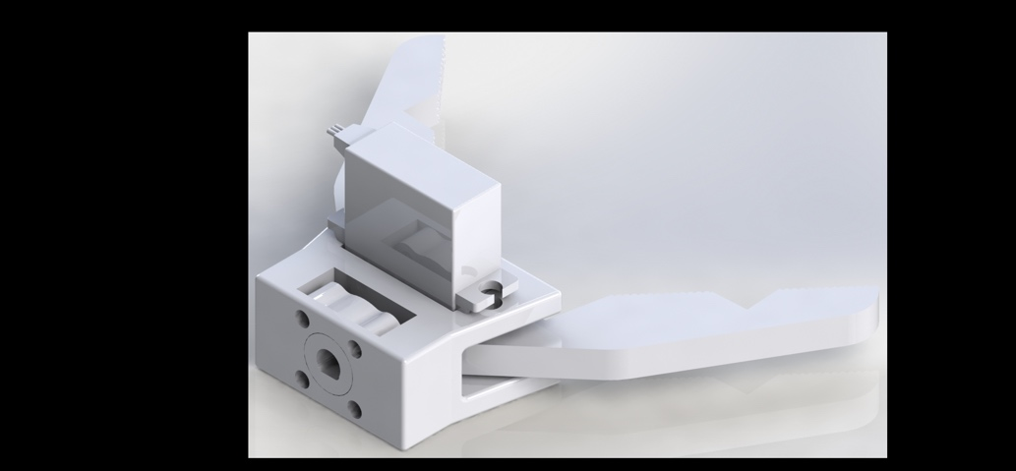

Figure .: Closed and open renders of the 2 finger end effector assembly.

The end effector is mounted through the back shaft hub onto the D-shaft of the interface plate.

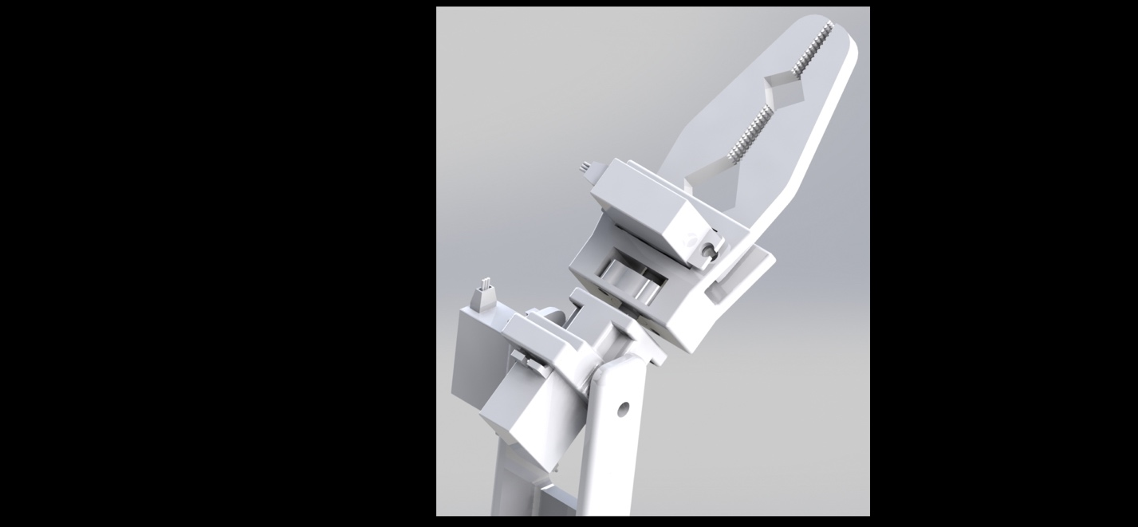

Figure .: Render of end effector and interface plate mounted on precision arm.

The wrist base and end effector fingers were 3D printed, assembled, and attached to the precision arm.

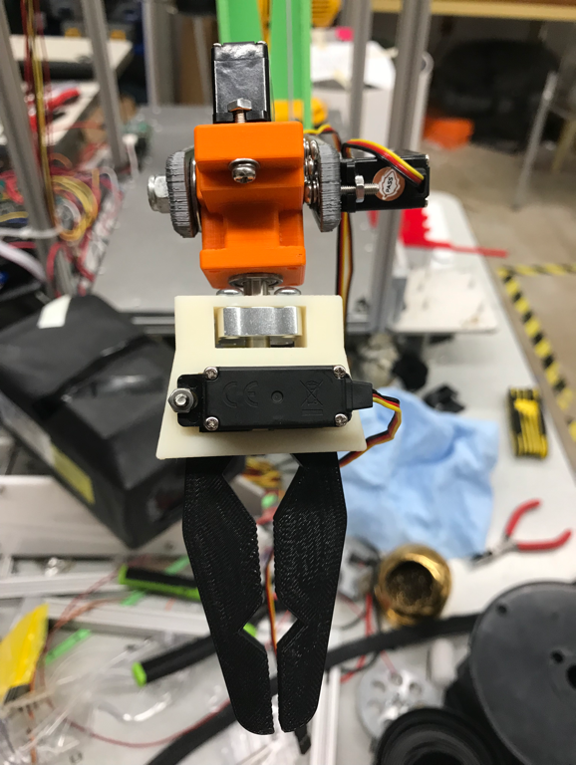 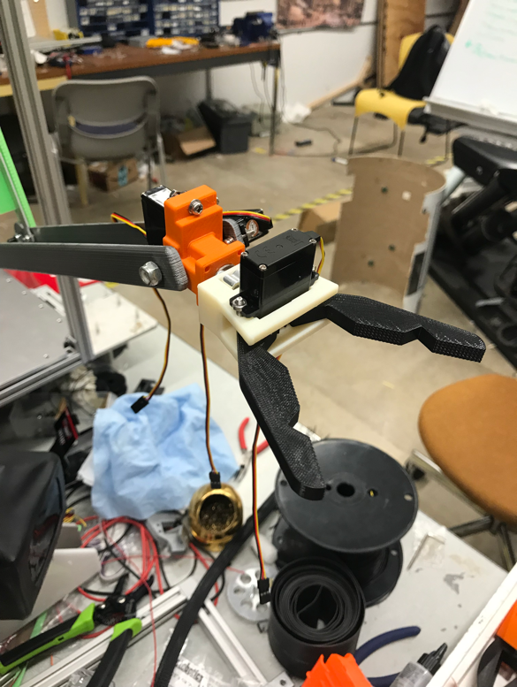

Figure .: Final assembled end effector mounted on precision arm.

# Strong Arm

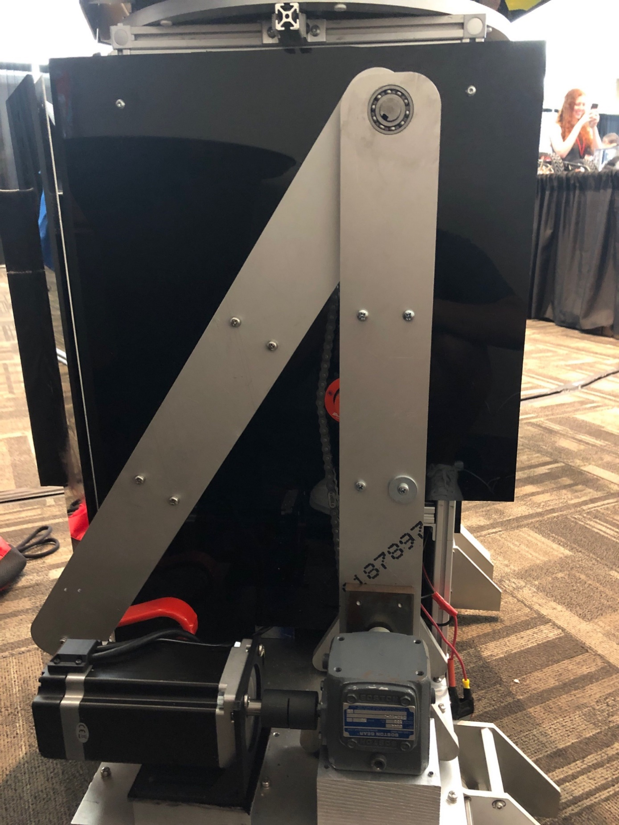

Figure . - Completed Strong Arm at NASA Kennedy Space Center

## Purpose

The goal of Strong Arm is to give R2 an arm that adds support for many tasks that require much more strength than R2 previously had. Strong Arm is designed to lift heavy objects (around 15 lbs.) and perform simple tasks, such as opening a door. These new abilities will allow R2 to roam more freely by allowing it to access multiple rooms, and it adds more utility as a lab assistant in its ability to lift heavier objects. The most recent design of the arm can be seen in Figure ‎7.7 below. The new arm moves R2 closer to the goal of having more interactive features which will elicit a stronger audience interest, and because of the impact the new functionalities have on R2 as a whole system, Strong Arm is seen as one of the most important additions.

### Decision Matrix

In order to determine general design choices for R2, the tasks that it would be designed to accomplish, it was important to initially create a decision matrix for each component including the Precise Arm. Our Systems Engineers created a decision matrix for the Precise Arm. A decision matrix provides a method of comparing different proposed design choices by assigning each design a score in various categories. The scores are then weighted to provide a final score (out of 5), and the features with the highest scores will be implemented in our final design. The decision matrix can be seen in Table ‎7.3 and Table ‎7.4.

The categories that were used to determine the collective value of each feature were educational value, feasibility, meeting project objectives and visibility along the way. Educational value was given the highest weight (5) as it was the most important. This category determined how important the feature was to help the team develop new skills. Feasibility was weighted with a 3 and entailed how realistic it was that the team would be able to take on each feature. Meeting project objectives was weighted with a 4 and entailed how well the feature added to the overall goal of R2. Finally, visibility along the way was weighted with a 2 and entailed how easy it was to see milestones as the project progressed. The scale can be seen in Table ‎7.1 below:

Table . - Strong Arm Decision Matrix Category Scale



Within these main categories, sub-categories were created. For Education, only educational value was a sub-category. Within feasibility, team skills, cost, time required, resources available and risks are all assessed. Under the Meeting Project Objectives category, interactivity, autonomy, and excitement to audience were all considered. Lastly, for Visibility Along the Way, milestones were assessed in the sub-category. The sub-category scale can be seen in Table ‎7.2 below:

Table . - Strong Arm Decision Matrix Sub-Category Scale



After all categories were considered, it was decided that the arm would be retractable into the body, transmission-based motors would be used, the arm would have a rotating and panning wrist, and the arm would be hanging. However, the final arm design is very different from what the decision matrix predicted because two categories were not considered when determining the total value of each feature: weight and space. The weight of the motors is too much for the arm to be hanging on the side of R2. As a result, the arm must be mounted to the base. There is also not enough space inside R2 to make Strong Arm retract into R2’s body, so, as a result, it is mounted outside the body.

Table . - Strong Arm Decision Matrix (Part 1)

|  |  |  |  |  |  |  |
| --- | --- | --- | --- | --- | --- | --- |
| **Category** | **Educational Value** | **Feasibility** | | | | |
| **Category Weight (1-5)** | 5 | 3 | | | | |
| **Feature** | Educational Value (what are the skills the team will be able to develop and to what degree) (5 = most educational) | Team Skills (confidence we can do this? Who is needed & how much of their time – can they assist more than one idea simultaneously or not?) (5 = most confident) | Cost (5 = least cost) | Time Required (5 = least time) | Resources availability (need highly specialized parts, need time with special equipment/tools, etc.) (5 = most availability) | Major Uncertainties, risks, assumptions (5 = least risk) |
| **Sub-Category Weight (1-5)** | 5 | 4 | 1 | 3 | 4 | 3 |
| Retractable into Body | 4 | 2 | 3 | 2 | 4 | 3 |
| Outside Body | 2 | 4 | 5 | 4 | 5 | 4 |
| Suspended motors | 4 | 2 | 1 | 1 | 2 | 1 |
| Transmission based motors | 5 | 2 | 1 | 1 | 2 | 1 |
| Normal joint layout | 1 | 5 | 4 | 5 | 4 | 5 |
| Rotational wrist | 4 | 2 | 3 | 1 | 2 | 2 |
| Rotation plus panning wrist | 5 | 1 | 2 | 1 | 2 | 1 |
| Base mounted | 1 | 5 | 5 | 5 | 5 | 5 |
| Hanging | 3 | 4 | 4 | 4 | 5 | 4 |

Table . - Strong Arm Decision Matrix (Part 2)

|  |  |  |  |  |
| --- | --- | --- | --- | --- |
| **Meeting Project Objectives** | | | **Visibility Along the Way** | **Feature Final Weight** |
| 4 | | | 2 |
| Is Interactive (5 = most interactive) | Is Autonomous (5 = most autonomous) | Excitement to Audience (provide how & reasons why), Kickstarter, other external companies, etc. (5 = wow) | Milestones (Project progression is visible along the way) (5 = most milestone visibility) |
| 5 | 5 | 5 | 5 |
| 4 | 5 | 5 | 4 | 3.933 |
| 1 | 4 | 4 | 2 | 2.786 |
| 5 | 5 | 3 | 4 | 3.567 |
| 5 | 5 | 3 | 5 | 4.067 |
| 2 | 5 | 4 | 1 | 2.548 |
| 4 | 5 | 5 | 4 | 3.733 |
| 5 | 5 | 5 | 5 | 4.214 |
| 1 | 4 | 4 | 1 | 2.429 |
| 1 | 4 | 4 | 2 | 3.129 |

## Design

Strong Arm is mounted on the base of R2 above the left wheel. The design of the arm consists of three separate linkages with an end effector (‎7.2.1.3) attached at the end. The first and second linkages will be powered by stepper-motors attached at the base of the robot, and the end effector will be powered by one servo for the wrist, one servo for rotation, and one servo for the actuation of the fingers. The second link will be operated by a winch-pulley system with the stepper motor at the base of the arm. This totals to five degrees of freedom. The total weight of the arm without the motors at the base is about 13 pounds and is made mostly of water-jetted aluminum. Figure ‎7.7 shows the current design of the arm. This design was ultimately chosen for several reasons: the arm must be very robust since it will be taking very large loads. Rotation at the base was forgone because it would have caused much too high a moment on the joints to reach the 15-pound lifting goal. The majority of the weight is centered on the base due to the heavy motors and gearboxes, to ensure the stability of the arm.

### First Iteration

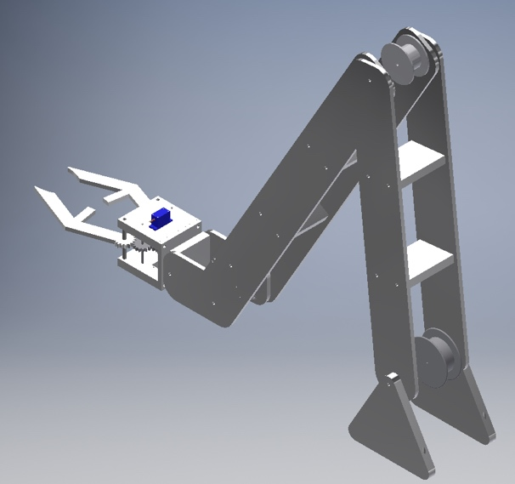

Figure . - Arm Design (Isometric View)

#### Winch System for Second Link

In order to save space and reduce the weight of the arm, the stepper-motor to actuate the second link of the arm is mounted on the base. First, the motor is geared down with a 10:1 speed reducer to produce the necessary torque for the system. Then, a winch system is used to connect the speed reducer output shaft to the joint of the second link. The ratio of the wheel at the joint to the wheel at the base is 1:0.7 (see ‎7.3.1 for calculation) with the wheel at the joint having a radius of 0.7 in and the wheel at the bottom having a radius of 1 in in order to optimize torque and rotational speed.

#### Wrist Joint

The wrist joint is the joint between the second link and the end effector. Since this joint is only actuated with a servo, a passive-locking mechanism (Figure ‎7.3) was added to provide stability without activating the motor. This ensures that there will not be too much strain on the servo during regular use. The locking mechanism is a ratchet-pawl system that is locked in normal operation by a spring. When R2 tries to move its wrist, a linear actuator pushes the pawl off the ratchet and lets the joint rotate. A passive lock mechanism was preferred to a motor controlling the joint decrease the wait on the end of the arm.

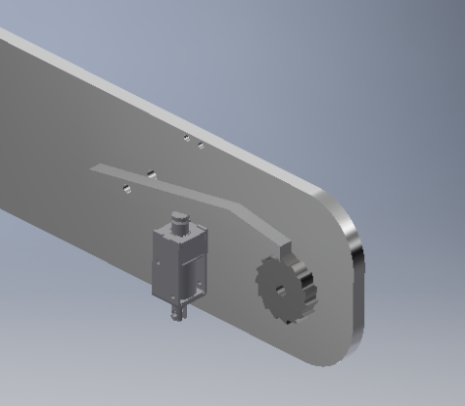

Figure . - Ratchet and Pawl Passive Locking Mechanism

#### End Effector

The end effector, which can be seen in Figure ‎7.4, Figure ‎7.5, and Figure ‎7.6, is actuated by a single servo-motor attached to a gear train between the two fingers of the end effector, causing the fingers to go in opposite directions with a gear ratio of 1:1.4. The end effector is attached to the rest of the arm by a rotation plate that allows it to spin 360°.

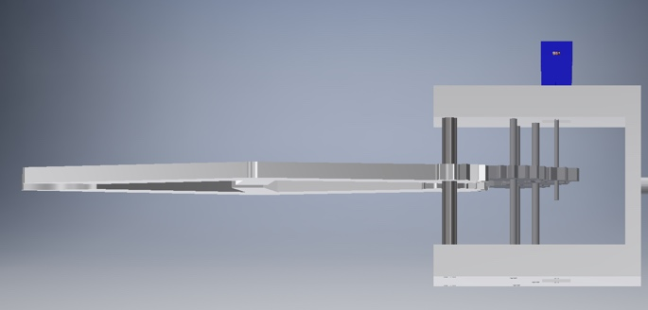

Figure .- End Effector (Side View)

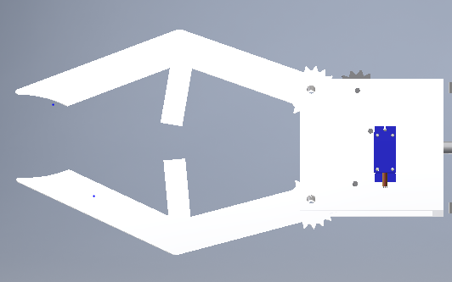

Figure .- End Effector (Top View)

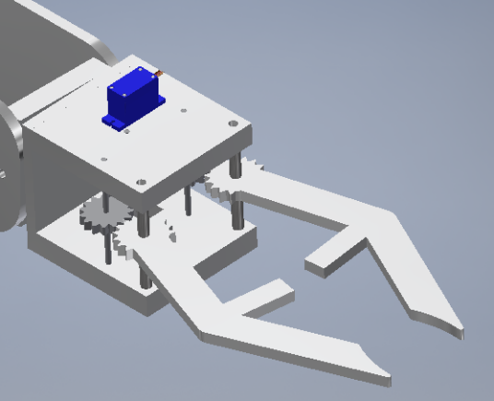

Figure . - End Effector (Isometric View)

### Second Iteration

The first iteration was never actually manufactured or assembled. It was the initial design for the arm, and many aspects needed rethinking before moving on to manufacturing. Therefore, the second iteration of Strong Arm saw lots of changes which are described in the sections below. The updated CAD model can be seen in Figure ‎7.7.

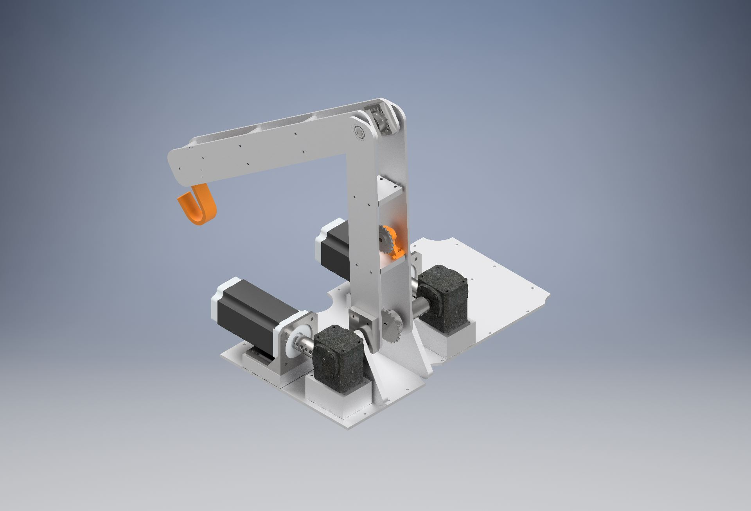

Figure . - CAD Render of Second Iteration of Strong Arm (Isometric View)

#### Sprockets and Chain

As the first attempt at assembly got closer, it was determined that the pulley and winch system would not work as expected due to a lack of connection point for the rope and slippage. In order to correct these issues, the actuation of the second link was switched to a sprocket and chain system. An ANSI 35 chain was used with sprockets of 11 and 16 teeth with the 16-tooth sprocket at the base, corresponding to a gear ratio of 0.685. This allowed the second link to rotate quicker, while still meeting the torque requirements. In figure ‎7.3.1, the gear ratio for the second link had to be between 0.36 and 1, so 0.685 is just about halfway between the two limits. A tensioner was mounted on a cross link to reduce slack from the chain.

#### Steel Plates

The two links are actuated using keyed shafts, but the links are made of aluminum which is not very strong. If the broach had gone into the aluminum links, they would have worn out very quickly. Instead, small steel plates were used for the broaching, attached by four screws to the aluminum pieces. Although, in the long term, this will cause corrosion of the materials, it fulfills the use cases for the arm.

### Assembly

Strong Arm began to be machined and assembled during the Spring 2019 semester. The arm links were all water jetted to the correct dimensions. After the parts were received, many alterations had to be made. Many of the joints needed ball bearings, so bores were required to press fit them in. In addition, all of the cross-links had to be drilled and tapped. After the aluminum was finished, it was necessary to machine the steel plates described in Section ‎7.2.2.2 above. In order to make these, they had to be bored out, then broached for the keyway. It was also necessary to bore out the shaft couplings that attach the motor output shafts to the gear box input shafts and from the gear box output shaft for the second link to another longer shaft. This longer shaft was meant to reach through to the middle of the arm in order to interface with the sprocket as shown in Figure ‎7.7. Once all of the pieces were machined, assembly started from the base up. While attempting to attach the first link to the second link, it was determined that there was not enough space for the screw heads that attached the steel plates to the inside of the second link. To fix this, the connecting links were machined to be narrower and a couple spacers were added in order to make the first link wider. To attach the arm to the base of R2, a mounting plate was designed and manufactured as seen in section ‎7.2.4. The gearboxes were screwed into a large aluminum bock which had holes to screw into the plate in order to account for the difference in height between the gearbox and the triangle bases. The motor also had an aluminum mounting block which had holes for the motor mount and screwed into the mounting plate for the same reason. Unfortunately, the dimensions that were on documents associated with the motor mounts differed from the actual mounts. As a result, the motor mount currently rests on a piece of acrylic epoxied to the aluminum block and motor mount. The chain and sprocket system to move the second link was assembled easily. A tensioner was purchased to help tighten the chain. There was not enough time to manufacture the end effector, so that is going to be the next step for the future. For the time being, a hook was attached to the end of the second link in order to be able to lift weight.

### Mounting Plate

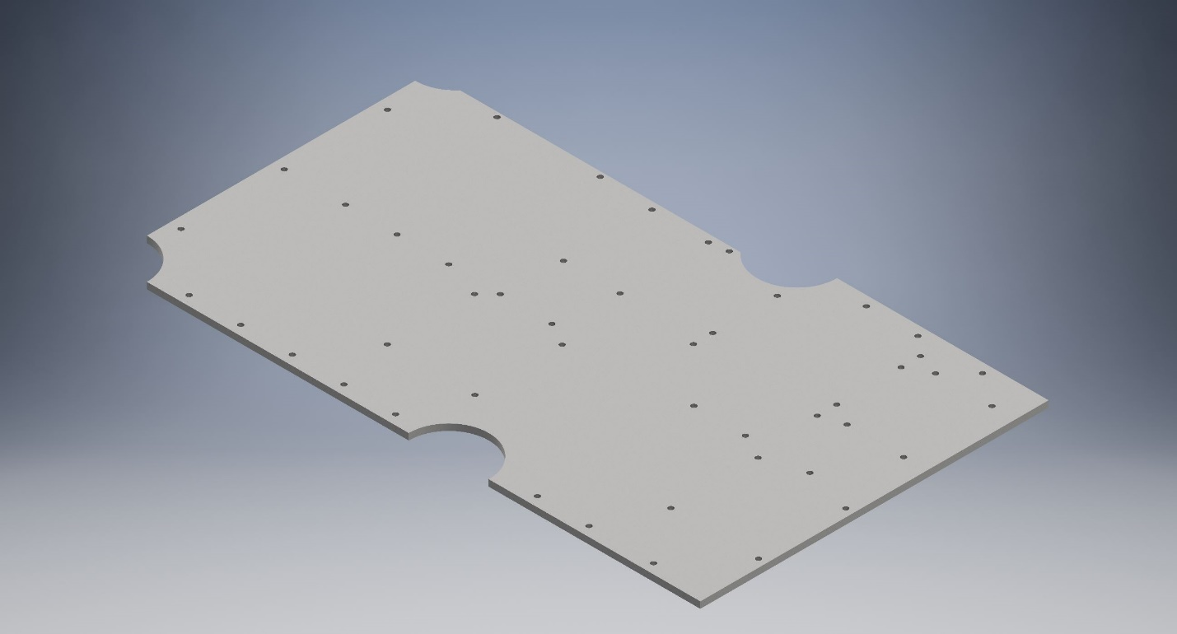

Figure . - R2 Base Mounting Plate

In order to mount Strong Arm in addition to many other necessary components to R2, it was necessary to design a plate to attach everything. Since Strong Arm had the most dimensional constraints, Strong Arm mechanical team designed the plate which can be seen in Figure ‎7.8.

In order to fit all the components in a way that moving parts could move correctly, the width of R2 had to be extended 1.5” with this extra length being used as overhang by the mounting plate. If the width had been increased any more, it would be tough for R2 to fit through a doorway and it would add a significant bending moment, but any less and Strong Arm would not fit as the arm would be inside the body of R2. This change in overall dimension was deemed to be okay since the only use case the change may affect is getting through a doorway. However, even with the 1.5” addition, R2 is still several inches narrower than an average doorway.

The large circular cutouts from the plate were necessary to allow space for the vertical frame beams that make up the base rectangular prism of R2 and the L-brackets that attach them to the base. Because of these circles, one of the attachments to the triangular bases of Strong Arm was lost, but the arm was still able to be attached in 23 other locations (3 on the inner triangular base, 4 on the outer triangular base, 4 on each of the inner gear box and motor mount, and 4 on each of the outer gear box and motor mount with inner being towards the inside of R2). These locations can be seen in Figure ‎7.9.

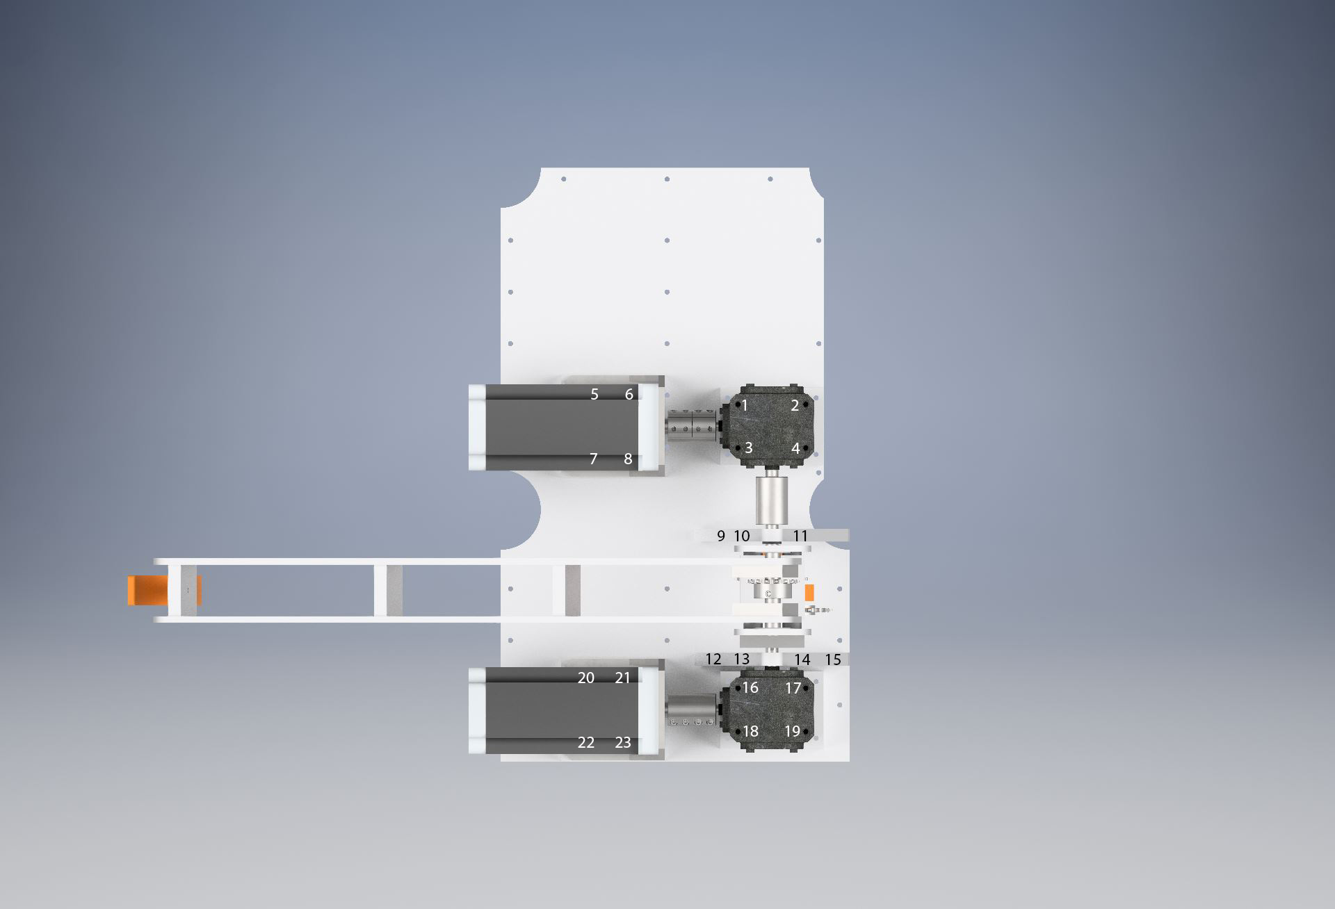

Figure . - Labeled Top View of Attachment Locations

The current configuration of components on the plate are Strong Arm on the right side as can be seen in Figure ‎7.9, just to the left of the arm are the two stepper motor drivers that are described in Section ‎7.4 below, and to the left of those is R2’s main battery which can be seen in the upper left-hand corner of Figure ‎7.10.

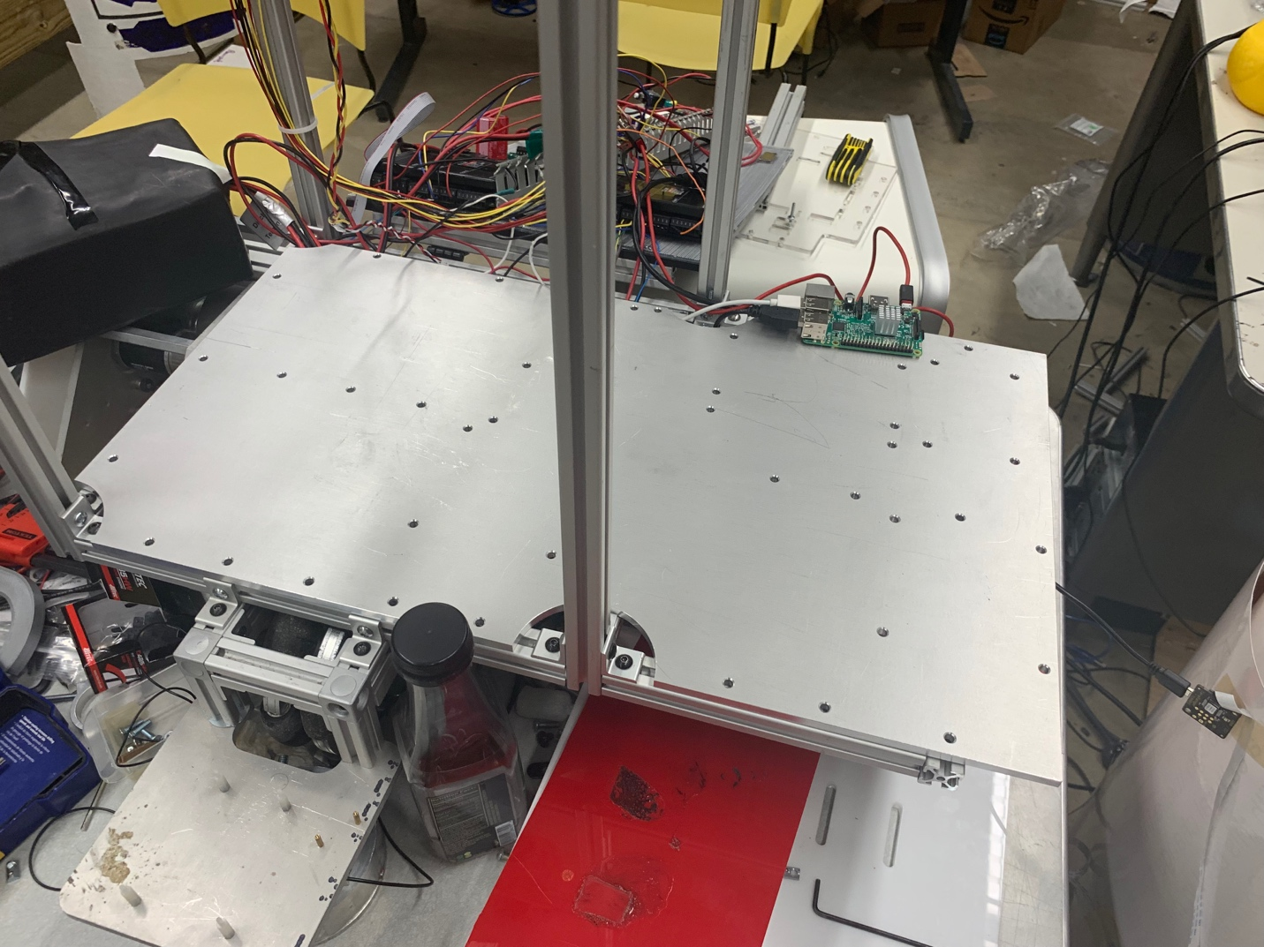

Figure . - Mounting Plate on R2 Before Components were Attached

## Motor Selection

The requirements for Strong Arm had to be determined before beginning the motor selection process. Generally, the requirements are that Strong Arm must be able to lift a 15lb object, and it must be able to open a door (see section ‎7.1.1 above for more information on the decision-making process). After the requirements were set, calculations were performed to determine the necessary power to meet the torque and angular speed requirements for the system at each joint. These calculations can be seen in ‎7.3.1 below. After the power requirements were determined, research was conducted on which motors would be optimal for each joint so that R2 could complete its tasks efficiently. It was decided that a servo would be acceptable at the wrist joint because the wrist will not experience as much torque as the other joints of the arm. This is because when the arm is lifting a heavy object the end effector will be left in a downward position. This results in no torque being applied at the wrist. For the first two joints (at the base and in between the first and second links), stepper-motors that provide a 9.588lb⋅ft holding torque were chosen. The two motors are identical, and the specs can be seen in Figure 7.22, Figure 7.23, Figure 7.24, Figure 7.25, and Figure 7.26. They are very heavy, but since they are mounted at the base, this weight poses less of an issue. Each motor will be operating at 15rpm, which will provide a torque of about the holding torque (may be slightly higher or lower; need to test as torque chart does not give data at that speed). For the first link, the necessary torque to move the arm is 66.53lb⋅ft. Since the motor has an operating torque of about 9.588lb⋅ft, a 10:1 speed reducer is being used to increase the torque to about 95.88lb⋅ft, well over our requirement. For the second link, the necessary torque is 34.49lb⋅ft.

Even though it was not the focus of the project, Strong Arm still needs an element of precision in order to be used autonomously by R2. As a result, a few methods were used to ensure that our motors would be accurate enough to function. First, a 1.9 Nm stepper motor currently in the lab was tested. Experiments with various Arduino code found that every time the stepper was pulsed, it would move a full step, or 1.8 degrees. However, by applying charge to different pins on the A4988 stepper driver used with the stepper, the motor could perform half steps, quarter steps, eighth steps and sixteenth steps. It was found in this process that the motor provides a higher amount of torque when it takes smaller incremented steps. Since the smallest step-size the motor could perform is a sixteenth step, and since the motors are geared up by a 9:1 gear ratio, it was found that these motors would be accurate to 0.0125 degrees.

It was also imperative to make sure that the stepper motors came with encoders attached to them because if R2 could not sense the position of the arm at any time, R2 would not be able to move the arm to any given desired position. Encoders are also necessary so that R2 would be able to compensate for extra resistance on the arm caused by the weight of the load.

### Calculations

A lot of time was spent calculating the different forces and torques applied by the weights of the different sections of the arm and were used in the motor selection. All of the calculations can be seen in Figure 7.19, Figure 7.20, and Figure 7.21.

First, the applied torque needed by the motor to move and support the first link of the arm was calculated using MATLAB. This minimum required torque was 66.53lb⋅ft or 90.2N·m. It was assumed that the NEMA 34 stepper motor will be able to support about 13N·m (the holding torque) or 9.59lb⋅ft at the operational speed because the pulse rate is so low, and after being geared down 10 times, it will be able to support 130N⋅m or 95.88lb⋅ft. This gives a factor of safety of 1.44 for the first link.

For the second link joint, the torque that would be applied by the arm itself was calculated using MATLAB. This came out to be 34.49lb⋅ft or 46.76N⋅m. The motor specs were then used to calculate the best ratio of the radii between the spools of the winch (base to joint). The range calculated was between 0.34 and 1, so a ratio of 0.7 was decided upon. From this, the output torque calculated was 67.12lb⋅ft or 91N⋅m. This gave a factor of safety of about 1.95 for the second link.

However, when the calculations did not account for the weight of the end effector because the design had not been finalized yet. Because of this, an estimate was made that the necessary torque for the first link would be about 72lb⋅ft and 40lb⋅ft for the second link. These then gave factors of safety of 1.33 and 1.68 respectively.

## Electronics

The motors used for Strong Arm are stepper motors, meaning that they are controlled by pulsing the four leads that connect to the windings inside instead of applying a flat voltage. The motors also have two channel encoders accessed by various pins on a VGA header. To control Strong Arm, the two stepper motors were connected to CL86T stepper drivers. These drivers can control both the step size and direction of the motors as well as step the motors each time the negative pulse pin was pulsed for 500 microseconds. When the drivers are pulsed, the drivers internally check the encoder input to make sure that the motor is moving the correct amount. The drivers also control access from the motors to their 24V power source. For these reasons, drivers are necessary to control Strong Arm reliably.

To figure out where each connection went on the driver, both the motor datasheet and the markings on the driver were used which can be seen in Figure ‎7.11 and Figure ‎7.12. The motor datasheet indicates which of the four lead wires corresponds to which part of the internal windings, as well as which pin in the VGA corresponds to which channel of the encoder.

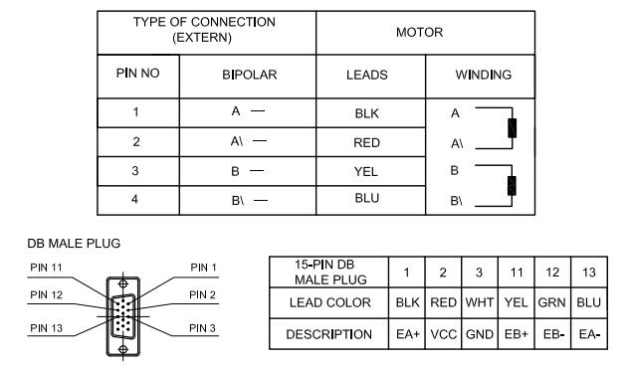

Figure . - Encoder + Motor Wiring Diagrams

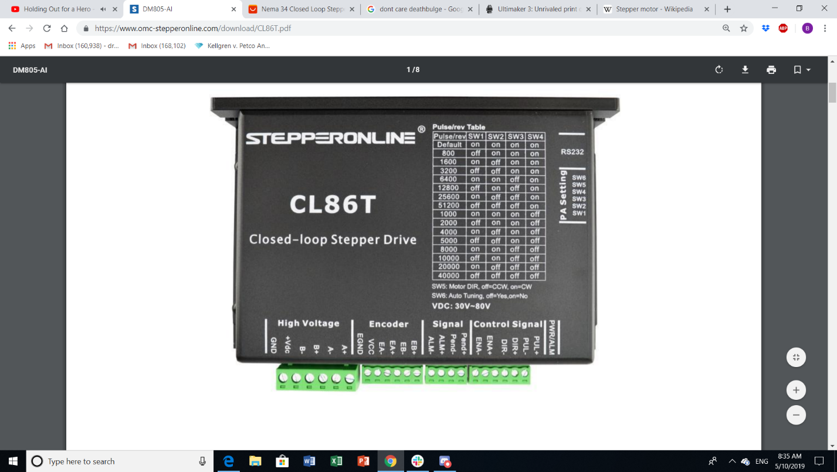

Figure . - CLT86 Driver Used for Stepper Motors

Since the descriptions on the driver match the descriptions on the datasheet, wiring the motor correctly was simple. After the motor was wired, breadboard wires from each negative control signal port were connected into digital pins in an Arduino Mega 2560, the positive wires into 5V power, and the high voltage wires into a power supply set to 24V and 2A. To inform the Arduino of the encoder position, the wires from EA+ and EB+ were connected to two interrupt pins. These interrupt pins will run a segment of code whenever they are pulsed.

The encoders attached to the motors are set to 1000 counts per RPM. When the motor shaft rotates one thousandth of a rotation, each encoder channel sends a pulse. However, these pulses are slightly offset. The direction of the rotation is reliant on this offset. If the A channel pulse is sent first, it means that the motor is rotating the opposite direction than if the B channel pulse was sent first. By checking which rising edge comes in first, it can be determined which direction the motor is moving and adjust the relative position of the arm accordingly.

To control the position of our arm, Arduino code was used. The code takes in a degree measurement from the main Raspberry Pi controller via serial and pulses the motor until the encoders have pulsed a sufficient number of times to indicate that the motors have reached the desired position. This code can be seen in Figure ‎7.13

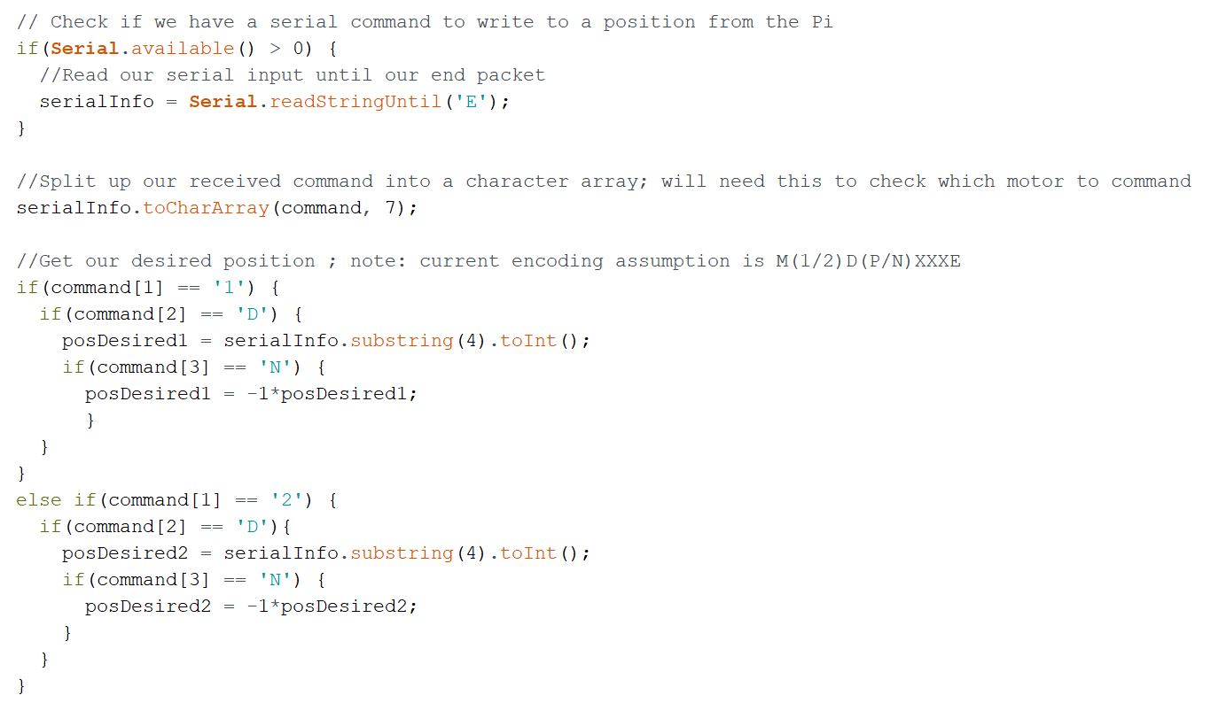

Figure . - Serial Control Code

The above segment of code first polls to check if a Serial connection to a master device (in this case, the Raspberry Pi sending the degree measurements) is available. If it is, the Arduino will then read the packets being sent until it receives the pre-programmed end packet (‘E’) and convert the received data into a character array. The Arduino then parses the sent packet based on a previously agreed upon encoding scheme [M(1/2)D(P/N)XXXE; the (1/2) specified which link to move, the (P/N) specifies whether the direction to move is positive or negative, and the XXX represent the degree measurement to move to]. One important thing to note is that the resting position of Strong Arm is programmed to be the “0 degree” mark for each link, meaning all transmitted degree commands are absolute commands relative to that angle. Once the sent packet is parsed, the code sets a posDesired variable for the particular link that was commanded to move. The code that controls the movement of the link to the received degree position follows in Figure ‎7.14.

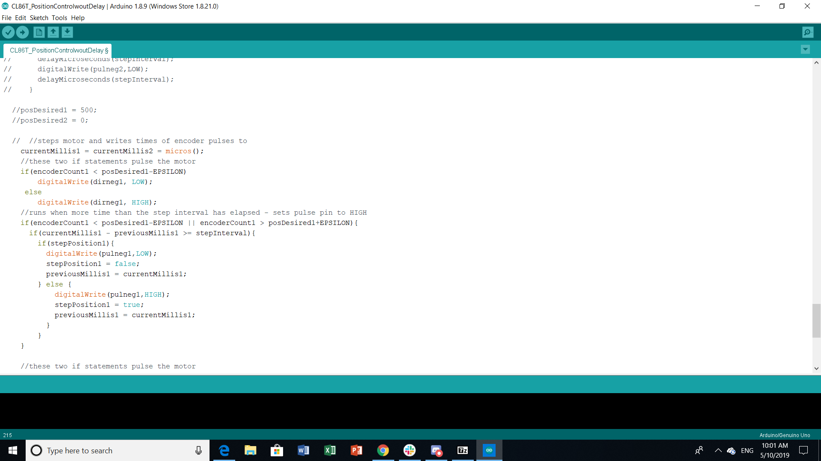

Figure . - Motor Control Code

This segment of code controls the position of the first link of Strong Arm. The code that controls the second link is exactly the same, except it uses data from the motor and encoder. We first set the current system time in microseconds to a variable, so we have a comparison point when we try to time 500 microseconds. We do this instead of using delay statements because delay statements effectively shut down the processor for the time delayed, meaning the chip would not be able to run any other commands while delaying. The next “if” statement determines which direction we should move the motor in. If the encoder count is less than the desired position minus the offset, the motor is moved in a direction where the encoder counts will increase. If the encoder count is greater than the desired position plus the offset, the motor is moved in the opposite direction. An offset of one encoder count in either direction must be used because the encoder has a slight uncertainty. The second “if” statement in Figure ‎7.14 runs when the first link is not within the desired position range. This code simply pulses the motor every 500 microseconds.

## Integration with R2

The below pictures (Figure ‎7.15, Figure ‎7.16, and Figure ‎7.17) show Strong Arm integrated onto the rest of R2. Figure ‎7.15 is a CAD render, while the other two images are screenshots from a video of the arm lifting a basket with 10 pounds of weight in it.

In order to integrate with the rest of R2, first, Strong Arm had to be attached to the mounting plate without the motors or gear boxes attached. The mechanical integration was done by suspending R2 between two tables with a gap in between in order to access the bottom. After the arm was attached, the blocks for the motor mounts and for the gear boxes were attached. The motors and gear boxes were then attached to those and re-coupled to the rest of the arm. Once this was finished, the motors and encoders had to be rewired. During testing, two voltage supply boxes were used in order to supply the necessary 24V and 2A for each motor, but on R2, this is supplied by the battery through the power board. Once the power was rerouted, the Arduino with Strong Arm’s code on it had to be integrated with the main Raspberry Pi controlling R2.

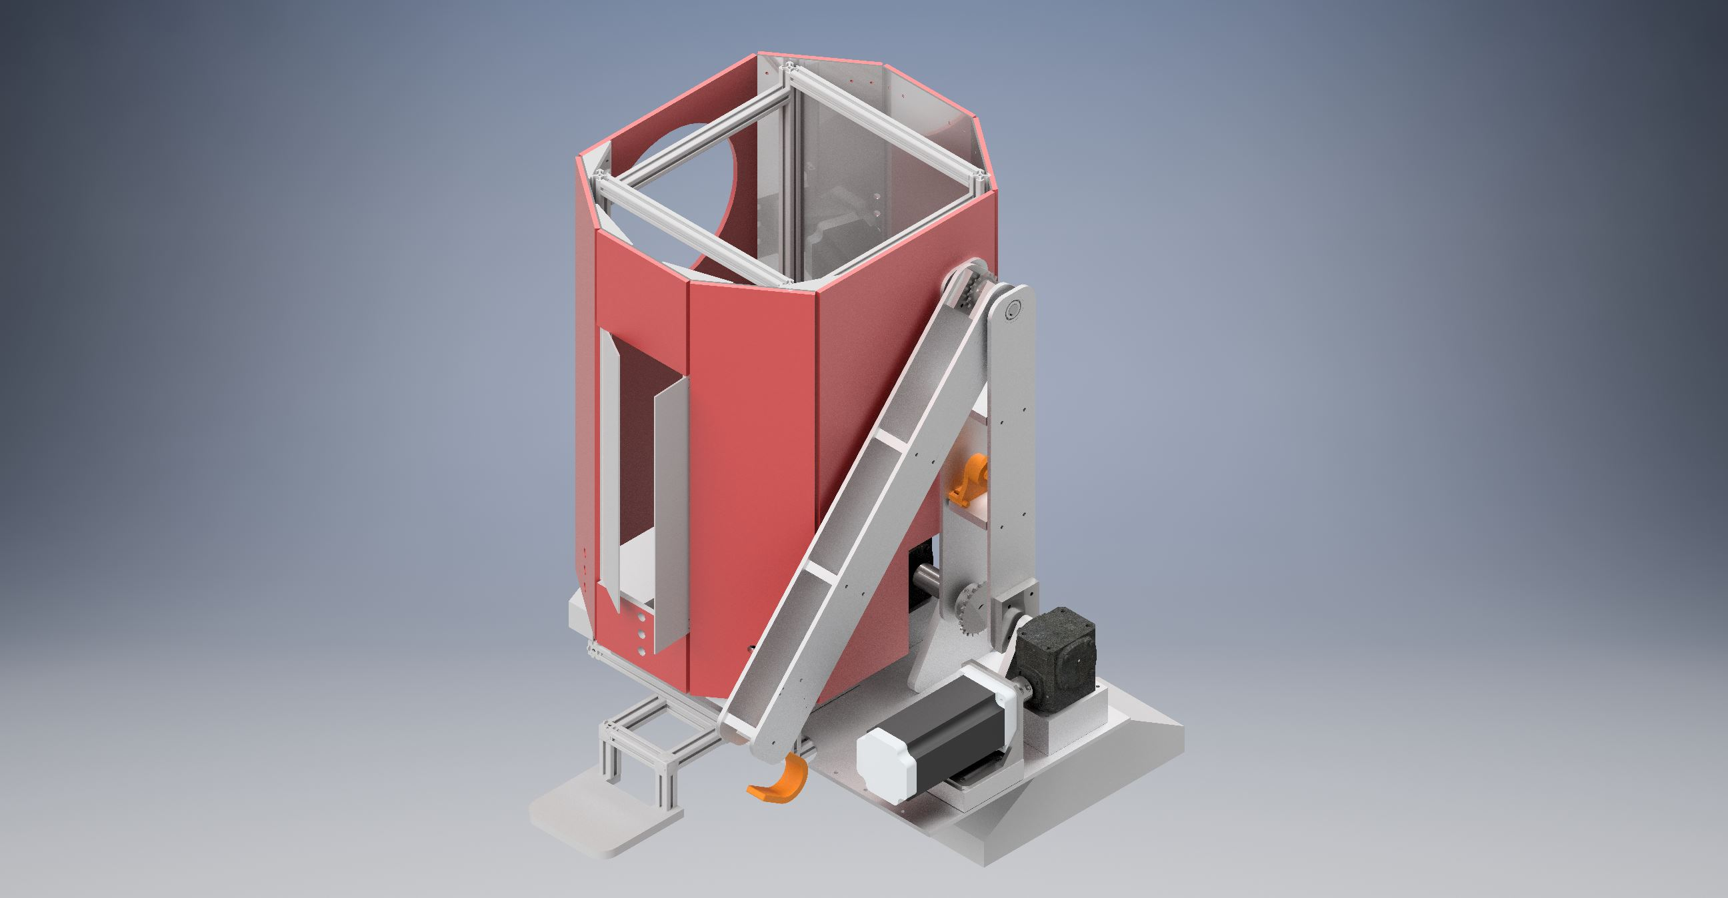

Figure . - Strong Arm Integrated with R2

Figure . - Strong Arm on R2 Preparing to Lift Basket Weighing 10 lbs.

Figure . - Strong Arm on R2 Lifting a Basket Weighing 10 lbs.

## Next Steps

There are several next steps for Strong Arm. The first major goal for next semester is to redesign and manufacture an end effector to replace the current hook. The end effector will allow it to actually grasp at many different angles as the effector will have 2 degrees of freedom in addition to the actuating grippers. One of the purposes of this end effector will be to allow R2 to open doors for itself by interfacing with the vision and object detection systems. Another goal for Strong Arm is to add closed loop control for angle. Currently, the serial command and motor control have closed loop control for the number of steps the motor takes, but once more than 5 pounds of weight are added to the end of the arm, the amount of rotation is very off. This will be accomplished by attaching an accelerometer or another similar type of sensor to each link. By using this, a closed loop controller will be able to be implemented to control exact angle of each link.

## Appendix

### Calculations





Figure . - MATLAB Code for Calculating Required Moments for the First Two Joints

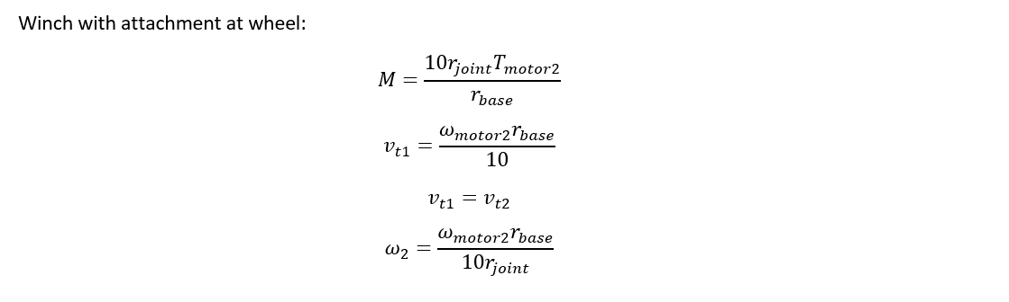

Figure . - Calculations for Output Speed

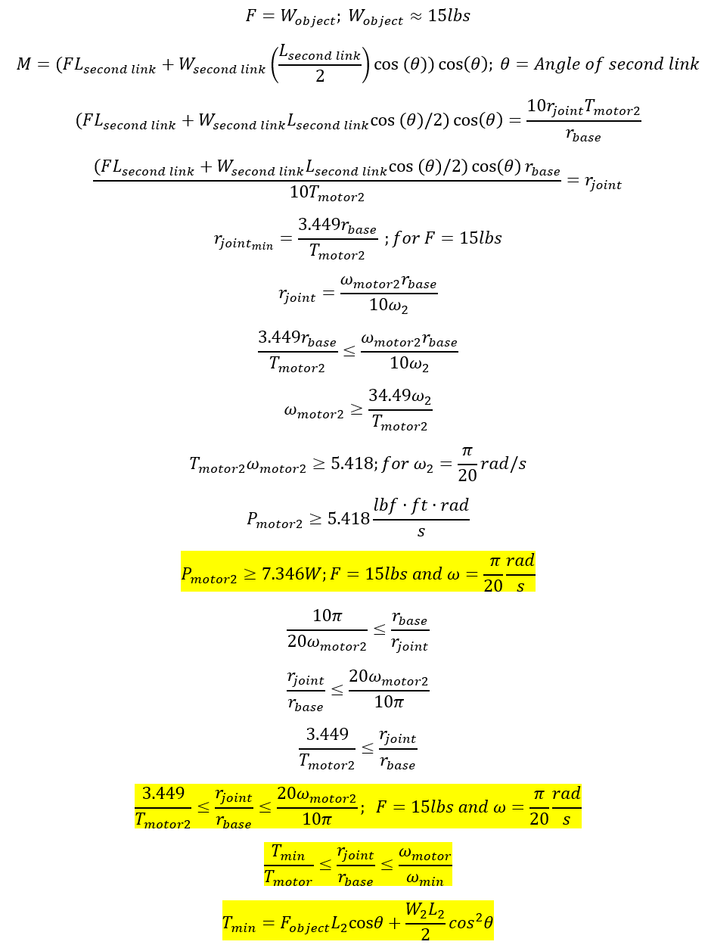

Figure . - Calculations for Power Requirements

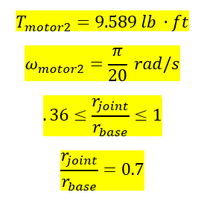

Figure . - Calculations for Ratio of Spools

### Motor Specs

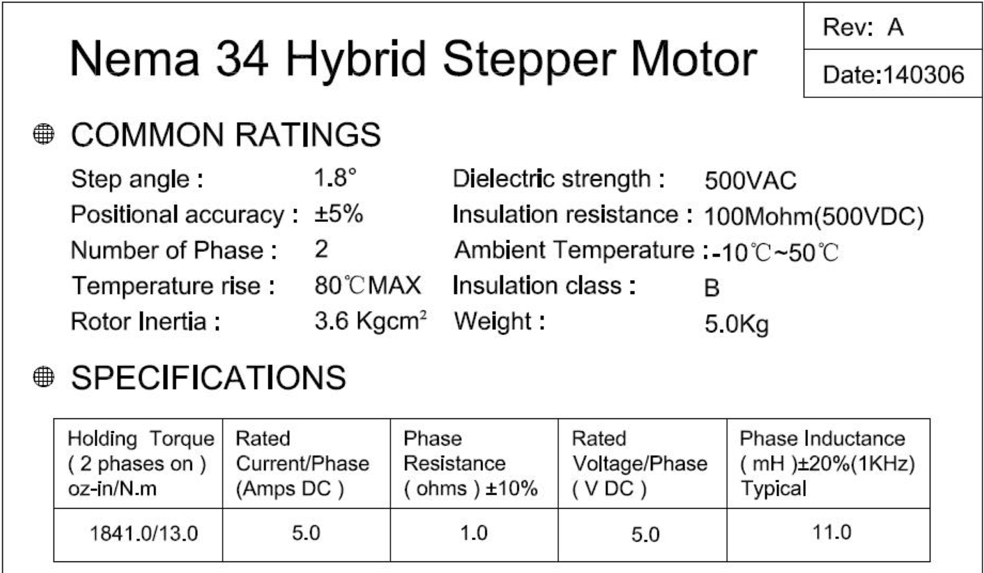

Figure . - NEMA 34 Hybrid Stepper Motor Specs (Part 1)

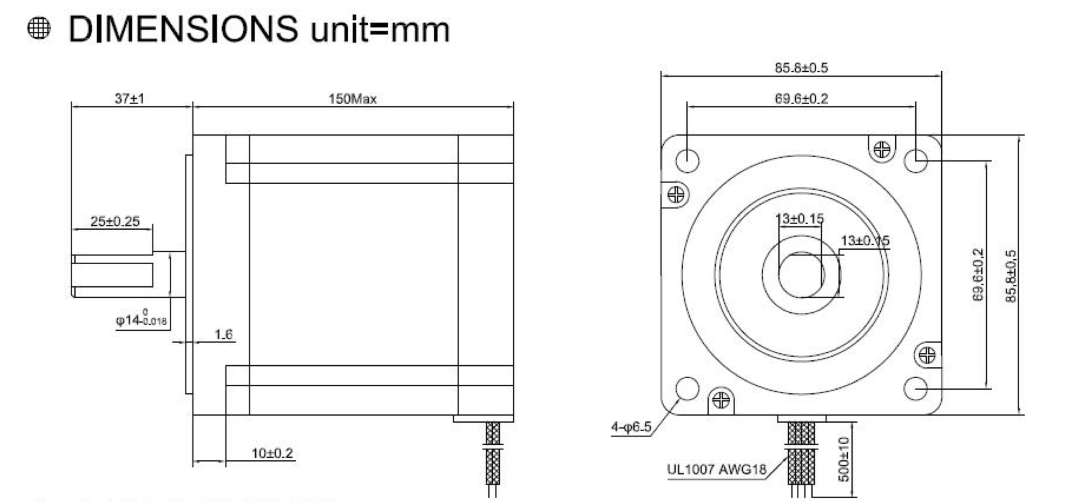

Figure . - NEMA 34 Hybrid Stepper Motor Specs (Part 2)

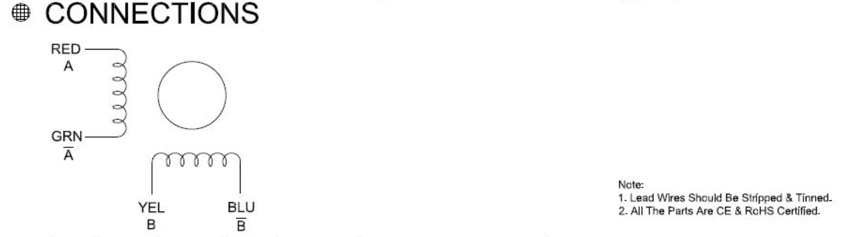

Figure . - NEMA 34 Hybrid Stepper Motor Specs (Part 3)

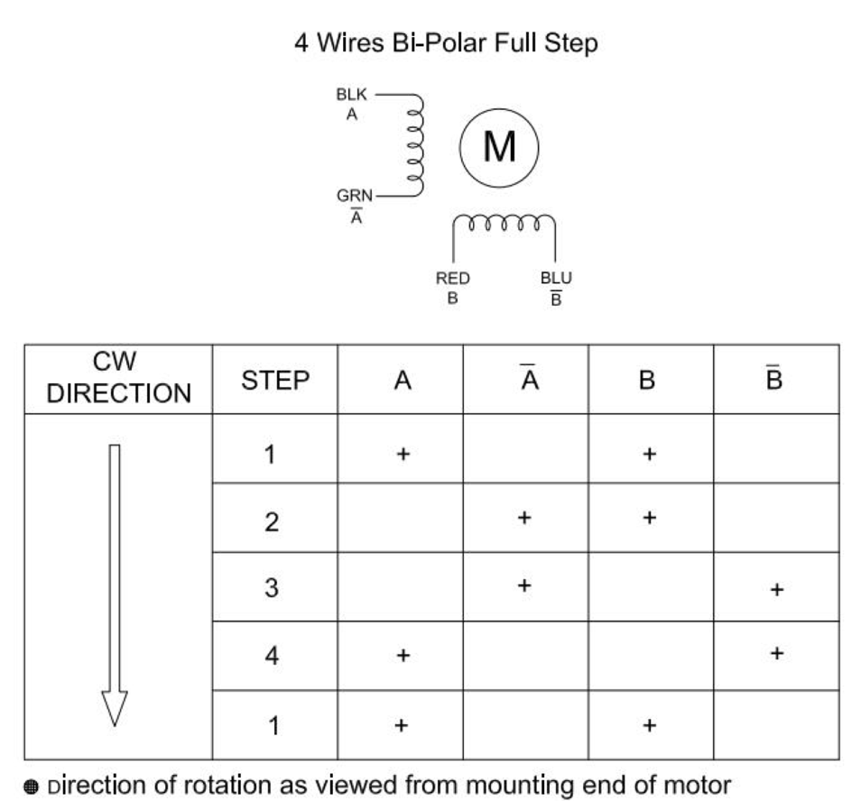

Figure . - NEMA 34 Hybrid Stepper Motor Specs (Part 4)

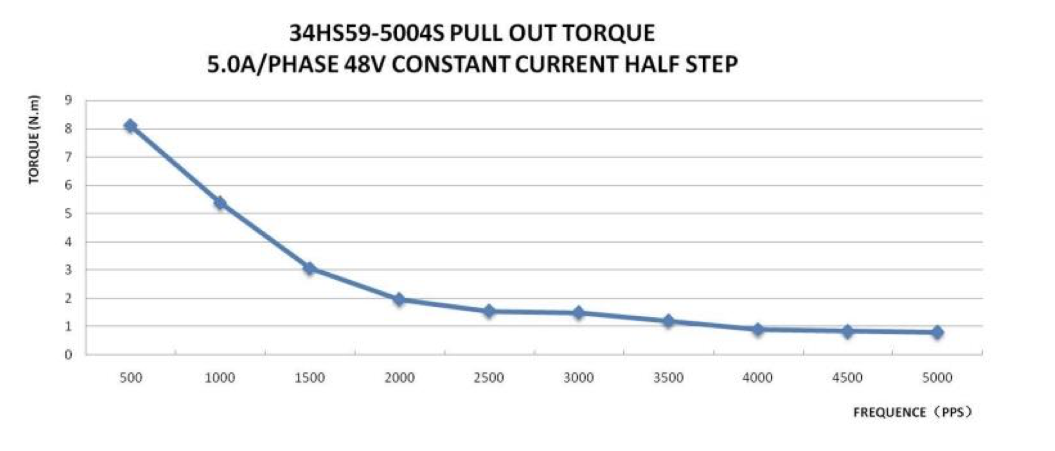

Figure . - NEMA 34 Hybrid Stepper Motor Specs (Part 5)

# Arm Control

Closed loop control of the precise arm was demonstrated at the end of the fall 2018 semester. The major items accomplished during this semester were:

* Defining R2’s tasks and creating functional flow block diagrams for each task
* Concepting controller flow for most difficult tasks
* Implementation of 2-servo arm control to arbitrary position in MATLAB
* Implementation of 2-servo arm control in python
* Managing interfaces and component data
* Implementation of closed loop control on R2 precise arm

## Task Definition

One of the first tasks the team performed was defining a list of tasks which R2 would perform. After creation of decision matrices and team discussion, the list of tasks was narrowed down to the tasks listed in **Error! Reference source not found.**. This table is an excerpt from R2’s Tier 1 requirements. Definitions of the “Level of Autonomy” and “Technical Difficulty” terms, as well as additional information on system and subsystem requirements can be found here: <https://docs.google.com/spreadsheets/d/16N13dBrgHb2V9-U3VHoshp6akM02LT5hSmH4AiM1WN0/edit#gid=0>

Table . - R2 Task List

|  |  |  |  |
| --- | --- | --- | --- |
| Task | Description | Technical Difficulty | Level of Autonomy |
| Open_Door |  | Medium | 2 |
| Open_Door_and_Enter |  | Hard | 3 |
| Open_Door_and_Hold_Open |  | Hard | 3 |
| Pick_Up_Light_Object |  | Medium | 2 |
| Pick_Up_Heavy_Object |  | Medium | 2 |
| Pick_Up_and_Deliver_Light |  | Hard | 3 |
| Pick_Up_and_Deliver_Heavy |  | Hard | 3 |
| Identify_and_Wave |  | Medium | 4 |
| Identify_and_Record_Attendance |  | Easy | 4 |
| Identify_Fridge_Handle |  | Easy | 4 |
| Identify_Door_Handle |  | Easy | 4 |
| Identify_Unique_Object |  | Easy | 4 |
| Identify_Soda_Can |  | Easy | 4 |
| Open_Fridge |  | Medium | 2 |
| Open_Fridge_Grab_Soda_Hand_to_User |  | Hard | 4 |
| Open_Drawer |  | Medium | 2 |
| Open_Drawer_Remove_Specific_Object |  | Hard | 3 |

Note that this task list contains smaller tasks that, when combined, result in execution of the larger tasks. For example, in order to perform the “Open Door and Enter” task, R2 must first be able to perform the “Open Door” task. This leads to a natural progression of tests, whereby R2 will perform the smaller tests first, and then combine smaller, simpler actions into a more complicated one. In addition to this task list, functional flow block diagrams were created for each “macro” task. An example of a functional flow block diagram is shown in Figure ‎8.1. This shows a functional flow for R2 approaching, opening, and moving through a door.

When viewing this task and all of our other tasks, the action that appeared most frequently was arm movement to a location and grabbing an object at that location. In addition to this, movement of R2’s wheels in order to arrive at a certain location frequently appeared, but as this action has been demonstrated in previous semesters (albeit not autonomously), we focused on the arm control to start. The entire collection of FFBDs can be found here: <https://docs.google.com/presentation/d/1A0UVcNKlvyg6syYMPnK8_QAfEyBOT6fuHyxyXbc9oMA/edit#slide=id.g44d3e625fb_8_0>.

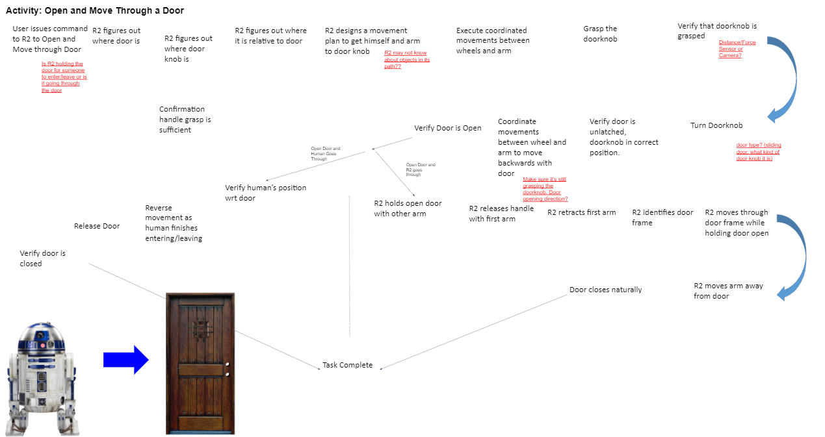

Figure . - FFBD for R2 Movement Through Door

## Concepting Controller Flow

The first task we focused on for controller development was arm control to position. In order to understand how this control would fit into the top level algorithm running on the R2 raspberry Pi, and how various subsystems would interface, we developed a preliminary multi-state controller flow diagram, including a mixture of functional and physical elements, as a thinking and discussion tool. This is shown in Figure ‎8.2. This figure contains a “State Selection” block and a subset of R2’s states focused around arm control. To describe R2’s behavior using the diagram, we shall begin with the “State Selection” block. This is an algorithm that will manage and schedule the sub-routines that R2 needs to execute to complete tasks.

While in the state of “waiting,” shown in the diagram, R2 will poll its sensors, microphones, and cameras and search for certain cues in the sampled information that indicate a task is to be performed. For example, R2 might receive an image of a face through the camera, and the state selection algorithm would initiate a script that causes R2 to greet whoever it saw. As another example, R2 might receive a verbal command through the microphone to “Grab a Soda Can.” The state selection algorithm would call the necessary object identification routines to locate a soda can, and pass the goal position onto the arm navigation, robot navigation, and coordinated arm movements states as needed. Each of these subroutines would execute until completion, and then communicate back to the “state selection” routine so that the remainder of the necessary steps can be completed.

After further development efforts, the controller diagram was refined and detailed more clearly for the “Arm Commanded to Grab Something” set of subroutines. This functional flow is shown in Figure ‎8.3. The blocks in this diagram are purely functional, but information transfer across different components is denoted through the dashed lines. In addition, the segmentation into raspberry Pi, Arduino, and hardware allows for discussion of program execution rates, which is critical for implementing discrete time control.

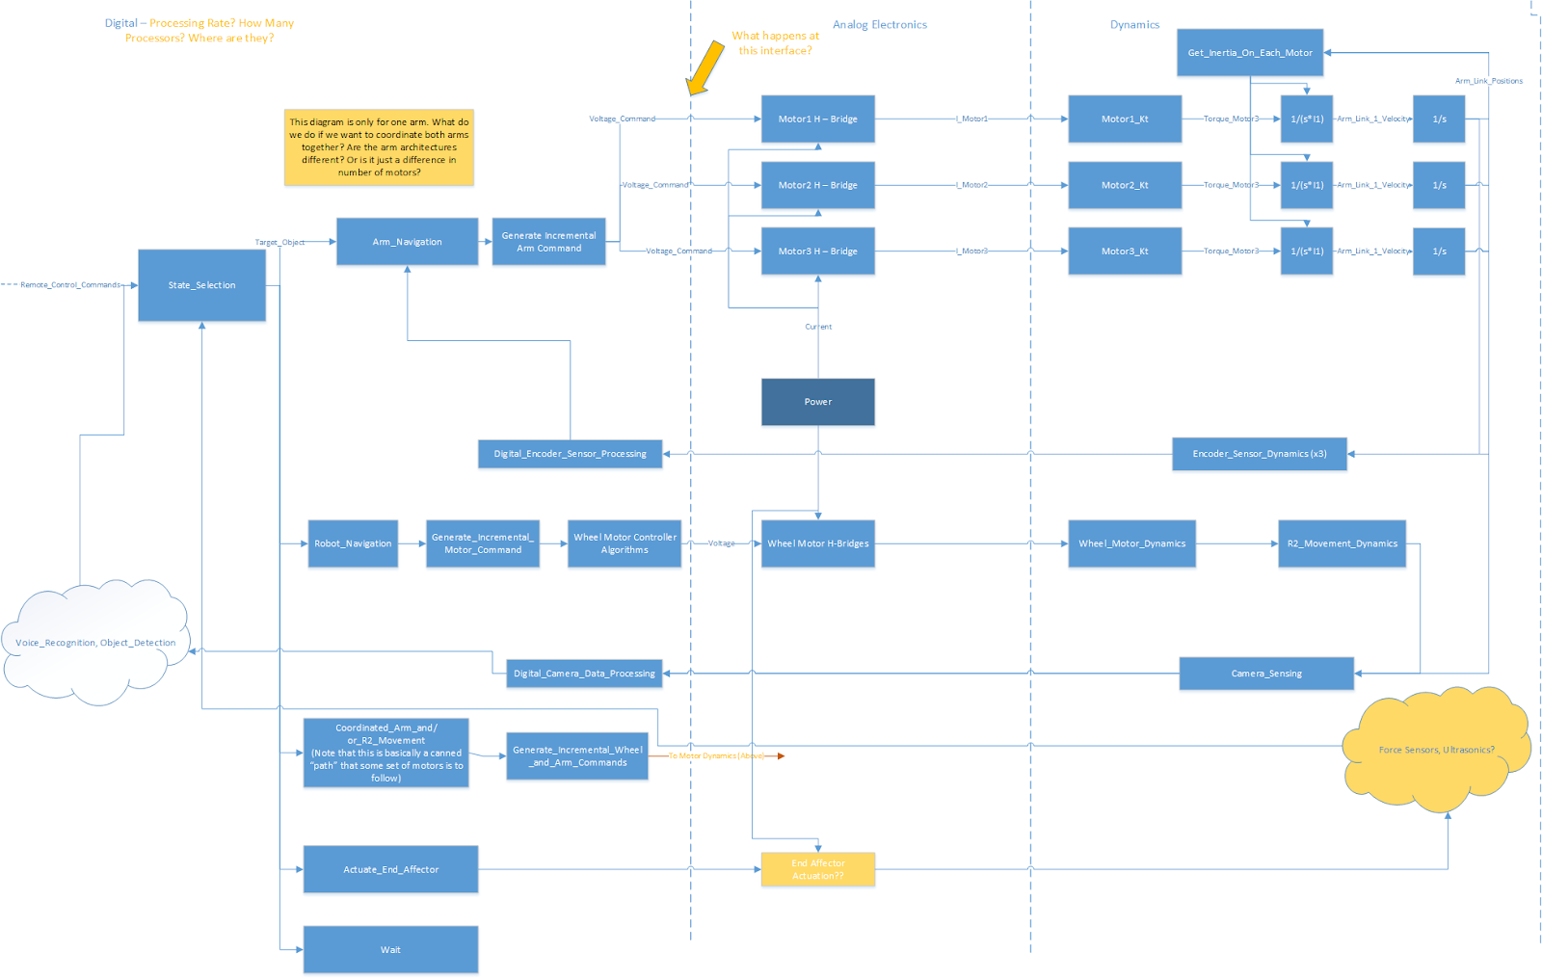

Figure . - Multi-State R2 Control Thought Exercise

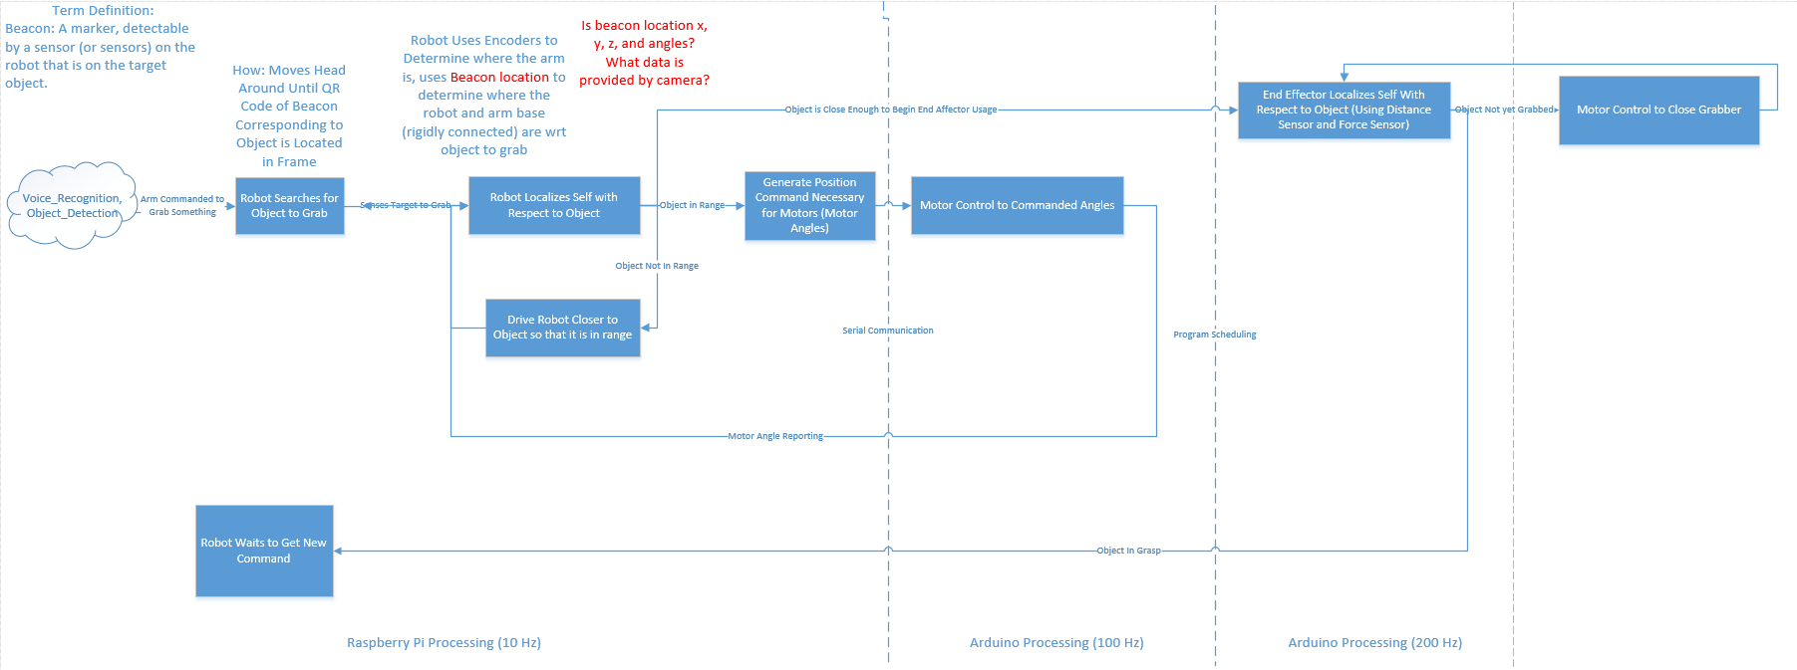

Figure . - Control Flow for Arm Grabbing Object

## Implementation in MATLAB and Python

After the creation of the functional flow, it came time to develop the actual algorithm. MATLAB was selected for this development due to its efficacy with matrix mathematics. The initial navigation algorithm was restricted to 2-motor control in order to simplify the problem during algorithm development. The algorithm selected was a form of inverse-Jacobian based path-planning. Then, the path planning algorithm simply iterates through a list of angular commands and sends them to the motor control algorithms. The algorithm flow can be described as follows:

$$θ,φ are motor angles, X_{EA}is the x position of the end affecter, Y_{EA}is the y position of the end affecter$$

$$X_{EA}=fcn\left(θ,φ\right), Y_{EA}=fcn(θ,φ)$$

$$Jac=\left[\begin{matrix}\frac{dX_{EA}}{dθ} & \frac{dX_{EA}}{dφ} \\ \frac{dY_{EA}}{dθ} & \frac{dY_{EA}}{dφ}\end{matrix}\right], evaluated at current θ and φ$$

$$\begin{matrix}∆X \\ ∆Y\end{matrix}≈Jac* \begin{matrix}∆θ \\ ∆φ\end{matrix}$$

$$\begin{matrix}∆θ \\ ∆φ\end{matrix}≈Jac^{-1}* \begin{matrix}∆X \\ ∆Y\end{matrix}$$

$$where ∆X and ∆Y are a small desired movement of the end affector$$

In its current implementation, motor positions are not fed back to the Raspberry Pi, so the trajectory of angle commands (a vector each of $θ$ and $φ$ commands) is computed before any motion occurs, and the successive angle commands are sent to the Arduino for command. A snapshot from an animated MATLAB implementation is shown in Figure ‎8.4. In this animation, the desired movement of the end affecter was specified as a portion of a sinusoid, as shown by the red line in the plot.

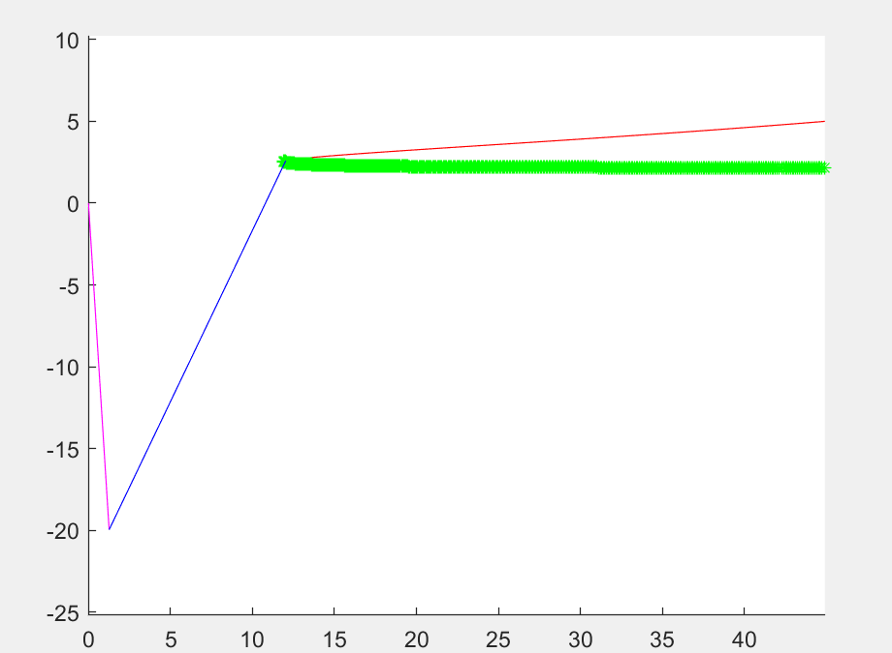

Figure . - MATLAB Implementation of Inverse-Jacobian Based Control

This was then implemented in python for execution on the real Raspberry pi, and a similar plot was created, shown in Figure ‎8.5. Note that in this plot, only the joint locations are plotted, rather than the arm linkages.

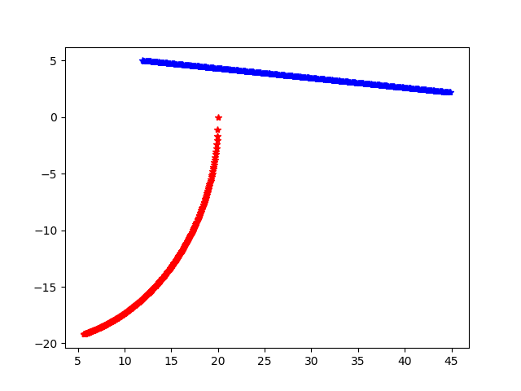

Figure . - Python Implementation of Two Motor Control

The arm control MATLAB file that generates Figure ‎8.4 can be found here: <https://github.com/cornell-cup/Arm_Control_Models/blob/master/Precise_Arm/MyInverseKinematics.m>

The python implementation of this algorithm which generated the plot shown in Figure ‎8.5, can be found here: <https://github.com/cornell-cup/Arm_Control_Models/blob/master/Scripts/ArmControl/PreciseArm_Control_To_Location.py>

## 3rd Axis Programming

The third axis of the precise arm (the shoulder rotation) was implemented using the same method as the two-axis implementation. The dynamics of the three axis system were first calculated as follows, solving for the x, y, and z position of the end affecter using the three motor angles:

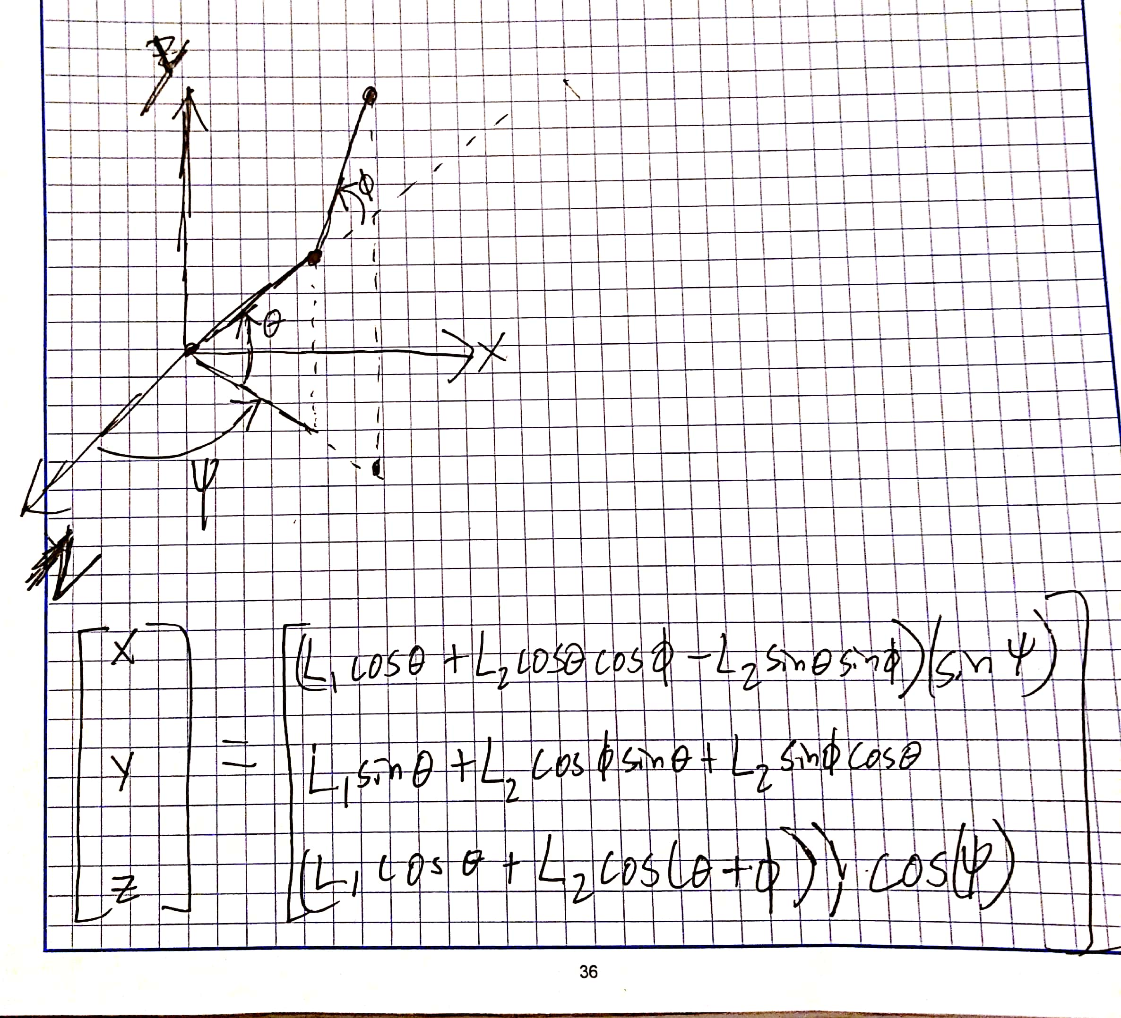

Then, in order to use the same Jacobian technique as in the 2-axis case, the partial derivatives of x, y, and z with respect to the three motor angles were computed per the following equations:

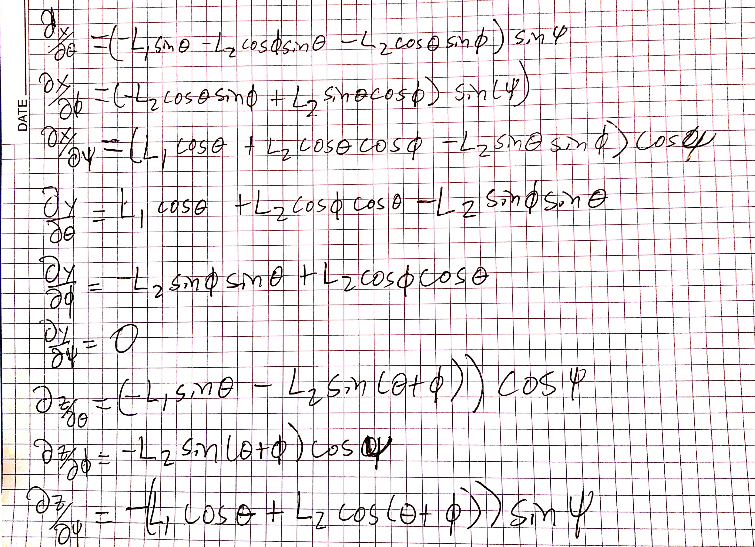

These partial derivatives were then assembled into a 3x3 matrix for use in computation. The jacobian is of the form:

$$Jac=\left[\begin{aligned}\begin{matrix}\frac{dX_{EA}}{dθ} & \frac{dX_{EA}}{dφ} \frac{dX_{EA}}{dψ} \\ \frac{dY_{EA}}{dθ} & \frac{dY_{EA}}{dφ} \frac{dY_{EA}}{dψ} \end{matrix} \\ \frac{dZ_{EA}}{dθ} \frac{dZ_{EA}}{dφ} \frac{dZ_{EA}}{dψ}\end{aligned}\right]$$

The three axis control then takes the following form around any x, y, and z and theta, phi, and psi:

$$\begin{matrix}∆θ \\ ∆φ \\ ∆ψ\end{matrix}≈Jac^{-1}*\begin{matrix}∆X \\ ∆Y \\ ∆Z\end{matrix}$$

The motors can then be commanded with the angular changes $∆θ, ∆φ$, $∆ψ$.

In testing, it was found that the Jacobian method did not always give a desirable path in between the start and end point. As such, the code is designed to just give final angular positions for any desired goal point. A few examples of different starting and ending points are shown below:

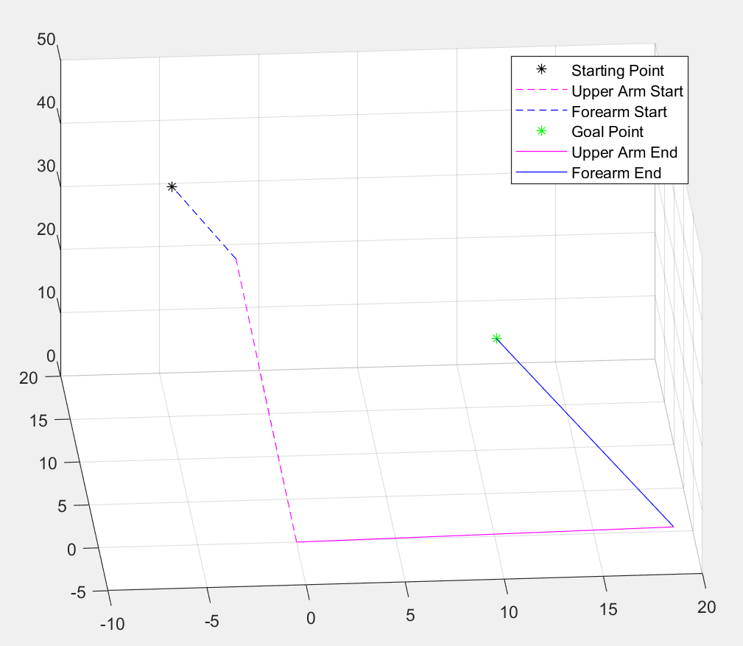

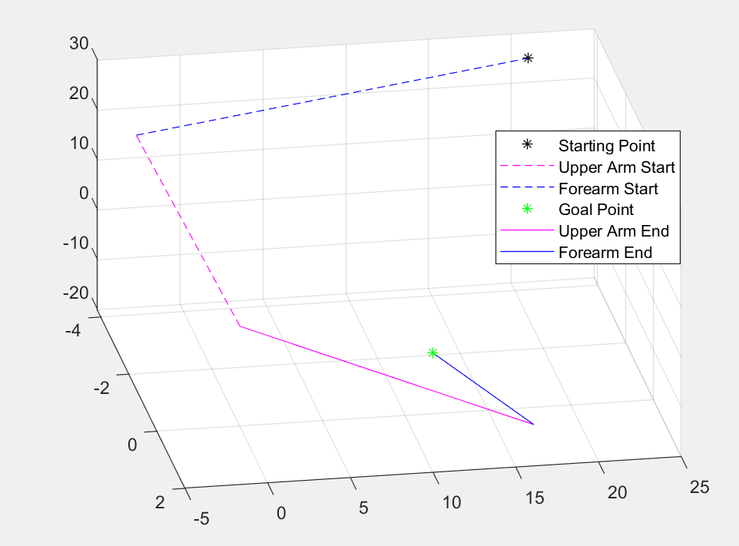

The MATLAB implementation of these functions are here:

<https://github.com/cornell-cup/Arm_Control_Models/tree/master/Precise_Arm/Arduino_functions>

Testing of the scripts can be run by cloning the folder, and executing TestFunction.m

The python implementation of these functions are here:

<https://github.com/cornell-cup/Arm_Control_Models/tree/master/Scripts/Precise_Arm_3Axis_Python_Implementation>

Note that the parameters for the arm being controlled are contained in the top-level python script. These scripts are intended to be run on the raspberry pi, with the angle commands sent to the Arduino (as shown at the end of Precise_Arm_3Axis_Python_Implementation.py).

## Strong Arm and Simulink-based Controller Development

The scripts developed for 3-motor control of the precise arm will also work for control of the strong arm, solely with different parameters. The third motor control will simply not do anything, but control in the X- and Y- axis will be sufficient.

During this semester, we also began development of a Simulink model, which could be compiled directly to the Arduino. The reason for this was to allow us to tune our control algorithms in discrete time and be able to test them immediately on the Arduino. It also allowed us to tune the algorithms in MATLAB / Simulink, which are much more appropriate control-development softwares than python. The command loop that we attempted to build is shown below. Note that it creates pulses to the stepper motor at a controlled rate. The rate is controlled with a PI controller.

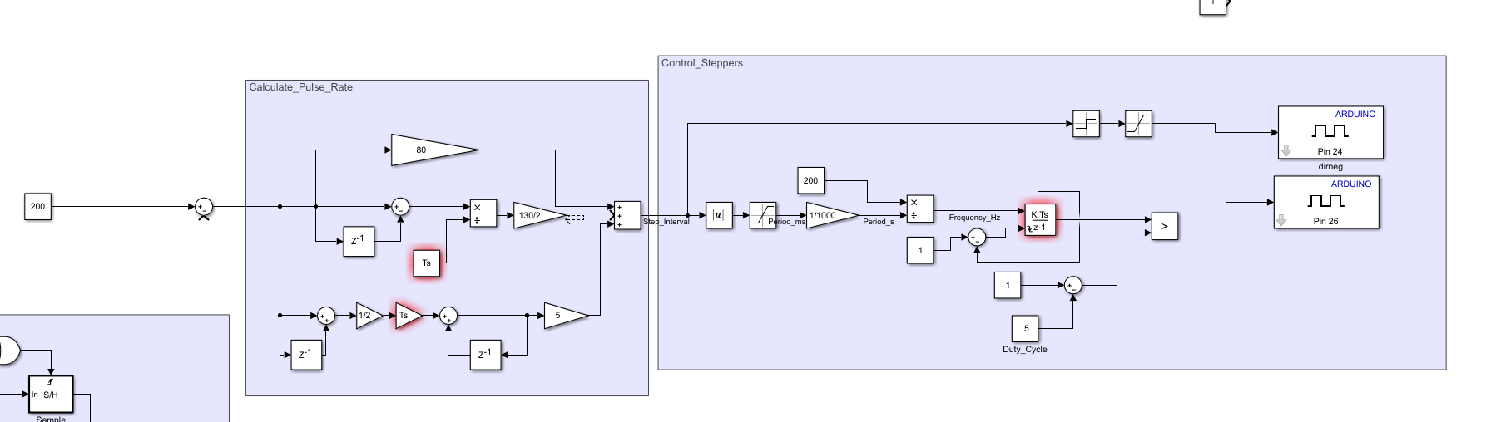

Our block diagram for reading from the encoder is shown below:

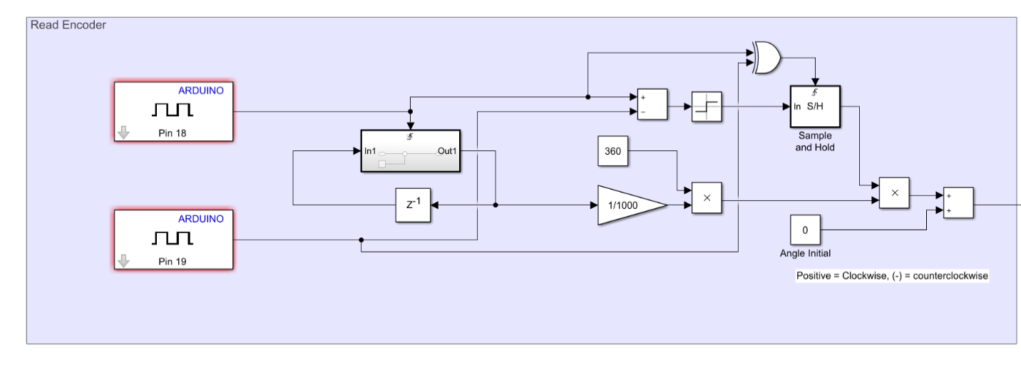

We were able to get these functions running on the Arduino, built directly from Simulink using the Simulink and matlab support packages for Arduino. Unfortunately, when combining all of the pieces of the block diagram together, and running the code at around two times the maximum needed pule rate (around 1300 pulses/second), we experienced frame overruns on the Arduino. We were unable to get the entire Simulink model running, with the control loop above without experiencing frame overruns.

In order to make this work in the future, the pulsing shouldn’t be executed in fixed-step discrete time. If it is managed by the Arduino processor, and pulses executed whenever the processor is able to handle the task, the Arduino will not overrun its frames. The control loop should also only be run at 10x the speed of the dynamic behavior that is desired of the individual motors. I.E., if a frequency response bandwidth on the velocity of each motor is desired up to 1Hz, then the discrete time control need only be run at 10Hz. The Arduino can then receive a “rate” from the control loop (degrees/second) for each motor and generate the pulses on the stepper motors at that rate.

It is recommended that both the encoder-reading and pulse generation are written and performed in Arduino code, and software variables passed to and from the Simulink block diagram, which will run at a fixed-step discrete rate.

The Simulink block diagram that can be implemented directly to Arduino is located here:

<https://github.com/cornell-cup/Arm_Control_Models/tree/master/Runnable_Simulink_Models/Strong_Arm>

## Strong Arm Arduino-Based Control

For the NASA demonstration, we developed strong arm control in python. This control was very simple, and only looked at the encoder counts vs the desired encoder position. It then pulsed until the encoder counts were the same as the intended encoder position. No discrete rate control was implemented for these motors. The .ino file for implementation on the Arduino can be found here:

<https://github.com/cornell-cup/Arm_Control_Models/blob/master/Strong_Arm/CL86T_PositionControl/CL86T_PositionControl.ino>

## AprilTag Localization

We attempted briefly this semester to implement AprilTags as a localization method for R2.

The package we used is here:

<https://pypi.org/project/apriltag/0.0.16/>

The setup we used to test the AprilTag localization is shown below:

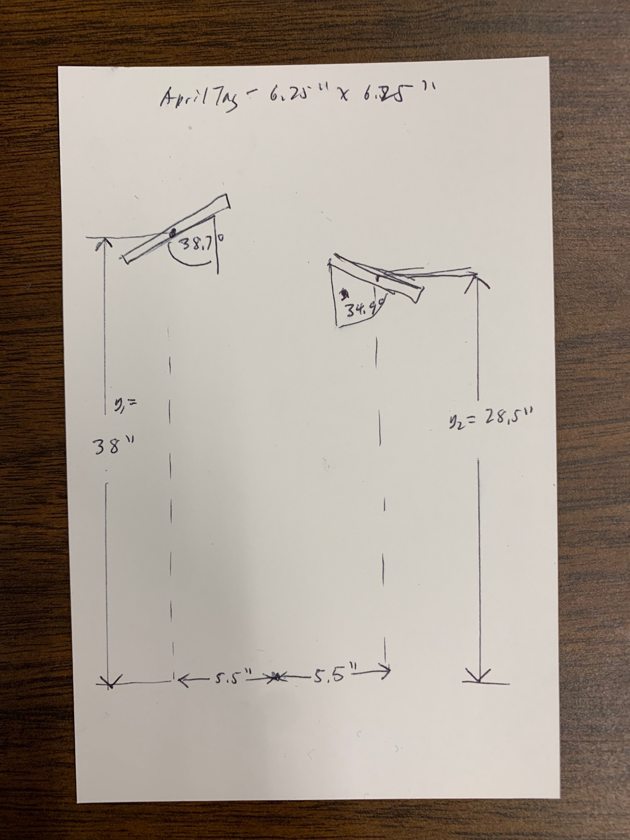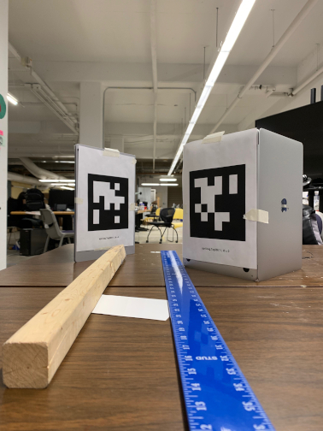

The output from the software on this setup is as below:

[251.73016223 238.16239821]

(array([[ 7.34553437e-01, -2.65532108e-03, 6.78545649e-01,

7.72246858e-01],

[-1.21594771e-02, 9.99780263e-01, 1.70755251e-02,

-1.68845738e-01],

[-6.78441888e-01, -2.07936459e-02, 7.34359741e-01,

1.38930007e+01],

[ 0.00000000e+00, 0.00000000e+00, 0.00000000e+00,

1.00000000e+00]]), 690.4611626643186, 6.141008976562829)

42.73050444154652 degrees

[128.1324107 237.26719251]

(array([[ 7.04871703e-01, 1.08621382e-03, -7.09333985e-01,

-9.80317166e-01],

[ 1.18924733e-02, 9.99840177e-01, 1.33487304e-02,

-2.33992093e-01],

[ 7.09235117e-01, -1.78448778e-02, 7.04746131e-01,

1.83789484e+01],

[ 0.00000000e+00, 0.00000000e+00, 0.00000000e+00,

1.00000000e+00]]), 461.27202438932744, 2.4622393283180815)

45.1808198978547 degrees

Unfortunately, we were unable to get pose estimation from this test scenario. More work needs to be done to understand the parameters of the Raspberry Pi camera, as well as the coordinate systems and rotation matrices associated with the AprilTags. Contact Scott Wang for more details.

## Integration

Integration efforts were performed on the precise arm in advance of demo day to demonstrate performance. These efforts centered around a few major tasks in order to achieve closed loop control functionality. The tasks performed and lessons learned from each are as follows:

### Servos and Potentiometers

With the servos integrated on the precise arm, control was initially difficult. With the control circuitry contained inside the servo, it was hard to explain the arm behavior. We tapped into the external potentiometers of each servo and used the voltage measurements from it to generate closed loop position control. This control eventually moved the motor to position but was slow and exhibited significant chatter. That being said, it was observed that the potentiometers gave fairly consistent feedback, which could likely be filtered and used for control in the Pi. Upon further inspection, it was observed that the leads to the potentiometer on the servos were intermittently shorting to each other. This was fixed, and the built-in servo-controllers displayed functioning closed-loop control.

### Structure and Interference

The link connecting the lower arm motor (mounted at the shoulder) and the lower arm was initially undersized. When attempting to drive the lower arm with the shoulder servo, this link would flex, resulting in inconsistent lower arm control. This link was braced using aluminum extrusion. It was also observed that interference occurred between a few screws/links at the limits of range. The locations of this interference will be documented and either fixed structurally or avoided programmatically in the future.

### Communication Protocol

The serial communication between the pi and Arduino of angle commands was necessary for control of the servos from the Pi. This communication protocol required debugging to understand syntax and data types sent across serial when using the Pi and Arduino serial packages. Strings are encoded in UTF-8 for easy decoding on the Arduino. In the future, this protocol will be well defined according to the communication protocol document developed here: <https://drive.google.com/drive/u/0/folders/12ZJQIZCLyRuzvNXMjsp-fWG3D2_zMO0t>

### Debugging Controls on Precise Arm and Algorithm Breakdown

The python implementation of closed loop control was executed on the precise arm. Within arm end affecter positions within the upper right quadrant of coordinated (+X, +Y), arm control was stable and consistent. Users were able to input starting and ending end affecter positions, and the algorithm would command the arm in a straight line between the two. The algorithm broke down, however, when the start/goal points crossed into other quadrants, and when the goal points were at the edges of arm range. Addressing this breakdown and extending the algorithm’s efficacy to the limits of the arm’s physical range are goals for next semester.

### Integration & Testing Before NASA Presentation

Unfortunately, we ran out of time as a team in advance of the presentation in Florida, and were unable to test the arm control algorithms on R2. Instead, the team focused efforts on achieving minimum viable product for the presentation. As such, integration and test of these python scripts should be an early-semester task in fall 2019. In addition, we did not have time to test/integrate the control algorithms for the end affecters.

### Next Steps

The next steps in controller development are:

* Including the end affecter on the arm during control
* Integrating and testing arm control while arms are mounted on R2
* Controlling to a location, and then grabbing an object in succession.

### Interfaces and Component Data Tracking

Some subtasks necessary for control algorithm development were the management of interfaces and of component data, specifically sensors. In viewing the diagram in Figure ‎8.3, it’s clear that there are a lot of software/hardware interfaces. As such, data transmission protocols had to be established, and the type of information being transferred at each interface had to be documented. A subset of the interface control document, describing just the interfaces the arm control algorithms on the Pi have, is shown in Table ‎8.2. The interface control document can be

found here: <https://docs.google.com/spreadsheets/d/1rKfUQBmJE3iey2N9qDrYso_b1j_L0K_6sH4crLxrvso/edit#gid=0>.

|  |  |  |  |  |  |
| --- | --- | --- | --- | --- | --- |
| Signal | Signal Name | Units | Description | Notes | Owner |
| Task Commands | Task_Command | enum | 1 = Wave Precise Arm 2 = Grab Round Door Knob 3 = Open Door with Round Door Knob 4 = Open Fridge Door 5 = Grab Object with QR Code 6 = Pick Up Object in Precise Arm Grasp 7 = Pick Up Object in Strong Arm Grasp | This is a variable in the Raspberry Pi software Generated By Some Program Figuring Out which Commands are Being Executed | Software/Voice Recognition |
| QR Code Angle 1 |  | integer (2^16) | Roll angle of QR code with respect to camera |  |  |
| QR Code Angle 2 |  | integer (2^16) | Pitch angle of QR code with respect to camera |  |  |
| QR Code Angle 3 |  | integer (2^16) | Yaw angle of QR code with respect to camera |  |  |
| QR Code Identifier(s) |  | Integer (2^8) | A number corresponding to a QR code received | How will this protocol handle detection of multiple QR codes in frame? |  |
| Serial Comms from Arduino | N/A | Serial | Information protocol here: https://drive.google.com/drive/u/0/folders/12ZJQIZCLyRuzvNXMjsp-fWG3D2_zMO0t?ogsrc=32 | This is all of the information coming back from the individual arduinos on the robot |  |

*Table ‎8.2 - Arm Control Raspberry Pi Software Interfaces*

In addition, the sensors on R2, both extant and desired, were documented in a Sensor Information and Needs Document. A subset of this document, including details on the Head Camera, Head IR Distance Sensor, and the Precise Arm Hand Force Sensor, is shown in Table ‎8.3. The sensor information document can be found here: <https://docs.google.com/spreadsheets/d/1oi4tHmYgDB3lBNEBizty54Nk6hjv-429mgYJybYMJmg/edit#gid=183399730>

|  |  |  |  |
| --- | --- | --- | --- |
| Sensor Name | Head Camera | Head IR Distance Sensor | Precise Arm Hand Force Sensor |
| Description | Used to Detect QR Codes | Used to detect distance to the QR Code. This will have to be fairly accurate and will be used in conjunction with the camera. The camera needs to be able to deliver the angles of the QR code with respect to itself | Used to verify that the robot has picked up the object |
| Range | TBD | 0.05 to 1.2 m | 0-11 lbs |
| Accuracy | TBD | +-2 cm | Precision: less than an ounce |
| Link to Part | TBD | https://www.adafruit.com/product/3316 | https://www.dx.com/p/open-smart-50n-5kg-fsr-sensor-module-for-arduino-2008190#.XBCiI6eZOU0 |
| Mounting Location | R2 Head | R2 Head | R2 Precise Arm Hand |
| Needs for Control System | Need to know range that it can detect them and the angle it has to be pointing to detect them. This is how R2 will search for the object in the first place. Physical attachment location WRT arm attachment location. Must also be very rigidly mounted | Need to know how accurate this is, how rigidly attached it will be to the same structure that the camera is, physical dimensions between this sensor and camera and arm | Needs to be able to verify that an object is in grasp. Want analog output on this sensor so that we can tune it for objects that need more/less grip strength to pick up |

*Table ‎8.3 - Sensor Information*

# Facial Recognition

## Goals and Objective

The goal of the Facial Recognition program is to have R2 take a picture when it detects a voice trigger such as “Sign me in.” This executes the client program, which then makes an HTTP request to the server-side facial recognition program. The server will return a JSON value containing the check-in information of the detected person, which is recorded for reference.

## Design

This system’s hardware utilizes a Raspberry Pi, a Raspberry Pi camera (ReSpeaker 4-Mic Array v2.0), a Raspberry Pi speaker (SKU: 7419007710 from Dexter Industry), and a server running on a computer. All programs are written in Python.

The whole software stack uses a client-server approach and is shown in Figure ‎9.1:

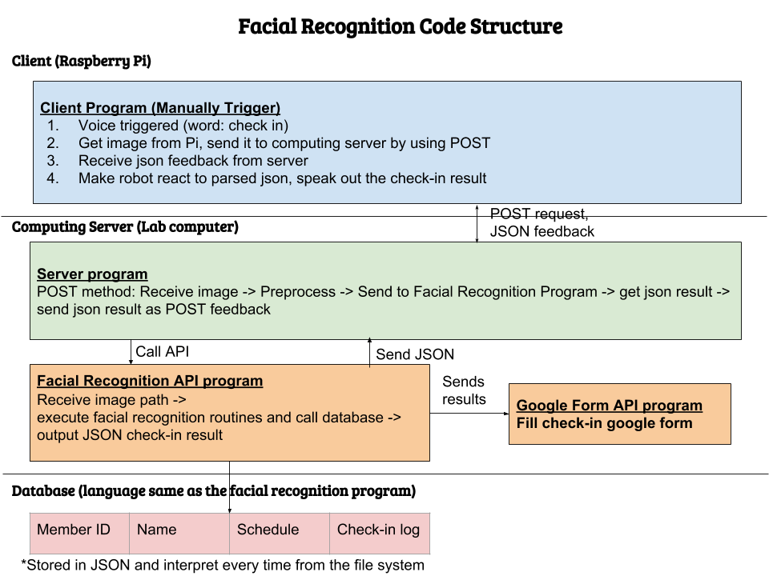

Figure 9.1 - Facial Recognition Code Structure

The software is divided into 2 parts, the client and the computing server, both implemented in Python.

The client program is running on Raspberry Pi and is triggered by either keyboard or voice. After receiving the signal from keyboard or voice, the client program will call the camera API from Raspberry Pi and send to the server side via HTTP POST method. The client program will receive the json feedback of the POST request. After parsing the json to fields of name, check-in status, meeting ID, we parse this information to audio and send it to the speaker. And the speaker can say the check-in information. The role of giving corresponding response is performed by speaker, which, after the whole program is finished, gives users necessary information regarding whether they are successfully checked in and their meeting types.

The server program is running on a lab computer. It is a HTTP server based on Python flask package. The server has only a POST method under the url extension of “/identify-face”. This POST method is supposed to receive an image from the client, apply the facial recognition program to get the face’s name, match the name to make check-in result into a json, and send back json as the result of the POST method.

The server program depends on a facial recognition package, which we implemented under the util folder, and is imported every time the server is running. The facial recognition program, at present, depends on the PyPI’s package, face_recognition.

A more detailed explanation of the program can be found in ‎9.5.

## Run Instructions

The following instructions can also be found on the Git repositories for this project in ‎9.8.

### Client

The client side of program just needs to run on a Raspberry Pi.

Before running the server program, the following packages needs to be installed:

face_recognition flask google-api-python-client google-auth google-auth-oauthlibface_recognition

In order to run the program, you need a computer served as client and a Raspberry Pi served as server:

After the packages are installed, you should first change the IP address and the port number of the server side in client.py by changing the url in the beginning of the program. Then you can run command:

Python client.py

in the terminal, and the program should start running. After about 8 seconds, the face name will be printed in the terminal and the Raspberry Pi will speak out the person’s name and the check-in status.

The following steps must be followed in order for the speaking program to run normally.

The computer has to install python 3 for best performance although python 2 can still be applied. Make sure the raspberry pi is powered up and is connected to a network. To make it speak, we need to convert the text into speech. Therefore, we need an engine for text-speech transition. We applied Espeak, which sounds a little robotic but it can be run offline, which is an added plus.

Run the following command to test whether the audio is working:

aplay /usr/share/sounds/alsa/*

If the sound such as “Front Center”, “Front Left” are heard, then the audio devices are supposed to work normally.

Note: these sounds are supposed to be built in sounds for raspberry pi.

To install Espeak, we need to run the following command:

sudo apt-get install espeak

Once Espeak is successfully installed, run the following command to test:

espeak "Text you wish to hear back" 2>/dev/null

where the quotation inside the parenthesis is the text you wish to hear back.

### Server

The following instructions have been tested on a computer running Linux with python 3.7.* installed.

The following packages must first be installed:

face_recognition flask google-api-python-client google-auth google-auth-oauthlib

Set the environment variable FLASK_ENV=development.

* Because the server program has been tested in a developmental environment, it is recommended to run the program in that manner

Now call flask run --no-reload

* Due to how the program handles OAuth for the Sheets API (discussed more in ‎9.5), running with reload enabled will prohibit the server from starting
* To change the host and port, consult flask run --help

A prompt will come up in the default browser requesting access to a Google account. This is required for the Sheets API to access the attendance spreadsheet.

If the server successfully initialized, the phrase “Server ready” should be printed in the terminal. Additionally, no errors should be printed.

## Timeline

By Oct 20th

Start to familiarize with the code structure; Raspberry Pi; communication through WebSocket, basic sensor usage, and face-recognition algorithm

By Nov 17th

Collect enough training data for the algorithm, with feature data necessary for facial recognition;

Implement the facial recognition algorithm.

By Dec 8th

Familiarize with the microphone usage, and research on voice-recognition algorithms (preferably keyword catching) and make the robot start facial recognition program by triggering certain keywords from the microphone;

Create a database of all the existing members in Cornell Cup.

By Dec 12nd

Finalize the program structure and refine the algorithms. Testing the final product and set goals for the next semester.

By Mar 12nd

Optimize the facial recognition algorithm and refactor the face encoding dataset

By Mar 27th

Construct and test “Make friend” function, which allows the user to enter a new face and store into database for future recognition.

Test the touchscreen keyboard on Raspberry Pi touch screen.

By Apr 17th

Design, implement, and beautify the tablet GUI

Test the web camera in the tab 2 in the tablet GUI

By Apr 27th

Finalize the program structure by adding the tablet GUI with all other programs, including Sentiment Analysis, Object Detection, and ECE locomotion.

## Implementation Details

### Client

#### Client Program

The client program can be triggered by the phrase “take attendance” and it get the image from Pi, and send it to the computing server by using POST request. It gets JSON feedback from the computing server and make the robot react to the signal by speaking out the check-in result. Details of the implementation are listed below:

Image Capture: It uses *picamera* library to control the camera connected to Pi and take a shot if triggered. Then it uses *request* library sends image to computing server using the post request with a pre-set url address.

Information Retrieval: It gets the response in json format, and retrieve the information using the *json* library with *person, checkInStatus, meetingType*.

Robot Speak out: It takes in the result of *person, checkInStatus, meetingType*, and uses the *espeak* library to speak out the result. If a person is not identified, it speaks out “No such a person”, if the person value is None, then it speaks out “No such a person and person is none”, else it speaks out “*person* successfully check in”.

In addition to taking attendance, the client program is also triggered with the phrase “call me <name>,” with the user saying their first name. This will trigger the “make friend” functionality that allows R2 to learn the names of new faces. The client will take a picture, then crop the image such that the face detected in the image still remains. This image, along with the spoken name, is sent to the server. The server side functionality for this is described further in 9.5.2.2.

#### Speaker

The implementation of the speaking part of R2 is achieved by a module called eSpeak. The main role of the speaker is for R2 to speak out the result after taking attendance so that the users are aware of their check-in status, whether they are successfully checked in. It mainly provides a two-way communication for the users to

Minor elaboration of speaking module:

This module allows users to set the language of the speaker, containing up to more than 30 available languages including Spanish, French, English and etc. Also, the accent of the speaker can be adjusted.

This module also allows user to change the voice of the machine, whether they prefer a male or female voice. The speed of speaking, pausing between words, and voices can also be modified by preference of the user, making it more user-friendly to apply.

If necessary, R2 can also count down numbers as an implication of the number of people who have already arrived in the lab by using this module.

### Server

The main motivation for the creation of a server portion of the project was to reduce the computational load on the raspberry pi. Two methods of implementing the server were considered: using low-level web sockets or creating a higher-level HTTP server. The web socket approach is detailed in ‎9.6.

The webserver approach is the current implementation of the server. The webserver approach was based around the idea of a REST API server: the client would send an HTTP request to a certain endpoint and acquire some data in the response. The python framework “flask” was utilized to create the server so that the software stack would be fully python based. Two endpoints were created: /identify-face and /save-face. The functionalities of the two endpoints will be covered in 9.5.2.1 and 9.5.2.2. Plans for an endpoint that would return the location of a face in an image were initially considered for usage with the nerf gun attachment (5.5), but were not implemented due to change in interests.

When the server starts up, it performs two tasks: generate face encodings and request access for a Google account. The first task speeds up the facial recognition process by saving the encodings (necessary for face matching) to a temporary file. This avoids having to recalculate the encodings for every new request. The second task is required for accessing the Google Sheets API. Both of these tasks will be covered in more detail in ‎9.5.2.1.

#### /identify-face

This endpoint accepts POST requests containing only an image file encoded with type multipart/form-data. It returns the name of the person identified in the image and various information about their check in status, which will be discussed shortly.

The facial recognition portion of the program utilizes a pre-trained model from the face_recognition python package. It is able to identify faces, but has some issues identifying the exact person (detailed in ‎9.6). The usage of the package is simple: it will identify a face found in a picture by comparing it to all photos in the face_set/ directory. Each photo in the face_set directory is named with someone’s name (ex: “Billy.jpg” or “John Smith.png”).

The attendance system utilizes the Google Sheets API to maintain an online spreadsheet of check in information for every meeting. The API offers two methods of utilizing Google accounts to gain permission to access spreadsheets: a user account or a service account. By default, this project will request to use a user account, but there is functionality to use a service account included in the project’s source code. Regardless of the method used, both require a “credentials file” which should be placed in the creds/ directory and should *not* be uploaded online (ex: pushed to a Git repository). Links to the official documentation on the authentication process will be in ‎9.8.1.

One function included in the sheets module allows for creation of new spreadsheets (an example is shown in Figure ‎9.2). The id of the new spreadsheet will be returned, which can be used to write data to the spreadsheet. Spreadsheet writing has been integrated with the facial recognition module so that it occurs right after a face is recognized. Functionality was included to be able to determine whether or not someone is late for a meeting, but the feature was not extensively tested. An example of what the data might look like is shown in Figure ‎9.3 and Figure 9.4.

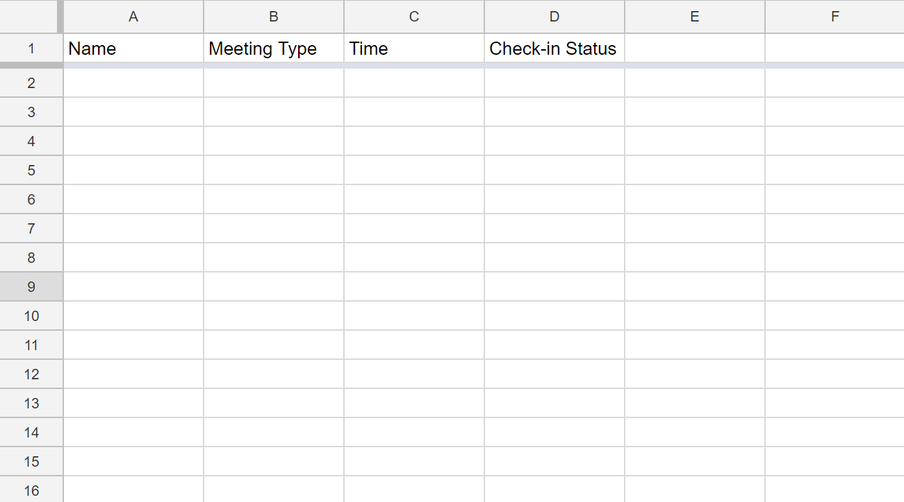

Figure 9.2 - A New Attendance Spreadsheet

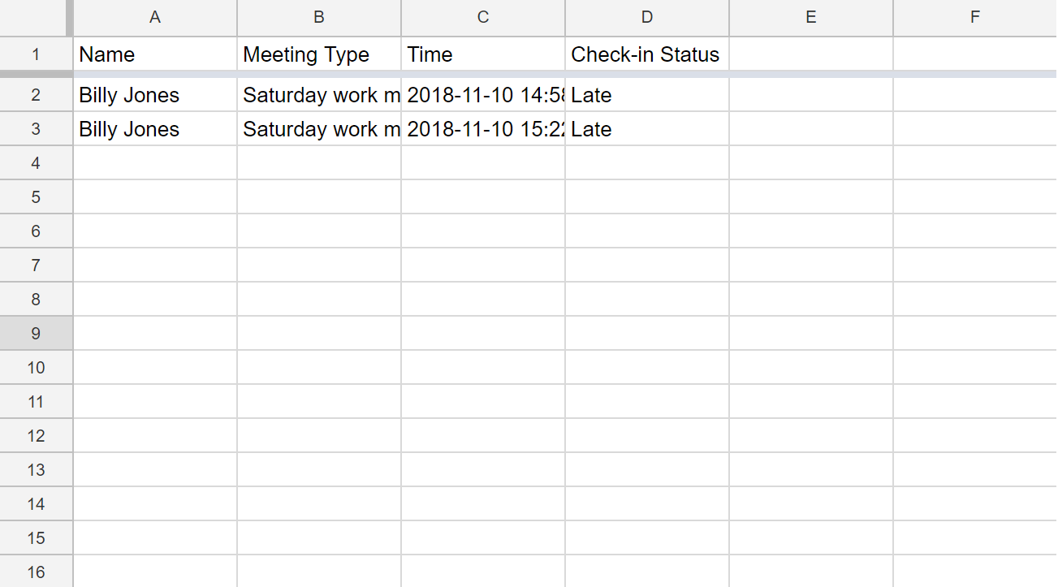

Figure 9.3 - Attendance Spreadsheet with Sample Data

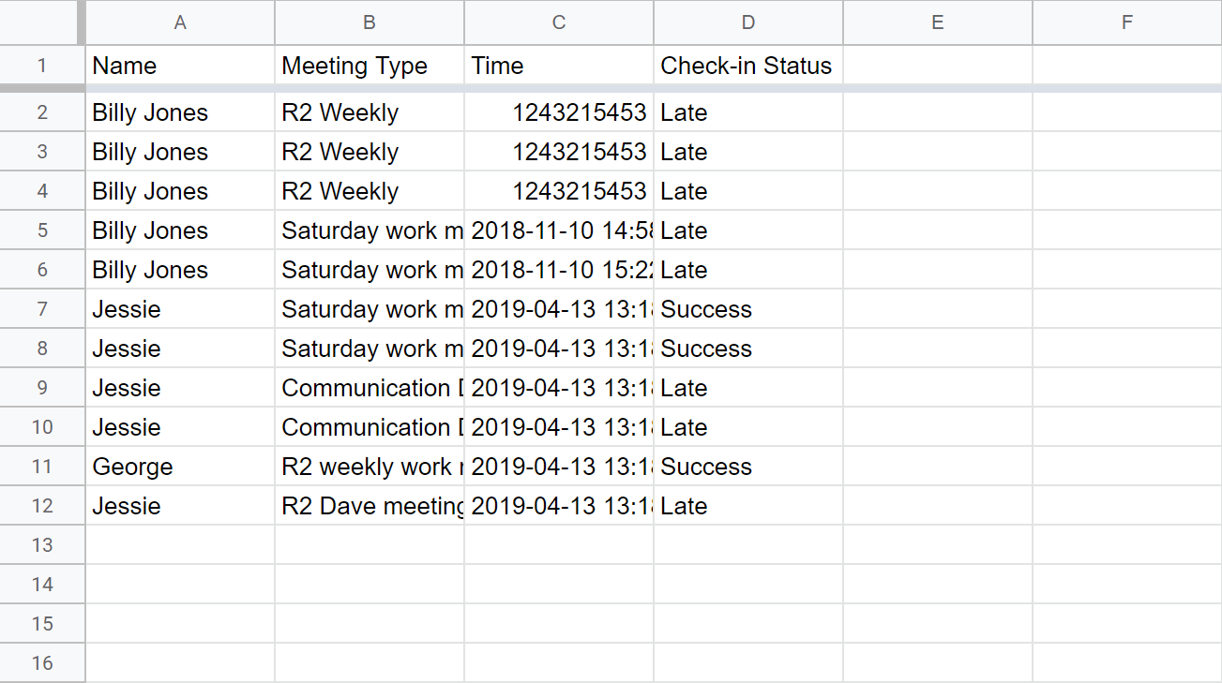

Figure . Spreadsheet with Varied Data Entries

Additionally, the attendance data from a single sheet can be used to generate a pivot table aggregating the data points together. An example is shown in Figure 9.5. This pivot table is generated in a new sheet, of which the name is timestamped to allow users to take snapshots of attendance throughout the year. The table displays total attendance by member (column E) as well as how many meetings in which they were on time, late, etc (cells B3 to C4). Other data is summed up as well, as per the functionality of pivot tables, but to varying degrees of usefulness.

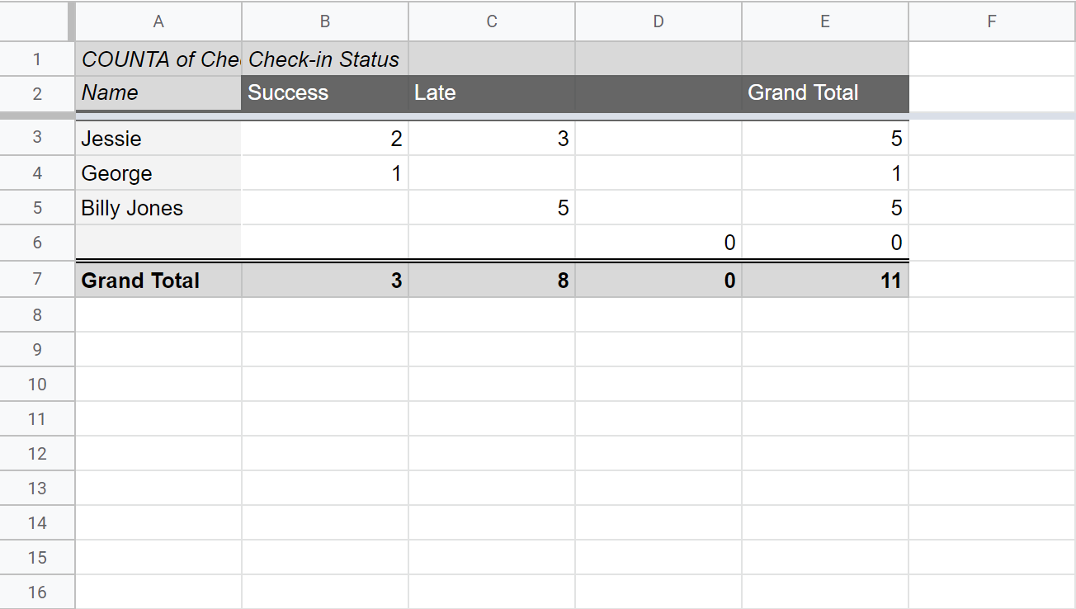

Figure . A Sample Pivot Table

#### /save-face

This endpoint is used for R2 to “learn” the names of new people, that is, matching a name to a new face. Because of the high accuracy of the face_recognition library, we were able to recognize new people with only one image of them, essentially one-shot learning.

The endpoint accepts only POST requests, requiring a form parameter name (the first name of a person) and a multi-part encoded file (the face shot of the person). Depending on the outcome, the endpoint will return two different HTTP codes:

200: if the person is not contained in the face dataset

422: if the person was already in the dataset

To determine whether face is in the dataset, we utilized the face_recognition library. If no match was found, the program proceeded. Otherwise, it would return early.

One point of concern was that many people may have the same names; this was due to how the *face_recognition* library requires that all images be named with the name of the person in the image. To avoid collisions in file naming, we took the SHA-256 hash of the uploaded image and prepended it to the name of the final file. For example, the image for someone named Bob may be 0000000000000000000000000000000000000000000000000000000000000000Bob.jpg. If the file needed to be accessed to acquire the person’s name, the first 64 characters (length of the hash) could be truncated, allowing for compatibility with existing code.

An alternative counter-based approach was also proposed that would consecutively prepend a number to the filename based on the number of other people with the same name. The issue with this approach was the need to store a list of existing names and the need to constantly update it. The hashing approach doesn’t require lookups and updates and is faster as a result.

After the new image is saved, the face encodings used by the program were updated.

#### Database

We complete the check-in conditions and database design. We use a Json database to record the time for Weekly Work Meeting, Saturday Work Meeting, Dave Meeting for team R2, Mini-bot, and communication, and the team each Cornell Cups members are currently in. When the facial recognition returns the person’s name, the name and the system’s current time will be used in identifying the check-in status and the meeting type for this person. Then the result of the person’s name, meeting type, and the check-in status will be returned as the result. For the NASA competition version of the check-in system, we make a simple version by removing the meeting time conditions. The NASA competition version of check-in system supports simple check-in: if the name returned by the facial recognition is inside the database, aka. this person is in the Cornell Cups, then the system will check this person in.

### GUI

The goal for the GUI is to display the necessary information for all the on-going CS projects, including facial recognition, path planning, object detection, and sentiment analysis. We implemented the GUI in python using an online toolkit called Tkinter. We were initially using Kivy, but since Kivy is more appropriate for dynamic GUI updates instead of static display of information, we then abandoned this tool and turned to Tkinter to create several tabs for the GUI with certain elements involving UI.

#### GUI Design and Implementation

The design of the GUI consists of four tabs: general information, visual image, data streaming, sign up, and program exit.

The general information consists of the symbol of Cornell Cup Robotics, a greeting message for the visitors, and a brief introduction to what we are doing. We aligned the messages to the left instead of the default aligning in the center, and we tested it on the raspberry pi touchscreen to make sure that the message’s fonts and sizes can fit perfectly.

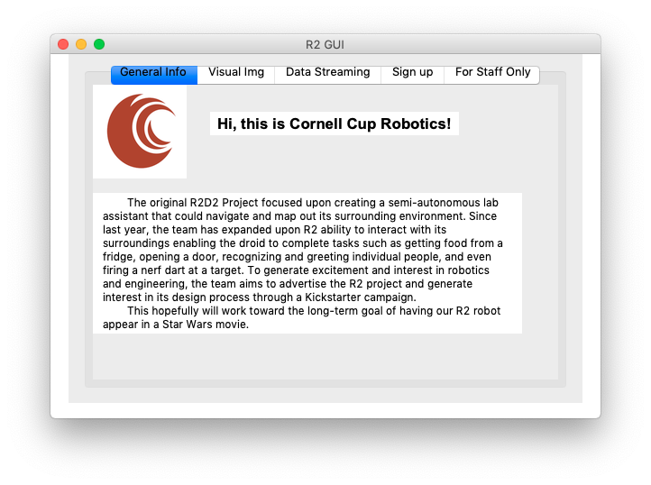

Figure 9.6 R2 Tablet GUI General Info Tab

The visual image part uses streaming to show the view of R2 on the screen. We bought another USB camera to avoid the problem in accessing the streaming data from two different programs, which is not supported in pi. We use the WebcamVideoStream package to display the streaming on the tab page.

The Data streaming part shows all the outputs of data from all the sub-projects. All necessary information, outputs of all the projects are recorded in the local files stored in the local directories, and the data streaming part update all the information in the local file every 1 second by running a separate thread, to make the information concurrent to the rest of the programs.

The local file dependencies is listed as follows:

The Voice Recognition Text fetches VoiceRecognitionText.txt

The Sentiment Analysis Output fetches SentimentAnalysisOutput.txt

The Facial Recognition Photo fetches cropped.png

The Object Detection Result fetches backimage.png

The Facial Recognition Result fetches FacialRecognitionResult.txt

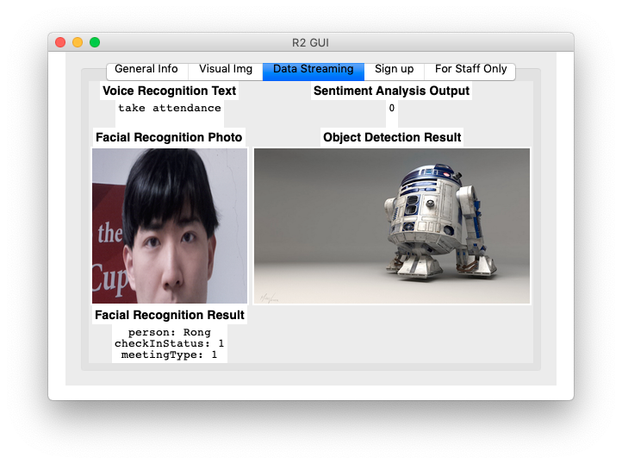

Figure 9.7 R2 Tablet GUI Data Streaming Tab

The signing up page allow the visitors to join the mailing list of Cup Robotics and receives up-to-date information of this project team. A pre-installed virtual keyboard will be evoked during the use of the sign-in page, and user will use the virtual keyboard to input their email. The way signing up tab is implemented is by using textfield and button, and once the button is pressed, the email in the textfield is saved to a local txt file. The content of the textfield will also be cleared after the pressing button event is detected.

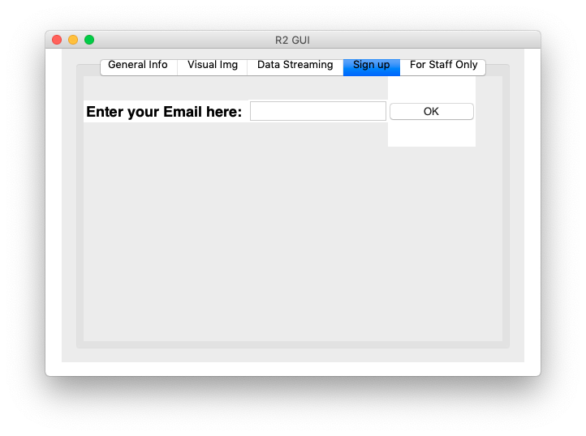

Figure 9.8 R2 Tablet GUI Sign Up Tab

We use the pre-installed virtual keyboard on Raspberry pi for text input. The installation command and steps for invoking and enabling the keyboard is listed in the Code Appendix part below.

The program exit is for safely quitting the GUI app. The tab name is designed as “Staff Only” for preventing users to accidently quit the program.

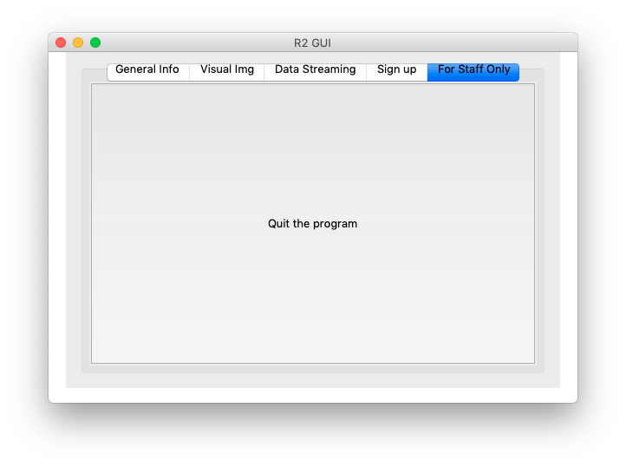

Figure 9.9 R2 Tablet GUI Quit Tab

## Issues

We initially wished to implement with web socket, since it allows two-way communication and the response is generally real-time. This method involved the client sending raw image data to the server. Some concerns over this approach included the feasibility of differentiating between different types of requests seeking different types of responses. This concern was due to members of the Nerf Blaster team requesting to utilize the facial recognition capabilities of this project to integrate target tracking (see ‎5.5). As such, a method to recognize a face’s position in a frame would need to be implemented as well. Because a solution wasn’t proposed that could utilize a web-socket-based server, it was decided that a web server approach may be more practical.

Another problem is that the latency of sending robot the signal and getting back the result. Taking 6 to 8 second on average, the program takes longer than we expected in the beginning of our implementation process. The latency is generally made up by the time of taking a photo, sending a high-definition photo, run the facial recognition library, and send back the json result.

On some occasions, multiple faces can be detected in an image. If this is the case, an arbitrary face is picked out and sent to the server. As such, the system may appear to be computing an incorrect result. The solution to this would be to require only the person of interest to remain in the field of view of the camera.

## Next Steps

Other applications of facial recognition on R2 to be updated.

## Code Appendix

The client part of the software is on <https://github.com/cornell-cup/r2-facial_recognition_client>

The server part of the software is on <https://github.com/cornell-cup/r2-facial_recognition_server>

The GUI part of the software is on https://github.com/cornell-cup/r2-tablet_GUI

Face_recognition package: <https://pypi.org/project/face_recognition/>

Virtual Keyboard on Rasberry Pi Installation commands:

*sudo apt-get update*

*sudo apt-get upgrade*

*sudo apt-get install matchbox-keyboard*

*sudo reboot*

Invoke the virtual keyboard : *Menu >> Accessories >> Keyboard*

Enable the display: *Menu >> Preferences >> Main Menu Editor*

### Google Sheets Authentication Guides

For the user account method: <https://developers.google.com/api-client-library/python/auth/installed-app>

For the service account method: <https://developers.google.com/api-client-library/python/auth/web-app>

# Speech and Sentiment Analysis

## Goals and Objectives

The purpose of this project is to make R2 able to react to sentiment in the user’s speech. R2 should react either negatively, by playing a sad noise on its speaker, or positively, by playing a happy sound on its speaker, based on the sentiment of the user’s speech. In the Fall 2018 semester, we were able to complete the building of a minimum viable product of our voice recognition and sentiment analysis project to be implemented on R2 as the main interface between user and machine.

The goals and objectives for this semester were three-fold. Each are described below.

The first desired improvement we wanted to make this semester was to take advantage of the direction of arrival capability the ReSpeaker Mic Array v2.0 has to determine sound localization - the direction at which a user is speaking from. Additional objectives we had for taking advantage of the microphone’s capabilities include finding both software and hardware solutions to improving the microphone’s ability to convert speech into text.

Another objective for this semester was finding a variety of sentiment analysis algorithms and APIs outside of NLTK, which was used last semester, to increase the accuracy of sentiment being outputted by R2 when a user speaks into it. APIs like Keras and IBM Watson were tested and implemented throughout the semester and tested for its viability for use in a setting such as the Cornell Cup competition held May 3 - 4 at Cape Canaveral, FL.

The final objective of the project this semester was to expand upon the front end of the program designed in the semester prior to run a set of commands for the Cornell Cup showcase. A major goal of this project was to create a seamless user interface so people that interact with R2 can speak anything into it, whether it be a command or some sentimental thought, and expect R2 react appropriately.

## Microphone Improvement

### Timeline

Going in to this semester, source localization and speech recognition accuracy were areas of concern. Along with searching for more sophisticated API for speech recognition and sentiment analysis, we looked into different microphones and source localization software in order to address these issues. Theoretically, a super cardioid microphone will have better localization for people speaking directly in front of R2, so up until March 2nd we looked into creating a super cardioid audio configuration. To this end, we explored ODAS, a software library for sound source localization and post filtering audio data. While ODAS did hold some promise for analyzing source localization and setting up a super cardioid configuration, it ultimately proved too CPU intensive. We also decided to stick with our current microphone since it has support for Direction of Arrival, Keyword Search, and a large range in comparison to a lot of the super cardioid microphones for the Pi.

Our current microphone can also do hot word detection using the Snowboy API. From March 2nd to March 16th we looked into setting up hot word detection for the phrases “R2” and “Hey R2” using the Snowboy API. We found that while it is possible to register “R2” as a hot word, it would take an infeasible amount of time to collect the number and variety of samples for training data needed to recognize “R2” in a setting like NASA.

From March 2nd to April 27th, we worked on calculating the angular direction of arrival from voice commands, the motivation being that a rough estimate of the direction of arrival would help with rotating R2’s head and a precise direction of arrival could help R2 find people who call for it. ReSpeaker advertises that the microphone comes with a built in DOA algorithm, and while this is true, we found that it was only accurate for some phrases and at close proximity. We tried making our own DOA algorithm by feeding the raw audio data into a Generalized Cross Correlation Phase Transform (GCC-PHAT) to calculate time delay of arrival between a signal and a reference signal (this can be done with just the ReSpeaker since it has 4 channels) and using this time delay to estimate the angle of arrival. Unfortunately, we found that this method didn’t improve much upon the built in DOA. Upon further research, we found that a set up of two to three microphones is necessary to get a precise DOA using the GCC-PHAT method.

For the remainder of the time, we focused on integration with the other CS subteams, ECE and MECHE teams. At this point we were primarily concerned with recognizing voice commands by factoring out common misinterpretations to voice prompts (i.e. if the microphone recognizes “hey are too” the speaker likely meant “hey R2”).

### Implementation

In order to obtain the desired direction of arrival (DOA) data, the following steps were taken:

1. Get the raw audio data from a voice prompt using Python SpeechRecognition library’s get_raw_data with a sampling rate of 16000 and a sample width of 2 bytes.
2. Convert the raw audio data to a numpy array using numpy frombuffer with data type int16 (since each sample is 2 bytes wide).
3. Break the array of samples into chunks of 2048 frames (8192 samples) each stored in numpy arrays.
4. Run the GCC-PHAT algorithm on each chunk and use the time delays to estimate direction of arrival for each chunk.
5. Average the direction of arrival estimates of the separate chunks. (optionally: remove outliers by removing chunks that have a direction +/- 60 degrees over the average and recalculate the average)

As previously mentioned, we estimated the direction of arrival of voice prompts using the Generalized Cross Correlation Phase Transform (GCC-PHAT) method. GCC-PHAT is a common algorithm in signal processing for estimating the time delay between a signal against a reference signal from a stream of bytes representing audio data. In order to use this method, we took the raw audio data from voice prompts and broke it up into chunks to simulate a pyaudio stream (we couldn’t use a pyaudio stream directly since the libraries we are using for speech recognition use a pyaudio stream). A chunk is a predetermined amount of frames and a frame represents one audio sample for each channel, so in our case a frame was 4 samples since our microphone has 4 channels. After some testing, we decided to use a chunk size of 2048 samples, which translates to 8192 bytes from the raw audio data. Running the GCC-PHAT algorithm on a chunk gives time delays between samples at different channels on the microphone. We then use these time delays to estimate the angle of arrival of that chunk of audio data (Note: the calculations on the time delays come from the Mic_array github repo). We then take the average of the directions from all the chunks in a given signal.

### Testing

We first did some preliminary testing of the microphone on the lab bench before testing it on R2’s head. In our preliminary testing, we were primarily concerned with how speech recognition and DOA performed for phrases that we recognize as commands and how they performed when we varied the primary sound source location. We tested the voice commands that R2 was supposed to recognize, making sure to vary position often so that we could get an estimate of our microphone’s effective range. During final integration, we performed the same tests that we did during preliminary testing but with the microphone mounted on to R2.

## Sentiment Analysis Algorithm Improvement

### Timeline

The main goal going into the semester was to switch from the NLTK bag-of-words sentiment analysis model to a more accurate neural network model. Initially, we decided to use Keras on top of Tensorflow since it allowed us to develop in Python and had clear documentation on the website. Nonetheless, we ended up going with IBM’s Watson Sentiment Analysis algorithm since the Keras model was unable to address certain issues we had with the NLTK model.

Between the beginning of the semester and March 2, we spent time learning about machine learning using Udacity (<https://www.udacity.com/course/intro-to-machine-learning--ud120>) and books from the Cornell library (Machine Learning: a probabilistic perspective, Machine Learning: A Practical Approach on the Statistical Learning Theory). The focus was on making sure we understood how training a neural network works so that implementing one in Keras would be easier to do. Once we had a good idea of what to do, then came the actual implementation.

Between March 2 and March 9, we spent time making the Keras model and testing it against the NLTK model with a set of sentences (look under Testing for more details). However, we wanted to see if there was a better approach we could take, such as using an API to perform sentiment analysis.

Between March 16 and April 13, we tried out IBM’s Watson API for sentiment analysis and determined that it was a better choice to use than NLTK or Keras.

Between April 13 and the end of the semester, we worked on integrating the sentiment analysis model into the main program and then spent time further working on the main program to appropriately respond to input. Details can be found under main program/user interface changes.

### Implementation

To create and find the ideal sentiment analysis model, the following links were extremely helpful:

* <https://visualstudiomagazine.com/articles/2018/11/01/sentiment-analysis-using-keras.aspx>
* <https://towardsdatascience.com/machine-learning-word-embedding-sentiment-classification-using-keras-b83c28087456>
* <https://medium.com/@thoszymkowiak/how-to-implement-sentiment-analysis-using-word-embedding-and-convolutional-neural-networks-on-keras-163197aef623>
* <https://keras.io/>
* <https://www.ibm.com/watson/about>

The first link provided was helpful in building the core Keras model while the other links helped in understanding how the model worked. Much of the code was drawn from the first link because it provided a convenient way of storing and testing the model once it was done training on the IMDB movie set pre supplied with Keras. However, we experimented with the model’s settings such as what classifier to use, and how many epochs to run the model for. We printed the accuracy of the model over time to the console to see if it was improving over time. We had to be careful not to overtrain the model (which wouldn’t be detected by the printed accuracy since that was dependent on the dataset itself not new data) which would happen if we ran too many epochs. After the final model was created, it needed to be tested against the NLTK model to make sure that it was in fact more accurate. The testing procedure is described in the below section on testing.

Ultimately, in the process of testing, we determined that the issues we had with the NLTK model, namely not being able to detect negation and negative sentiment that well, weren’t addressed adequately enough by the Keras model (albeit slightly better than NLTK). We wanted to see if there was an API we could use instead which would address the difficulties in the NLTK and Keras models. We decided on using IBM’s Watson API for sentiment analysis which worked wonderfully. Although it wasn’t perfect at identifying certain sentences nor completely addressing the weaknesses of the NLTK and Keras models (which is due in part to the fact that sentiment analysis is a developing field and isn’t clear cut - for example humans often disagree about whether certain ideas or thoughts are positive, negative, or neutral), testing revealed that it was our best option and we decided to stick to choosing Watson as our sentiment analysis model. Because Watson returns JSON in response to requests, we parsed through the JSON to obtain the sentiment analysis value (on a scale from -1 to 1, -1 being negative, 0 being neutral, 1 being positive). We had to do this since Watson also provides information such as emotion, keywords, and tone within a sentence.

Around early April, we felt confident in the sentiment analysis model we developed and decided to focus on adding it to the code we implemented in the fall. We then spent the rest of the time working on the main program and ensuring that R2 reacted appropriately to input. Additional information is found under the section titled “Main Program/User Interface Changes”.

### Testing

To compare the NLTK sentiment analysis model from Fall 2018 against the newly implemented Keras model, we tested if the sentiment analysis outputs matched up with what we expected. For example, for the sentence “My day has not been so great”, we tested if the algorithms output a negative sentiment value (in this case, none of the models correctly identified the sentence as being negative). However, later testing on a selection of sentences (which can be found on the spreadsheet “Sentiment Data for MVP” in the Cornell Cup/C2/R2/Speech and Sentiment Analysis google drive folder) revealed that the Keras model performed noticeably better than both NLTK. Nonetheless, there were still sentences that couldn’t be correctly identified by any of the models. To address this issue, we decided to employ IBM’s Watson Sentiment Analysis API. Fortunately, Watson was even more accurate than the Keras model. After going through the sentences in the spreadsheet and testing out additional sentences, we finally decided to stick to using Watson as our sentiment analysis model. A script for comparing the NLTK and Watson sentiment analysis models, which can be found in the CSVSentences folder under the r2-voice_recognition Cornell Cup GitHub repository as main.py, showed that the Watson model had an accuracy of approximately 77.5% as compared to NLTK’s 61% accuracy. To make sure that these numbers were truly representative of each model respectively, we ran the script on a dataset of 3000 sentences from the UC Irvine Machine Learning Repository (<https://archive.ics.uci.edu/ml/datasets/Sentiment+Labelled+Sentences>). Once testing was completed, the primary goal was to make sure that the Watson model was fully functional in the main program rather than as a standalone model (as it was during the testing phase).

## Main Program/User Interface Changes

### Timeline

Throughout the whole semester, we worked heavily with Systems to determine which use cases needed to be implemented for demonstration in Florida and how those cases would be operated. This involved numerous meetings with the Systems and ECE teams to determine the design and operation of the main program we created.

Between the beginning of this semester and March 2, we spent time looking for an API that enabled our program to perform keyword search within a user’s statement toward R2. The API we ended up choosing, cortical.io, first enabled us to detect if a user wanted R2 to perform a specific command such as waving or grabbing a certain item. Eventually, it also gave us the capability to be flexible in implementing various projects into our code structure that can be easily called upon by a user should they request some specific action to be executed.

Between March 2 and March 16, time was spent implementing cortical.io into the main program to detect keywords a user would say. A text-based input main program was created to test the API’s effectiveness and reliability relative to the program. Then, keywords for each possible way users can ask R2 to perform some action were generated. These keywords were then used to create dictionaries that mapped keywords to executable functions.

Between March 23 and the end of the semester, full integration with the CS, ECE, and Systems subteams were performed. In particular, our program was integrated with a GUI tablet program that displayed a summary of what users have asked and said directly to R2. Systems continued to request the implementation of various skills as the team approached the demonstration day deadline (which we implemented), and, alongside ECE, manipulated our program structure to simplify the implementation process for ECE to interface between the Raspberry PI containing the main program and the Arduinos containing the hardware manipulation code they required to perform some of their demonstration tasks.

### Implementation

To run the program on R2, run both /r2-tablet_GUI/voiceInterface_FINAL.py and /r2-tablet_GUI/tkinterGUI.py in separate terminals by typing *python3 voiceInterface_FINAL.py* in one terminal and *python3 tkinterGUI.py* in another. More information about *tkinterGUI.py* can be found in the Section 9.5.3.

To have R2 pay attention to what one is saying, first input the phrase “hey r2”. Upon hearing a sound confirming that R2 is listening, input your next statement. If the first word uttered in your statement is a verb, then R2 will treat the statement as a command for it to perform some action. From there, R2 will identify keywords in the statement that it can use to determine what type of action it should perform. Otherwise, R2 will react to the statement as if it were in conversation. After this, R2 will wait for someone to say “hey r2” again for it to direct its attention to the user.

As previously mentioned, if the first word uttered in the statement is a verb, then R2 will take the user’s statement to be a command to execute. The NLTK API was used to determine the part of speech of the first word. From there, keywords from the statements were parsed using the cortical.io API to determine what command the user wants R2 to execute. The cortical.io API generates a list of keywords. A sequential loop iterates over these words to determine if there exists a word within the list of keywords that is recognized as a function R2 can execute. The first word that is recognized as an implemented keyword will have its corresponding function executed. Then, R2 waits for the user to speak to it again.

If the first word uttered is not a verb, then R2 takes the user’s statement to be something it should respond to with sound. Again, the NLTK API determines if the first word uttered is not a verb. If it is not a verb, the statement the user utters is passed into the IBM Watson Sentiment Analysis API, where a sentiment number ranging from -1 to +1 is generated. Once that sentiment number is generated, R2 responds with the appropriate sound to the user and then waits for the user to speak to it.

As all of this occurs, the GUI program running behind the main program updates depending on the information it receives from the user to display what R2 hears from the user and to maintain a history of what has been spoken to R2 in previous uses. This transfer of information is performed through VoiceRecognitionText.txt, which records the last phrase the user uttered to R2, and SentimentAnalysisOutput.txt, which recorded the sentiment value of any phrase the user said to R2 – assigning commands a sentiment of 0.0 and other statements a sentiment value based on the value generated by the IBM Watson Sentiment Analysis API.

The procedure described above has been summarized in the flowchart seen below:

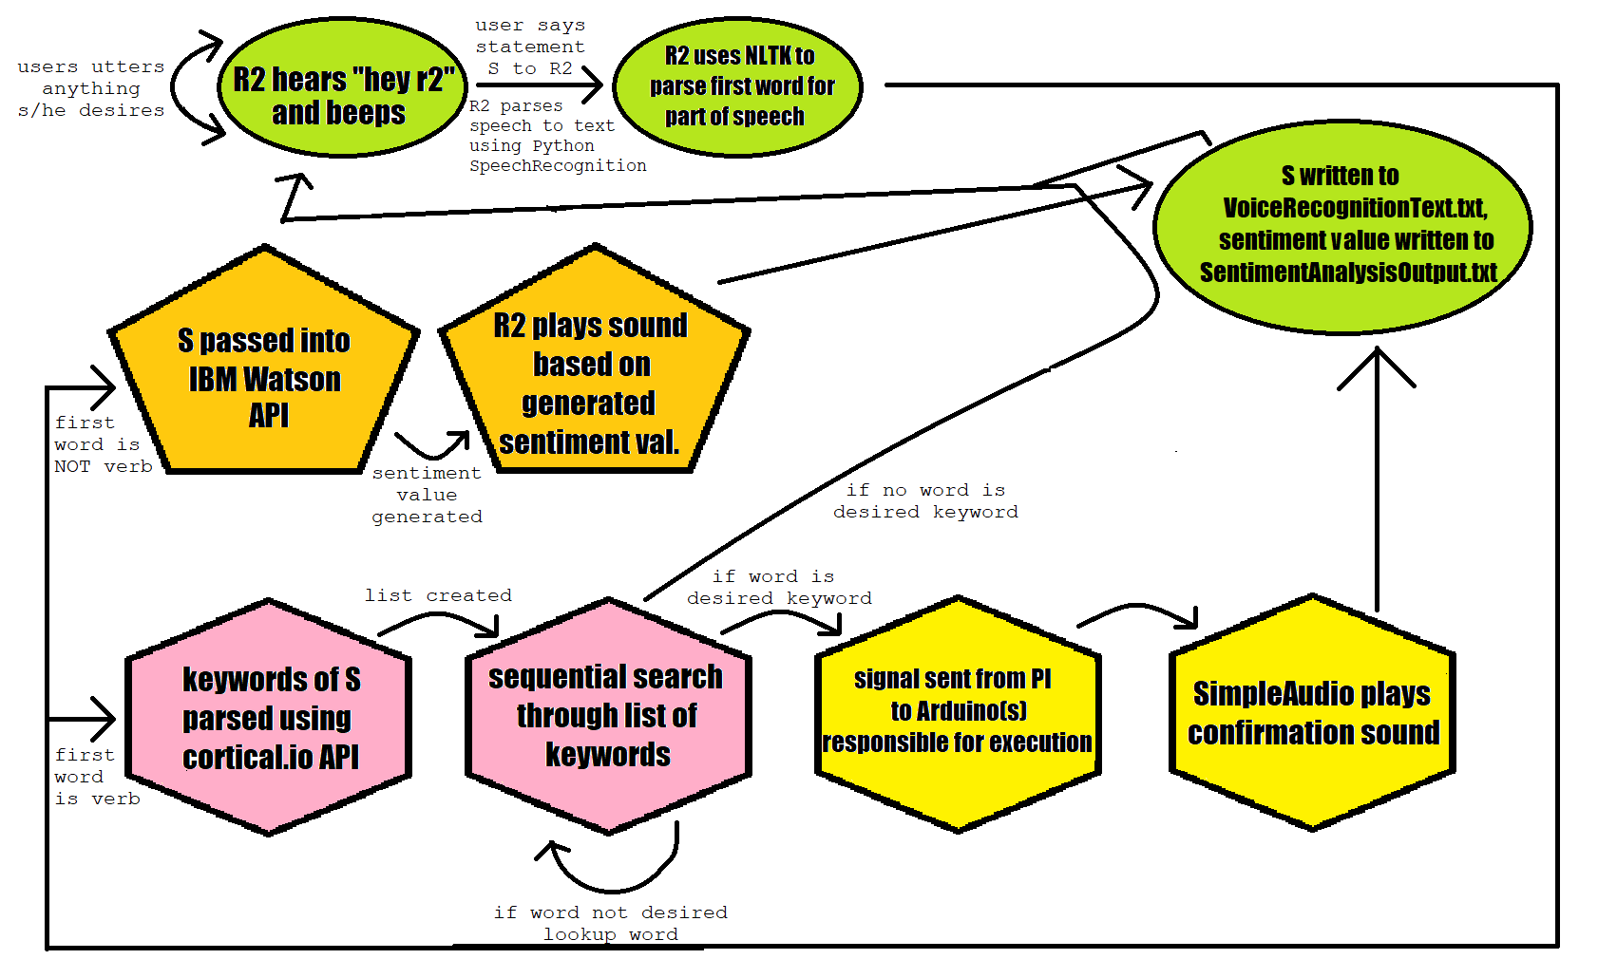

### Testing

Testing of the main program came in three stages. The first stage involved creating a list of keywords whose reference can immediately be used to call upon a respective function to execute (see hexagons). Overall success in this stage of testing was measured in increments. The first success was being able to come up with a list of potential phrases users may utter to R2 when it desired one task to be performed. From there, keywords were generated from each phrase using the coritcal.io API. Some issues that arose in testing include the mis-inclusion of statements that can be used to declare a command, cortical.io not finding any keywords for a particular statement, or cortical.io finding similar or identical keywords for two commands with different intents. Solutions included manually adding statements into the program that map to its respective function without keyword parsing and continued testing with multiple people to increase the number of ways some action can be requested.

The second stage in testing involved creating dictionaries that ensured that whenever a keyword was uttered, that the function paired to it would be called. This stage in testing took the longest because for all keywords, testing needed to be performed to ensure that the function associated with some keyword would be called. Issues that were encountered in this step included finding a solution to ensure that the function corresponding to a keyword would be called at the right time, of which a dispatcher dictionary was instantiated to help facilitate such intent.

All stages above used a text-based input system. The last stage in testing involved in integration of projects into the main program using voice recognition. It was in this stage that everyone’s work was tested to see if communications between the RaspberryPI and Arduinos responsible for executing commands were being executed or not. Issues encountered during this procedure included using too much of the PI’s memory, to which new SD cards with larger memory were flashed and used to help stymie this issue. In addition, testing at this stage also involved integrating the voice-based user recognition system with the GUI to ensure that each user intent was being recorded and displayed in real-time.

## Next Steps

This semester, progress was made in terms of making improvements to the system currently in place. Going forward, we will be looking to using our existing systems to improve what we have already built. The goal will be to further integrate voice recognition into the system by having it be the main catalyst for path planning and having R2 follow a user based on his/her direction of speech, in addition to creating a system (either through software or through hardware) that will continue to improve the accuracy at which speech is translated into text to be parsed. Goals for sentiment analysis, as mentioned in the Fall 2018 Documentation, will be to use existing systems on R2 such as its head and its arms to create a more interactive sentiment analysis algorithm that can be used to make R2 seem more human-like. The facial recognition software built for R2 can also help to recognize human emotions such as happiness, anger, or sarcasm, which can help improve the accuracy of sentiment analysis.

## Code Appendix

All files to run the software side of R2 has been placed here: <https://github.com/cornell-cup/r2-tablet_GUI>.

The files that were created for this project is voiceInterface_FINAL.py and voiceRecognitionTextTest.py.

# Object Detection

## Goals and Objective

The goal of the objection detection project is to be able to classify and locate an object from an image capture to guide R2 around the lab. Our eventual goal is to create a pipeline that can train a model to recognize objects in the lab given a set of training data, i.e. images with classification and segmentation labels standardized in COCO format ([http://cocodataset.org/#overview](http://cocodataset.org/)).

By having standardized training file in COCO format, we can utilize many established frameworks that can train a model with custom files and hyperparameters, such as Mask-RCNN (<https://arxiv.org/abs/1703.06870>) , and SNIPER (<https://arxiv.org/abs/1805.09300>). We will be able to tune the models specifically for the lab environment with strategies such as OHEM (online hard example mining) and verify the classification result with QR code/AprilTags.

## Design

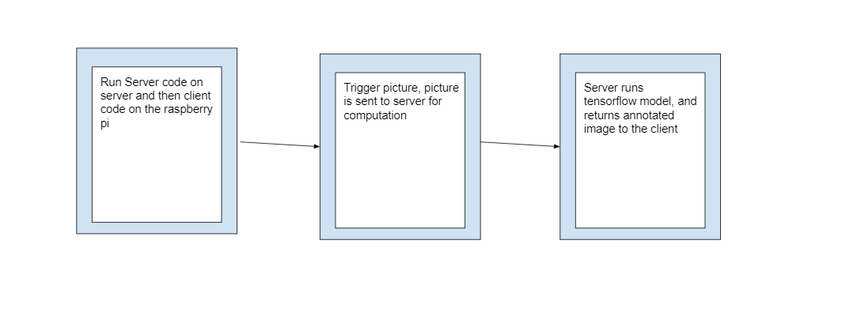

The general design of our code is a general server client where the client represents the Pi and the server does the actual computation. The client takes a snapshot of the image which is sent over to the server. The server proceeds to run the object detection algorithm with GPU acceleration. We are currently using a pretrained model, Faster RCNN NAS model. This model can detect a wide range of objects with high accuracy. The model can be found at http://download.tensorflow.org/models/object_detection/faster_rcnn_nas_coco_2018_01_28.tar.gz.

We have also experimented with other types of models such as a model that classifies rock, paper, scissor. We used the code from <https://github.com/aneesahmedpro/rock-paper-scissor-vision> to train the model. This never yielded accurate enough results even as we added more images with more noise, due to the low representational capacity of their CNN model.

## Timeline

1. January-February: Configuring dependencies, getting our code to a place it could run in conjunction with the pi.
2. Late February- March: Testing code, testing rock-paper-scissors algorithms that were eventually discarded.
3. March-April: Switching hardware. We moved our server on to a desktop in the hopes of finding a more usable GPU, however this proved insufficient, and we ended up purchasing a new one that cut our processing time by a factor of 4.
4. April-May: worked on sending data back to the pi and integrating with the main loop.

## Implementation Details

Currently, we are using Tensorflow’s API to perform inference on an image with an out-of-the-box object detection and segmentation model from Model Zoo as explained above, but we plan to change this to our own model in the future semesters.

The inference procedure is achieved by an inference script test.py (see GitHub repository for more information) that outputs the classification of objects detected in the image and their corresponding bounding box coordinates, given a path to a frozen detection graph/model in pb format and a directory of images. The script will start a TensorFlow session which will convert the images to NumPy arrays and make predictions. We have also included the option to visualize the results (bounding boxes and labels) as a popup window in the terminal to make evaluating the accuracy easier.

We implemented a server-client model to facilitate communication between R2/Raspberry Pi and our server computer. In our design, the client side would be the Pi, which would take a picture of its view with the camera when prompted (we can likely transfer this to using a button control on an Xbox controller in the future) and send the picture over a web socket immediately.

The server will stay open for connection requests and receive the image sent to it. The server will run inference on an image in real time after it’s received and output the visualization and prediction. This is then sent back the client pi, which saves it.

In order to run our program, we require basic python dependencies for the client side and additional TensorFlow libraries for the server side. First make sure that you have installed libraries PIL, NumPy and TensorFlow. These libraries are necessary to do much of the image recognition processes. In order to run the program just run command “python3 server.py” . From the client side you want to connect to the port number designated by the server side.

A summary of what to do:

1.) Clone the repository from <https://github.com/cornell-cup/r2-object_detection>

2.) Install libraries PIL and NumPy with commands pip3 install ….

3.) Install tensorflow with “pip install tensorflow-gpu”; we suggest using virtual environment to run the tensorflow inference, due to many possible version conflicts.

Instructions for installing and starting virtualenv:

1. pip install virtualenv
2. virtualenv my_project (this create a folder with python executables in current directory)
3. virtualenv –p /usr/bin/python2.7 my_project (this is optional and can be used to change the Python interpreter to a specific versio
4. source my_project/bin/activate
5. Deactivate (shuts down virtualenv when you are done working)

Alternatively, install Anaconda, create a virtual environment within it, and then use “active <virtual environment name> to access it, and conda install tensorflow-gpu. This will help deal with system compatibility, dependency and versioning issues.

4.) Clone the tensorflow models repository containing inference API: pip

<https://github.com/tensorflow/models>

5.) Place the server.py and test.py script from r2 object detection repository in

models/research/object_detection folder; the scripts can only be run from there due to imports that are dependent on the current pwd. For the current model, use server2

3.) Run the server side with “python3 server2.py #port” on one laptop, #port should designate a usable port number

4.) Run the client side with “python3 piimages.py #IP of server #port” on the pi, #port should be the same port number that is specified by the client.

5.) When the prompt says to press enter to take a picture, do so .

6.) The server has received the image and will proceed to perform inference, the image with bounding boxes will show up in a pop-up window from the terminal,

7.) The server will send the image back to the pi, where it will be saved.

After executing the program with the above photo, the below picture with bounding box

prediction and estimated probability will appear in a pop-up window.

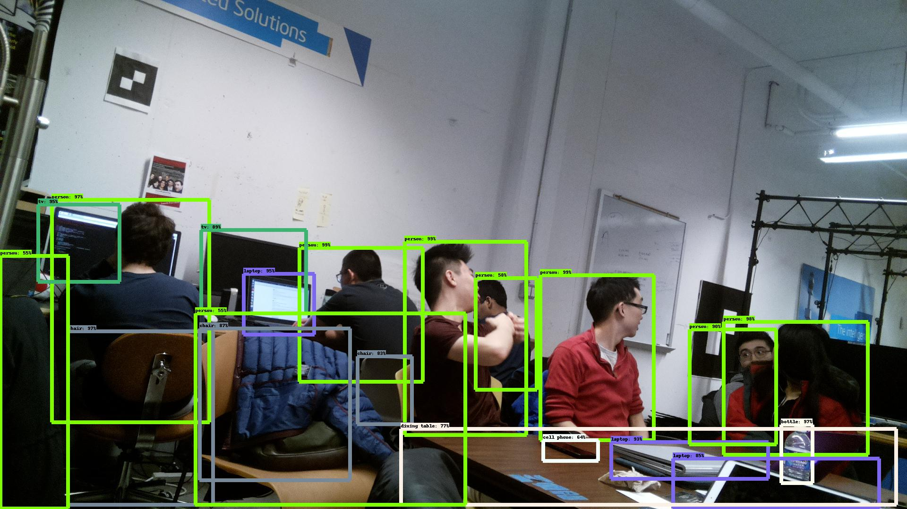

## Issues

Most of the roadblocks issues we had this semester was optimizing the speed for inference and training an accurate model. This semester, we have developed a streamlined pipeline for server-client communication fairly quickly and spent most of our time optimizing the speed of inference. We started with a baseline of ~ 5 minutes on a Mac, which was attributed to the CPU only computational support and redundancy in code. After refactoring the code to initialize inference environment at startup and saving extra import time, the speed wasn’t improved too much. So we decided to add GPU acceleration trying to match the benchmark speed of ~3 seconds we found online here: <https://medium.com/@madhawavidanapathirana/real-time-human-detection-in-computer-vision-part-2-c7eda27115c6>. They have 16 GB Memory and nVidia Geforce GTX 1060 6GB VGA. We purchased GTX 1070 which should outperform GTX 1060, and there was a lot of compatibility issue with the server computer we were using that was quite outdated, so we had to spend a lot of time finding cuDNN and cuda versions that were compatible and manually installed them. After the installation, the speed improvement still wasn’t ideal and we could only achieve a runtime at ~25 seconds per image, due to the loading of cuBLAS which takes almost all of the time while the inference computation is almost instant. We attributed the slow loading to the memory hardware of the computer as we have noticed surges in use of memory while running.

We also had problems with the accuracy of the Rock-Paper-Scissor model we trained using a structure from github as described above; this problem is attributed to the low representational capacity of the model, and we should be able to either train with a more sophisticated model or come up with our own in future semesters to achieve better accuracy.

## 10.6 Next Steps

Our main next step for the semester is to figure out what exactly our use case should be. Our ultimate use case was simply showing an annotated image after the model ran that was sent back to the pi. We need to better integrate our functions with the main code loop, and then figure out how to transmit position data back and forth between the server and the robot. Ideally, we would also upgrade our hardware to something resembling a Google Coral development board, which is specifically designed for running inference locally, removing the need for a server and thus simplifying our robot overall. In the future, we could also work on algorithms for calculating a z position for objects we detect, working to identify specific instances of objects, integrating QR codes and more. However, beyond this, we need to know specifically what our robot can do and what it needs from our team to do it. We could also revisit rock-paper-scissors in a more controlled scenario, possibly with a specific light source and green background.

## 10.7 Code Appendix

Github Repository: <https://github.com/cornell-cup/r2-object_detection>

11 Low Battery Detection and Wireless Charging

11.1 Objective

To create a hardware interface which can help in monitoring battery status of the R2 bot; And trigger appropriate events when the battery gets low. In our case that event will be enabling wireless charging circuit.

11.2 Background

11.2.1 Low Battery Detection

Detecting low battery is more of a safety feature than a functionality. If R2’s battery voltage gets below a certain point, then it can damage some components on R2. Previously, the only way to detect low battery was to manually take out the battery, check its status and charge if need be. Adding this feature into R2 gives a level of autonomy including using vision to identify where we want R2 to go and charge itself.

11.2.2 Wireless Charging

As part of R2’s cool features, we want R2 to charge itself autonomously. To make R2 connect itself to a socket is difficult. If R2 were to connect itself in a socket, it would require a high level of kinematics combined with object detection and localization to find a socket and connect into it. To save ourselves some time and effort, we opted for wireless charging.

11.3 High level design

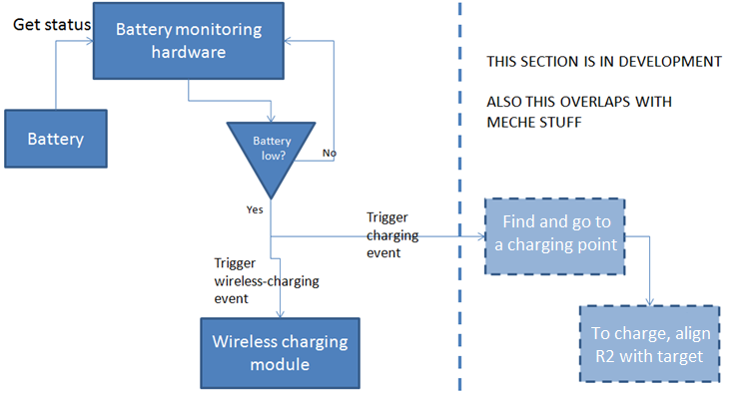

Figure : High level design for Low Battery Detection and Wireless Charging

11.4 Initial Research

11.4.1 Battery Voltage Detection

Some research went into finding various ways to detect battery status. In the current market, there are 3 dominant ways through which we can check status of a battery

* Coulomb Counting – This a common method used in our laptops and mobile phones to maintain our battery status. Briefly speaking, this method checks the amount of charge leaving or entering from a socket. Although it sounds simple, but this method is inefficient because when device/batteries get old they do not charge with the same speed. For example, when our mobile phones get old, they discharge very fast even though they show 100%. It is because as per Coulomb counting, the battery charged but in reality, it is still partially discharged.
* Electrolyte Density – We can measure a battery’s electrolyte density by adding a sensor inside it; This density can directly be mapped to a voltage value. This method is very hard to implement and hence is not a candidate for R2.
* Zener Diode – A Zener diode is a simple electrical component that has a cutoff voltage such that it only conducts when voltage across it is more than its cutoff. But in our case, we will use a Zener Diode in a reverse manner. We will detect when the voltage across a Zener diode has reached below its cutoff level; then trigger an event which in our case will be turning on wireless charging.

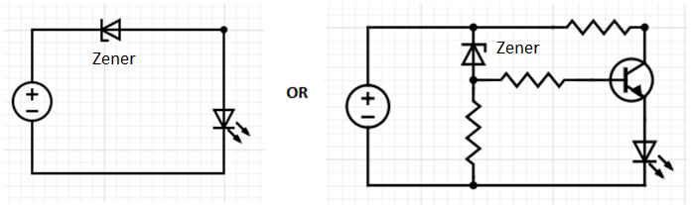

Figure X: In these circuits, LED will only turn on if voltage is more than the cutoff voltage of Zener Diode

11.4.2 Wireless Charging Module

The main concern of integrating wireless charging with R2 was that whether this module will be sensitive to magnetic field or can create a magnetic field that can cause some noise in the circuit. In this respect, the following observations were noted -

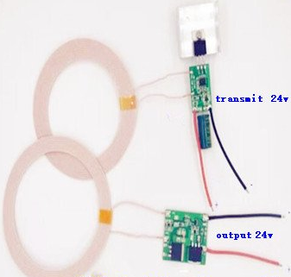

Figure X: 24V Wireless Charging Module

* The 2 coils, one being a transmitter and other being a receiver, must be aligned together within the range of 3cms to 10cms. This also means that the 2 coils cannot come closer than 3cms. The transmitter will be connected to a power source, to charge R2. The receiver will be connected to R2 battery, that will enable charging when R2 detects low battery.
* The voltage remains constant up to 8cms of distance between transmitter and receiver. This also means that after 8cms the coils will conduct but voltage can be less than what it is supposed to provide.
* Any influence of an external magnet does not affect the working of wireless charging (not widely tested but it is tested up to some extent, and it works). Also, no severe noise was observed due to the wireless charging circuit.
* The alignment of transmitter and receiver need not be 100% correct. So, the alignment shown below works too.

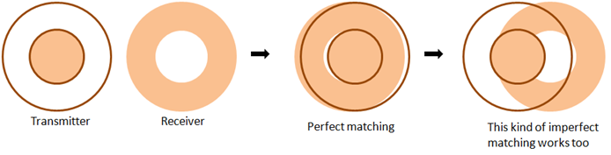

Figure X: Alignment between Transmitter and Receiver

11.5 Final Design and Implementation

The figure below shows the final design of the integration of Low battery circuit with Wireless charging module. The Zener Diode is connected in parallel to the whole R2 system and there is a Relay connected in series with the Zener Diode (cutoff voltage is around 24V for our case). How Relay works is that it has 2 modes i.e. NC (Not Connected) and C (Connected); with one relay control input. When control input is grounded or open, then the C-mode is active and when control input is HIGH, NC-mode is active. So, when voltage is more than or equal to 24V, then the Wireless module in NC-Mode. When voltage gets below 24V, the relay switches to C-Mode and the Wireless Module gets active. Now if the Receiver coil is brought close to a Transmitter Charging Point, it will start conducting.

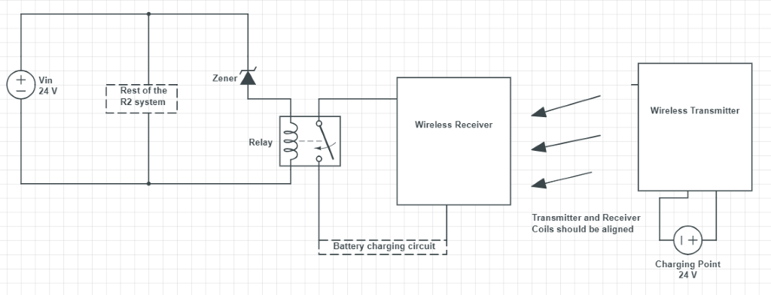

Figure X: Circuit Diagram for Low battery detection and Wireless charging

There are various ways in which we can implement this. So, this is one way in which a simple Relay can do the trick. We can also use a BJT or MOSFET as a switch, to work with the Zener diode to produce the same result.

# 12 R2C Protocol

R2 Communication Protocol (a.k.a R2C) is a protocol that enables a formalized serial communication in R2 architecture. R2 has a Master-Slave configuration, where a PI acts like a Master and various ARDUINOs act like Slaves. This protocol is a request-response schema, where the Master-PI initiate commands for different actions or function and the Slave-Arduino acts and responds to these commands.

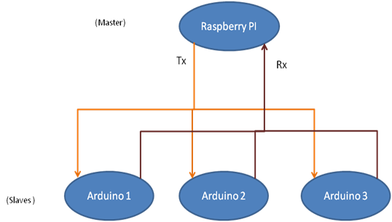

Figure X: System Overview for R2C Protocol

12.1 Protocol data packet schema

The communication between PI and Slaves use RS232 as the physical layer with following packet/data structure.

**Baud Rate:** 115200 bits/sec (Can be changed)

|  |  |  |  |
| --- | --- | --- | --- |
| **Fields** | **Description** | **Size (In Bytes)** | **Hexadecimal Values** |
|  |  |  |  |
| **ADDR** | Address of Master or any Slave | 1 | 0x01 (default value for Master)  Every other Slave will be assigned an address |
| **CMD** | Command to be performed by slave | 2 | Every command can be given a unique number in the system |
| **LEN** | Length of the parameters passed within packet | >=0 | Length of PARAMS |
| **PARAMS** | Parameters relevant to CMD | N | - |
| **CRC** | Checksum | 1 | XOR of ADDR, CMD, LEN & PARAMS |
|  |  |  |  |

Table 3 - R2C packet schema

12.2 Example

Consider a scenario where we command an arm to move to an (x,y,z) position. Now the important thing to note here is that the Slave i.e. Arduino responsible to move the arm, only understands angles like α1, α2 and so on, where α is the angle by which motors on the arm must be rotated. So, it is the responsibility of Master-PI to convert coordinates (x,y,z) into angles. So, this is how the communication looks like between master and slave.

**Request packet sent from Master to Slave**

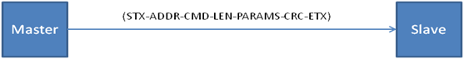

**Note:** STX and ETX are delimiters that is handled by serial protocol itself. We don't have to incorporate that in our packet format.

**Description of packet**

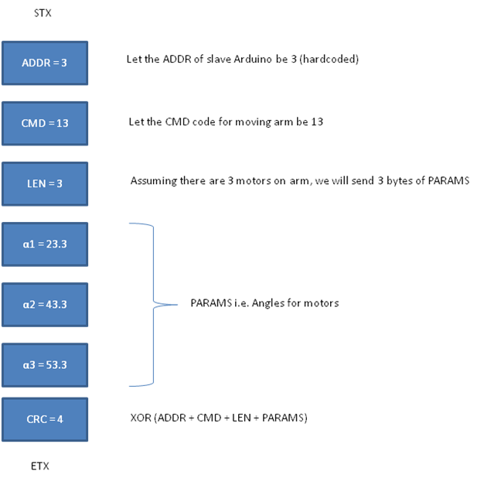

**Response packet sent from Slave to Master, when command was successfully executed.**

**Note:** STX and ETX are delimiters that is handled by serial protocol itself. We don't have to incorporate that in our packet format.

**Description of packet**

Now, let's assume that command was not executed properly, or some error occurred. So, we can produce a response like this -

Hence, we can also define an error table to map errors. This will help us a lot during our development phase, when we debug errors. A sample error table will look like this -

|  |  |  |
| --- | --- | --- |
| **S.No** | **Error Code** | **Error Description** |
|  |  |  |
| 1. | 0xFF | Unknown Error |
| 3. | 0XFE | Invalid Length |
| 3. | 0XFD | Invalid CRC - CRC did not match |
| 4. | 0XFC | Invalid CMD |
| 5. | 0XFB | Invalid PARAMS |
| 6. | 0XFA | Error during initialization |

*Table 4 - R2C sample error table*

12.3 Future Perspective

R2C protocol is designed to be scalable w.r.t. accommodating more commands and error codes in future. It is independent of any transmission medium. It can be used with any serial communication like UART, SPI etc. It can also be scaled to provide connectivity over Ethernet or Cloud for remote execution of actions needed for automating test cases.

13 RPLidar and proximity sensors

On R2, we need 2 types of distance sensors – one that will be responsible for collision detection, localization and path planning, and others that will be integrated with the arm to help detect objects during arm operations.

13.1 RPLidar

We want R2 to know about its surroundings, so Lidar was a clear-cut choice for our application. RPLidar A1M8 was selected and tested. RPLidar is found to be the best suited device for our uses because it is easy to use and is highly accurate. It is capable of reading distance values all-around 360 degree. And if we only want values along a field of view (FOV), then it is very trivial to write a wrapper on RPLidar values to filter out the desired values.

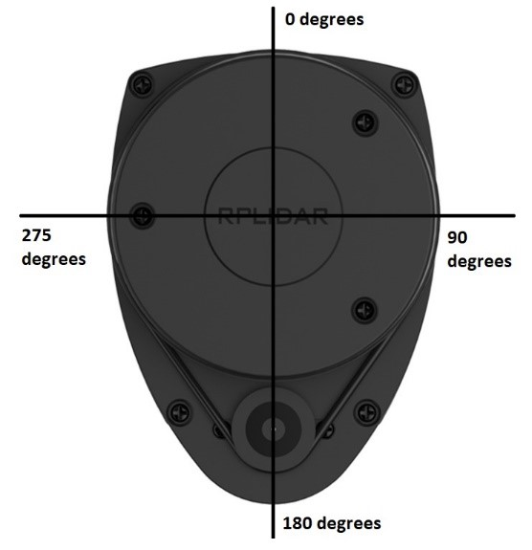

Figure X: Global axis frame for RPLidar

Almost every spec is defined in RPLidar datasheet, but the most important performance spec is that it can only measure within the range of 0.15 meters to 12 meters. This is something that must be taken into consideration before installing RPLidar on R2.

To implement the RPi Lidar, we need to import the RPi Lidar library. In order to make the main program be capable of receiving the data collecting from Lidar. We wrote two UDP program to support.

From the Lidar part, we build a client program. In this program, we implement the Lidar and read the data. Since the Lidar will keep rotating to collect data from different angles. We preprocess the data, once the distance is lower than the threshold that the other team required, this UDP client program will send “0” to the server program. Otherwise, it will send “1” to the server program.

When the server point received the “0” message, it will set the motor speed to 0. This can avoid the robot hit the obstacles when its moving by our voice control function. The code can be found [here](https://github.com/cornell-cup/r2-locomotion-ece/tree/master/HeadLocomotion).

13.2 Lidar vs. distance sensor

Before we choose to use the Lidar sensor, we implement the GP2Y0A21YK0F Sharp IR Analog Distance Sensor. But there are two reasons that we give it up at the end:

First, this distance sensor can only detect the distance from one direction, which is not wide applicable for R2.

Second, if we use the Lidar, once we have the distance data from 360 degrees, we will be able to draw the whole map for the surrounding environment. This can be implemented in the CS team functions to improve the R2.

Thus, we end up with implementing the Lidar sensor.

## 13.2 Other Proximity Sensors

There are a lot of short-range sensors available in the market, but there is a trade-off between cost and accuracy among the available options. For initial testing, some cheap Sharp sensors, both analog and digital, were considered. They were highly unreliable since they produced a lot of incorrect outlier values. They can also produce analog-digital interference in the whole circuit and there is a limitation of the number of these that can be put within one system.

Post that, some industry-grade sensors were considered. Among these, 2 were shortlisted – Adafruit Time-of-Flight and Terabee Multiflex sensors.

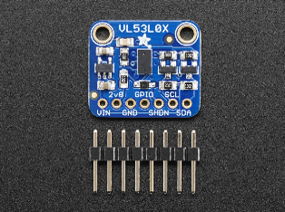 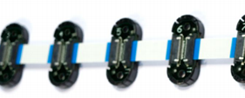

Figure X: Adafruit Time-of-Flight sensor (left) and Terabee multiflex sensors (right)

Adafruit sensor has a range of 0.05 to 1.2 meters, with a FOV of 25 degrees. Terabee sensor has a range of 0.04 to 1.2 meters, with FOV of 20 degrees. They are easy to implement and don’t have any analog-digital interference. All specifications can be found in their respective datasheets.

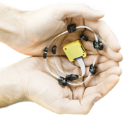 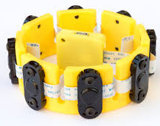

Figure X: Different forms of Terabee multiflex sensors

As far as their application goes, if only a single sensor must be installed then Adafruit sensor comes in handy. But if we want proximity values of a single target from multiple angles or field of view, then Terabee should be the choice because Terabee multiflex is a bus of 8 (or less) sensors (see in the above figure) that can be read in parallel. So, for example, we have a hand-like arm then these sensors can be installed on finger-tips or in other words end-effector tips to read values from different views.

After furthering testing, both Adafruit sensor and Terabee were used in the design of R2. Adafruit was to be implemented near the head camera for proximity values in the near-head area and Terabee multiflex was to be used to detect objects in different positions near R2’s body. As the ranging accuracy of Terabee in related to the ratio of object surface area and the field of view of a single Terabee sensor, two sets of Terabee multiflex (16 sensors in total) and half of the sensors will be placed in the front panel of R2, which is the direction R2 moving forward.

# References:

[1] “GP2Y0A21YK0F Sharp IR Analog Distance Sensor 10-80cm Cable, Arduino Compatible,” Amazon. [Online]. Available: <https://www.amazon.com/GP2Y0A21YK0F-Sharp-Distance-10-80cm-Compatible/dp/B00IMOSEJA>. [Accessed: 01-Dec-2018].

[2] phi-robotics.com. [Online]. Available: [http://www.phi-robotics.com/#/](http://www.phi-robotics.com/). [Accessed: 06-Dec-2018].

[3] “ ESCON Motor Encoder ”, <https://www.maxonmotor.com/medias/sys_master/root/8818448400414/422969-ESCON-70-10-Hardware-Reference-En.pdf> [Accessed: 09-December-2018].

# Communication and Integration

## Overall process

The overall structure of the locomotion system and R2 Protocol is shown as following flow diagram. This flow diagram indicates that how we use 3 different ways (Xbox Controller, Voice Data, Lidar Data) to control the R2-D2 robot based on R2 Protocol program. We will specify each part in the following sub-sections.

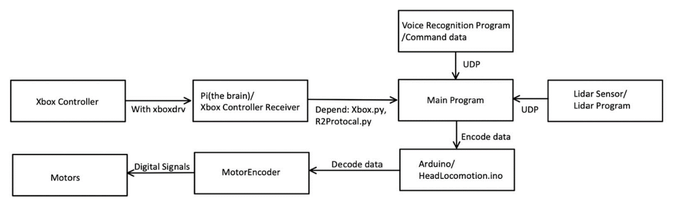

Figure 11.1 flow chart of the overall communication process

## Xbox Controller setup

### Establishment of Xbox Controller Connection with Pi

The first step for using Xbox controller to control the robot is to establish the connection between Raspberry Pi and the Xbox 360 Controller. For Linux distributions, there is a developed driver, especially for communicating with (wireless) Xbox controllers. We first need to install the driver so that it can be communicated with the controller:

*sudo apt-get install xboxdrv*

Also, the USB receiver should be connected to Raspberry Pi. With lsusb, we can check if it has been detected:

*pi@raspberrypi:~ $ lsusb*

*Bus 001 Device 005: ID 045e:0291 Microsoft Corp. Xbox 360 Wireless Receiver for Windows*

Turn the controller on and test if it is detected. To do this, we start the driver using:

*sudo xboxdrv --detach-kernel-driver*

After that, press the keys to change the log, which indicates which key(s) is/are pressed and its value.

One way to use the driver in our own scripts is the manual readout of the output values. We used an open Python library and downloaded it in our Pi:

*git clone https://github.com/FRC4564/Xbox*

*cd Xbox*

After we setup all the dependencies, we just need to import the Xbox library and read the controller’s data when we need it in the program:

*import xbox*

*joy = xbox.Joystick()*

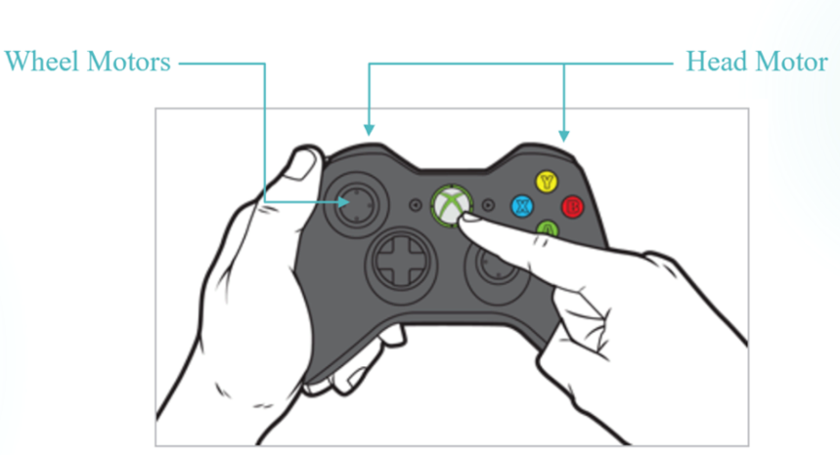

Fig.11.2 The instruction for controlling R2-D2 Robot

The Xbox data comes with four directions, each direction has a value from 0 to 1 representing the speed. We can get the data from the left joystick to control our wheel motors and from the top two buttons to control the head motor. Then, we use our R2 protocol to encode the data in specific forms and send the data to Arduino for further transmission.

### Xbox control vs. keyboard control

In the beginning, we use the keyboard to control the robot move in four different directions for prototype testing. But we end up with using the Xbox controller.

There are two reasons:

First, the keyboard could only offer four directions movement. For a robot like R2, it requires to be flexible and can be able to avoid obstacles in different scenarios. Using Xbox joystick, it will be easier to get the four parameters at a time and calculate the corresponding speed and direction which is a better choice.

Second, for our competition demand, we need to control the robot in a wireless way. Using the keyboard is inconvenient compared to the Xbox controller. Thus, we decided to implement the Xbox controller for the control.

## Arduino and Motor Encoder

14.3.1 Arduino program

When we successfully send data from Pi to Arduino, the first thing we need to do is to decode the data. Recall from our previous example in Section 2.1.4, if we want to decode the data for wheel motors, we first need to check if the type is “BM” and check if the data length is 4 bytes. If these conditions pass, then we can get these 4 bytes data and pass them to corresponding motor connections.

*if (strncmp("BM", fsm.type, 2) == 0 && fsm.data_len == 4) {*

*set_left_motor(fsm.data[0], fsm.data[1]);*

*set_right_motor(fsm.data[2], fsm.data[3]);*

*}*

Once the data has been decoded, we then can use these values to set the corresponding pin value to LOW/HIGH to control the motor to spin as the command. Each motor has 3 input pins, CW_PIN, CCW_PIN, SPEED_SET_PIN. We use the direction data to determine whether the motor spin clockwise or counterclockwise and use speed data to set the motor spin speed.

*void set_left_motor(byte dir, byte speed) {*

*if (dir == 0) {*

*digitalWrite(LEFT_CW_PIN, LOW);*

*digitalWrite(LEFT_CCW_PIN, HIGH);*

*}else {*

*digitalWrite(LEFT_CW_PIN, HIGH);*

*digitalWrite(LEFT_CCW_PIN, LOW);*

*}*

*analogWrite(LEFT_SPEED_SET_PIN, speed);*

*}*

14.3.2 Arduino-Encoder connection

The Motor Encoder we used for R2-D2 Robot is ECSON 70/10. In order to connect the Arduino to Motor Encoder, we chose 3 digital pins for each motor, which corresponds to CW_PIN, CCW_PIN, SPEED_SET_PIN. Following figure is how we connected the Arduino to our Motor Encoder.

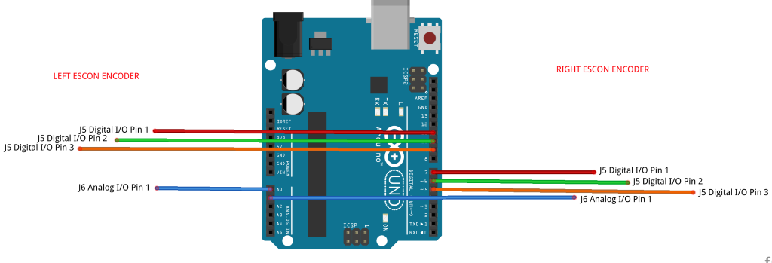

|  |  |
| --- | --- |
| Arduino Pin Number | Motor Encoder Pin |
| Digital 3 (Output) | HEAD_PWM_PIN |
| Digital 4 (Output) | RIGHT_CCW_PIN |
| Digital 5 (Output) | RIGHT_CW_PIN |
| Digital 6 (Output) | RIGHT_SPEED_SET_PIN |
| Digital 9 (Output) | LEFT_CCW_PIN |
| Digital 10 (Output) | LEFT_CW_PIN |
| Digital 11 (Output) | LEFT_SPEED_SET_PIN |
| Analog A0 (Input) | LEFT_SPEED_READ_PIN |
| Analog A1 (Input) | RIGHT_SPEED_READ_PIN |

Fig.11.3 Connection of Arduino and Encoder

14.3.3 Encoder-Motor connection

The last connection step is to connect the Motor Encoder to the real Motor that controls the wheels to move. To establish the connection, we need to connection total 9 wires. Following is a diagram of how to connect the Motor Encoder to Motor.

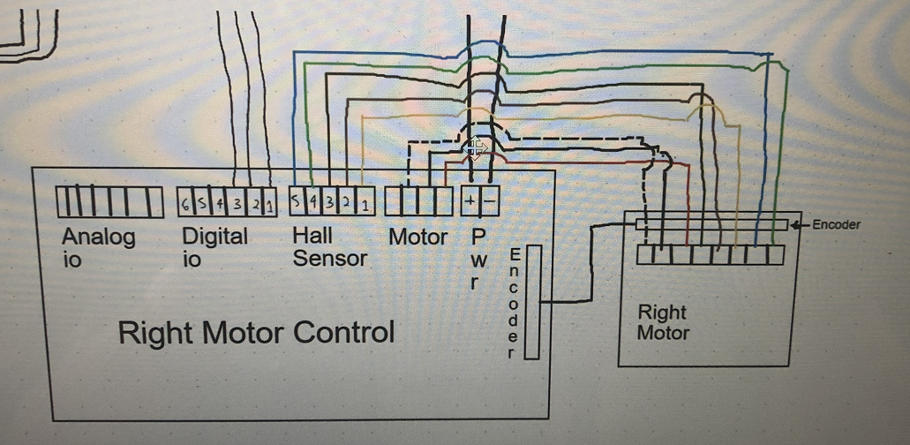

Fig.11.4 Connection of Motor and Motor Encoder

## Main Program

14.5.1 Voice Recognition

The voice recognition program has two programs supporting the UDP protocol. One is the client program. This program is integrated with the voice recognition program. If we tell the robot to move “forward”, “left”, “right” or “back”, the client program will translate it to 1, 2, 3 and 4 for the corresponding directions.

Once the server program received the message, it will control the robot to move in certain directions using the data received.

14.5.2 UDP Transmission

As mentioned in previous sections, both the voice data and lidar data are received by UDP. The main program contains two UDP listening thread (receiver end). It is a multi-thread program that both UDP sender ends continuously send data to the main program. Once the main program receives data, it first decodes the data and stores it to global parameters. These global parameters are only used in specific mode.

14.5.3 Connection between Pi and Arduino

The connection between Pi and Arduino is established by USB connection. When we need to transmit data from Pi to Arduino, we establish a serial connection with destination '/dev/ttyACM0' and set the baud rate to 115200.

*motors = serial.Serial('/dev/ttyACM0', baudrate=115200, timeout=1)*

Once the encoded data is ready for transmission, we use the following command to send the data to Arduino.

*motors.write(send_data)*

14.5.4 Initialization and Controlling Robot

At the beginning of the program, we initialize both wheel motors and head motor to be steady state by passing 0 to each motor. Once a command is detected, we change the corresponding parameter value to be the -1 or 1 based on the direction it is commanded.

*ls = joy.leftX()*

*rs = joy.leftY()*

*headR = joy.rightTrigger()*

*headL = joy.leftTrigger()*

Then we pass the parameter value to the R2 Protocol to encode the data.

*send_data = R2Protocol.encode(b"BM", struct.pack("4B", dir(ls), clamp(abs(ls), 25, 230), dir(rs), clamp(abs(rs), 25, 230)))*

Once the send_data value is ready, we use motor.write() command to send the data to Arduino.

## Software User Guide

To run this program, we list the processes as below:

1. Run the Xbox driver program in the Pi
2. Connect the Xbox receiver to the Pi, check the USB port if it is functional.
3. Turn on the Xbox controller to search the receiver for matching
4. Implement the protocol program into the Arduino.
5. Run the main program, this program includes two server programs in two threads.
6. Run the Lidar client program, keep collecting data and sending to server end.
7. Run the voice recognition client program, prepare for the future use.

Notice: we need the Xbox.py, R2protocol.py, Lidar.py and the Headlocomotion.py, these four libraries as dependencies for the programs above to running.

# Power

## Charging Procedure

Use the dark-greenish 2 hour charger. Before charging, find R2’s discharge cable and disconnect it. Then, there should be another charging cable which you plug into the charger by matching the colors.

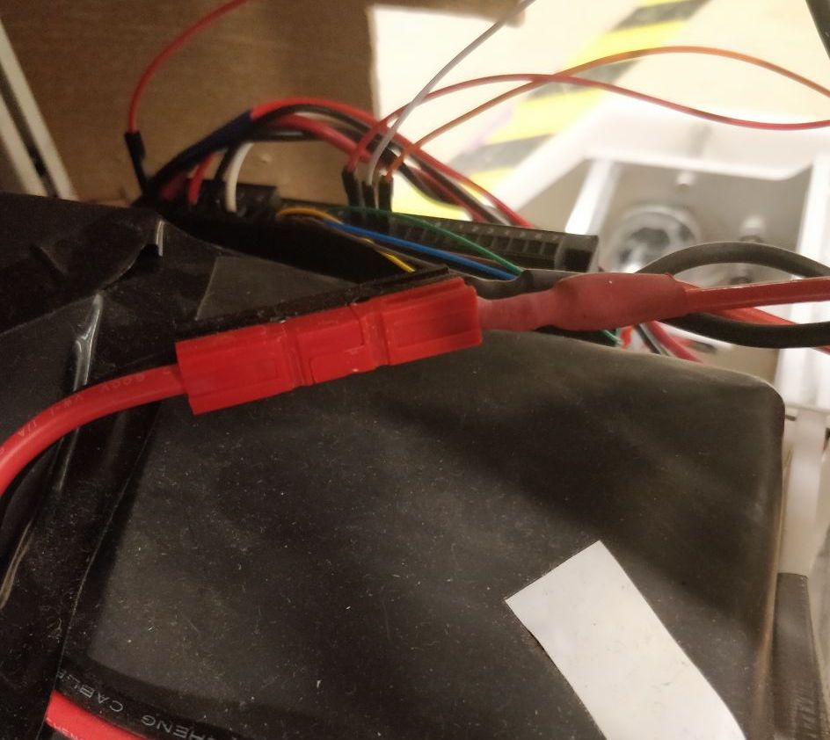

Figure 11.4.1 Disconnect these terminals

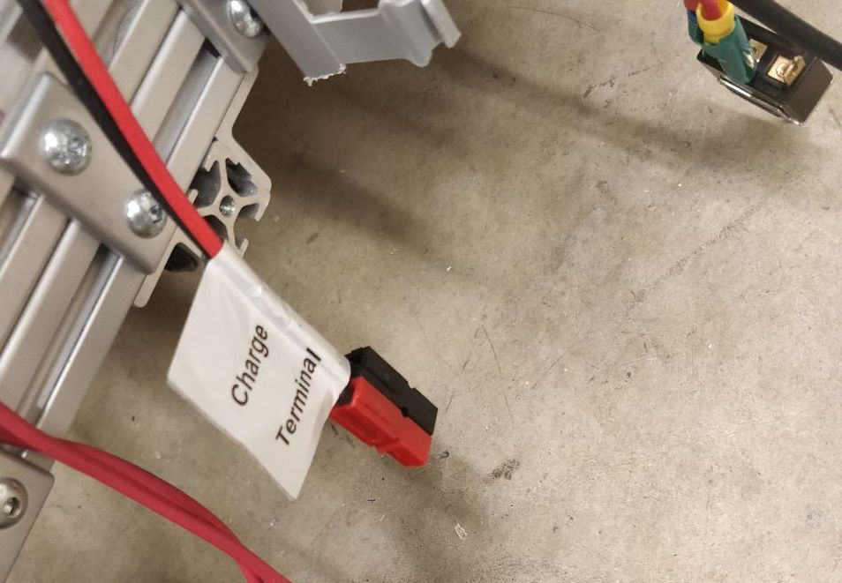

Figure 11.4.2 Connect the 2hour R2 charger here

## Battery and Power Specifications

The following chart was used to tally power consumption of all major components of R2:

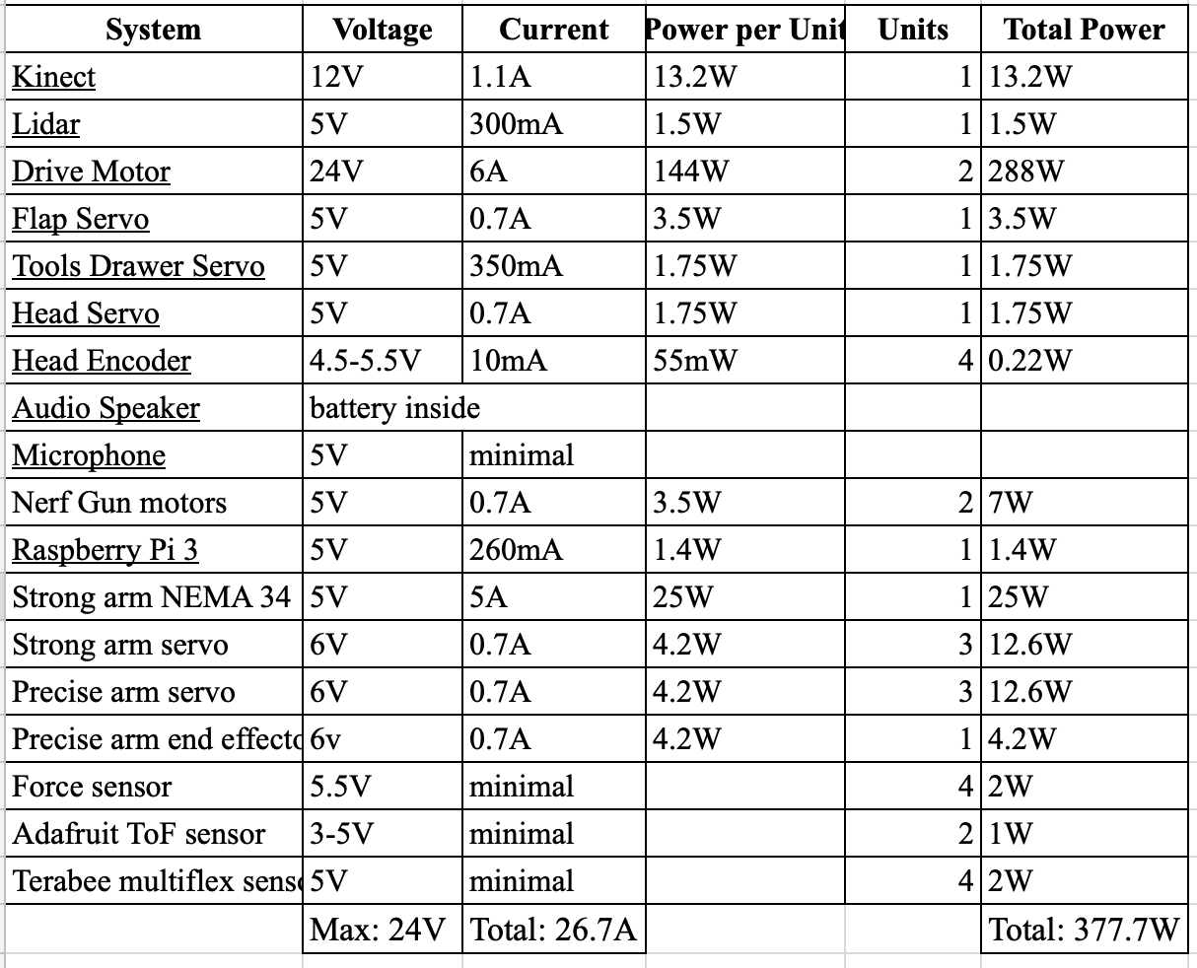

Figure 12.9.2 Power Specifications

The power consumed by all the components totaled 377.7W. Max voltage was found to be 24V and total current draw 26.7A. The existing battery can provide 25.6V and 20Ah and the existing power board can provide 25V and handle 30A. The current R2’s max consumption is 377.7W which is close to the previous R2’s ratings of 378W. Therefore, the existing battery and power board will be used to manage the new R2’s power.

The existing battery on R2 is a 25.6V 20Ah 512Wh LiFePO4 battery from Battery Space. It weighs 9.0 pounds and 11.8 ounces and has dimensions of 8.1”x5”4.8”. There are four separate terminals, two for charging and two for discharging, since the charging and discharging rates of the battery are different. Specifications of the battery are shown below:

|  |  |
| --- | --- |
| **Voltage** | 25.6V nominal, 29.3V peak, 20V cut-off |
| **Capacity** | 20Ah |
| **Protection** | Overcharge, overdischarge, overcurrent, short circuit |
| **Terminals** | Charge and discharge |
| **Charging Rate** | 20A max |
| **Discharge Rate** | 40A max |
| **Dimensions (LxWxH)** | 204mm(8.1") x 125mm(5") x 120mm(4.8") |
| **Weight** | 4420 grams (9.0 lbs 11.8 Oz) |

*Table 32: Battery Specifications*

The existing battery is thus suitable for R2’s current power ratings.

# Path Planning

## Goals and Objectives

We have outlined several goals that we hope will be accomplished in future semesters. These goals are necessary for the robot to navigate around obstacles without human intervention (ie. autonomous movement) as well as for localization.

The most immediate objectives are implementing a distance estimation using AprilTags and localization within a coordinate grid. For the first objective, it’s important for the robot to be able to estimate the relative distance and angle from an AprilTag in order for the team to get a bearing on where it is. Only then can commands be sent to it for how and where to move. The second objective, localization, is the first step to implementing a grid traversal algorithm that would minimize the distance between the origin and destination while avoiding obstacles. To be able to update the robot’s physical coordinates during movement is imperative, because there’s bound to be some inaccuracies with projected coordinates due to sensor noise and movement variables.

Once these objectives are working in code, we have to test them using hardware. The distance estimation using AprilTags should be obtained using the PiCamera parameters and an image from the PiCamera that includes several AprilTags and compared to the actual distance. Localization should involve placing the robot in various locations and having it calculate its coordinates relative to an origin.

After these objectives are tested, further goals include being able to detect and avoid objects using lidar sensors. Although we haven’t worked with sensors yet, we currently have a functional A* graph traversal algorithm working. Assuming that the previous objectives are accomplished, it should not be too difficult to update the algorithm to work with sensors, although it is probably necessary to bloat obstacles radii to the size of the R2 robot, since the A* algorithm assumes a point traversal.

## Design

Our code is separated into two main parts: localization and path selection. Currently, localization was partially implemented in eyes.py, which utilizes a 3rd-party Python implementation of the AprilTags visual fiducial system located at (https://pypi.org/project/apriltag/). Meanwhile, path selection was written in Python.

### Localization

The localization calculates take place in eyes.py. In order to use AprilTags, you must run:

pip install aprilTag

and make sure it is located in the default installation of Python.

Our implementation calls detector.detection_pose and stores the resulting pose estimate. From this estimate, we extract the 3D offset of each object as dx, dy, dz = (pose[0][0][3], pose[0][1][3], pose[0][2][3]). Furthermore, we extract the offset angles as: angle_x, angle_y, angle_z = (math.atan2(pose[0][2][1], pose[0][2][2]),

math.atan2(-pose[0][2][0], math.sqrt(math.pow(pose[0][2][1], 2) + math.pow(pose[0][2][2], 2))), math.atan2(pose[0][1][0], pose[0][0][0])).

Unfortunately, the rest was not implemented due to time restrictions.

In order to localize the robot and generate a two-dimensional mapping of the position of the robot within the world, its orientation, and positions on surrounding obstacles, we created a Grid, Tile, and TileWrapper classes in Python.

### Search Algorithm

The A* search algorithm is implemented in the file grid.py. The completed the A* Search Algorithm that gives the “best-guess” path given the path of object locations that are known.

The “world” as R2D2 sees it is concretely represented by a Grid class, which is populated by instances of the Tile class, each representing a “tile” that could potentially have an obstacle in it. To preserve modularity, the actual search algorithm is carried out in a Search class. In addition, the search algorithm does not operate on the Grid or Tile classes themselves; it instead stores information about each Tile in a TileWrapper object, which also allows us to store additional information - such as the instantaneous tile cost - important to the search algorithm. TileWrappers are all stored in a TileDict class. We list the fields and the methods of each class below.

#### Grid

tiles - internal representation of the grid as a two-dimensional list of Tile objects

tileSize (optional) - lists the “size,” in pixel units, of the internal representation of each tile

tilesX, tilesY - the size of the world with units as tiles

createGrid(tilesX, tilesY) - creates a Grid class with fields tilesX, tilesY

getTile(x, y) - access the [xth][yth] tile in the list of tiles

loadNeighbors() - updates each tile’s reference to its neighboring tiles using;this function only needs to be called once

getNeighborsOf(x, y, allowDiagClipping = false) - returns the neighbors of a tile at (x, y), which are defined to be any of the 8 adjacent tiles that are not obstructed or diagonally-obstructed by an object

isFreeTile(x, y) - checks if the tile at (x, y) is not obstructed

#### Tile

setNeighbors(neighbors) - sets self.neighbors with neighbors, which is a list of Tile objects

addNeighbor(neighbor) - adds an additional neighbor to the list of neighbors

getNeighbors() - return the internal list of neighboring Tiles

getHashCode() - returns the string “(x,y)” where x, y are the x- and y- positions of the tile, respectively

TileWrapper

futureCost - estimated future cost to the destination

accCost - accumulated cost from start to this TileWrapper

setParent() - sets parent TileWrapper; allows the search algorithm to reconstruct the optimal path from a chain of TileWrappers

reset() - clears any parent relationship

cost() - returns the sum of estimated future cost and accumulated cost

#### TileDict

dict - internal dictionary that stores hashcode-TileDict key-value pairs

insert(hash, tileWrapper) - stores a new tile in the internal dictionary

get(hash) - returns the TileWrapper with the unique hash code

mem(hash) - determines whether there exists a TileWrapper with the given hash

pop(hash) - removes the TileWrapper from the internal dictionary

#### Search

openListWrapper - a TileDict that stores the open list of TileWrappers

closedListWrapper - a TileDict that stores the visited list of TileWrappers

reset() - clears visited and open lists

search() - iteratively calculates a path of TileWrapper nodes using the A* algorithim as the list of objects is constantly updated; returns nothing otherwise

hybridDist(tile1, tile2) - calculates the manhattan distance between the two tiles, except taking a diagonal shortcut when possible

### How To Use

Since the objectives were not completed, we describe the process of utilizing the code as if it were finished.

The process is envisioned to be quite simple. The user must first set up the obstacles and AprilTag markers. Then, the user must adjust the hard-coded positions of the array of AprilTags that will be located in the eyes.py file. Finally, the entire localizing process will be started by simply running the “eyes.py” file.